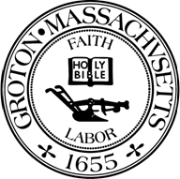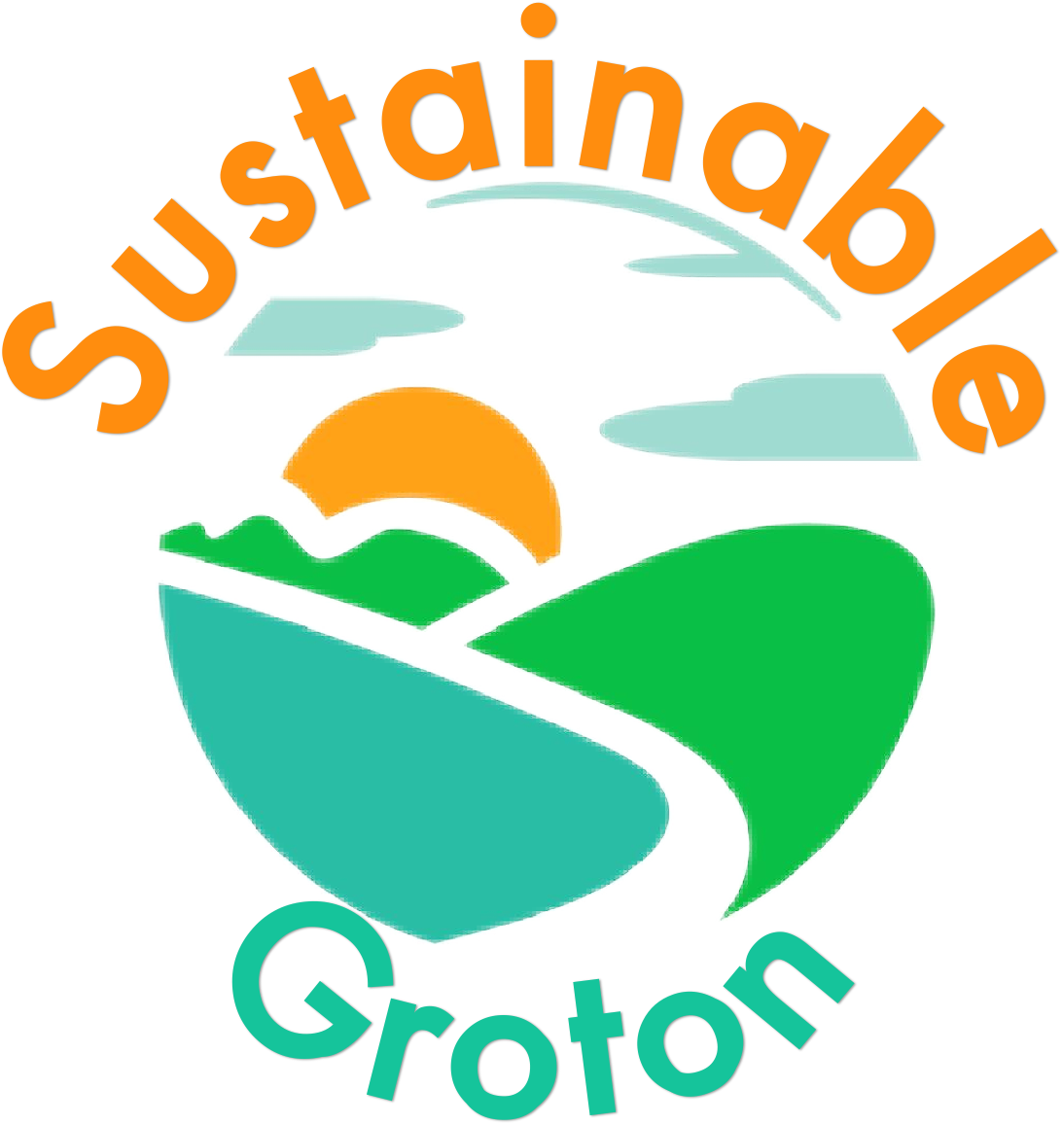

SUSTAINABILITY COMMISSION

Sustainability Commission Meeting Minutes
Meeting Date: Thursday, March 21, 2024
Meeting Time: 7:00 PM
Meeting Location: The Groton Center

Attendees: Phil Francisco (Chair), Alison Dolbear Peterson, Bruce Easom,
Sue Fitterman (alternate), Linda Loren, Pat Parker-Roach,
Ginger Vollmar, Charlotte Weigel
Absent: Jim Allen, Ken Horton, Jim Simko, David Southwick
Guests: Clio Fisher, Andrew Scott

Minutes:
Called to Order – 7:00 pm

- Consider elevating Sue Fitterman from “alternate” to “full” member of the Commission (Phil/Alison/Sue/all)

Sue stated she’s learned about the excellent work done by the Commission by attending all their meetings since November and several Education Seminars. She’s interested in becoming a “full” member of the Commission and helping with the Pollinator Garden and the Pollinator Pathway, and writing/editing content for the new website and taking photos as needed. A motion was made and seconded to elevate Sue Fitterman from an alternate member to a full member. The motion passed unanimously.

- Plans for Town Meeting, March 26th, 7:00 pm (Phil/all) (Coverage of posters and handouts at table in hallway, Advocates sign-ups in hallway?, plans for commentary in Town Meeting for our funding requests (main funding and CPC grant)

For Town Meeting, Phil will set up a table near the entrance to the auditorium with a poster for the EV Petting Zoo, trifold brochures, Sustainable Groton stickers, and handouts about the April 3rd Education Seminar on Sustainable Food Choices. Linda, Bruce and Charlotte will help at the table.

There are two items on the Town Meeting warrant from the Sustainability Commission: Article 11 requests $9600 in funding for FY2025 for the Sustainability Commission, and Article 13 requests Community Preservation Commission funding of $3600 for FY2024 for the Pollinator Pathway. For Article 11, Phil plans on saying this year’s request is 36% less than last year, and the Commission plans on returning several hundred dollars in unspent FY2024 money to the Town. For Article 13, this is FY2024 money that was already appropriated at last year’s Town Meeting and the Pollinator Pathway project has been reviewed and unanimously approved by the Community Preservation Commission. After a discussion, a motion was made and seconded to present Article 13 at Town Meeting as written in the warrant. The motion passed with 6 yes votes and 1 abstention.

- Prospective request for resolution from the Select Board re: “Stop Private Jet Expansion” initiative for Hanscom Field (Ginger/all)

Ginger updated the Commission about the proposal that a private developer expand the hangar space for private jets at Hanscom Field. Somerville has submitted a Resolution and Wayland has submitted a letter to Governor Healey opposing the expansion. There are 14 other towns throughout Massachusetts that are working on either a Resolution or a letter to the Governor. Pat asked if this work is within the scope of the Sustainability Commission. Members agreed that it was, and that Groton should be part of this effort to help prevent carbon emissions and noise pollution in the area. Ginger will draft a letter to the Select Board, and will present it at our next meeting in April for review.

- Subcommittee & Workgroup Updates

Education – update on April 3rd seminar “Sustainable Food Choices”, and EV Petting Zoo at GrotonFest (Phil). The next event is Wednesday April 3rd at 7:00 pm at the Groton Center on “Sustainable Food Choices”. There will be presentations by speakers representing generations of local farms and orchards: Autumn Hills Orchards, Blood Farm, Spiczka/Kirk Farm, Theo’s Market Gardens, and Tully Dairy Farm. Ed McNierney from the Groton Conservation Trust will be the MC, and Andrew Scott will speak about the Groton Grange. Phil created a list of local farms and orchards which will be a slide at the April 3rd talk, as well as a handout for attendees. He will email the document to the group for review.

The next event is the EV Petting Zoo at the Spring GrotonFest 2024 on Sunday May 19th from 11:00 to 4:00 at the Prescott Community Center. Two large color promotional posters for the event have been created. The Town’s Nissan Leaf will be parked at the Commission booth on festival grounds behind the Prescott Community Center, along with an electric golf cart from the Groton Country Club. There will be approximately 17 other plug-in and hybrid vehicles (large and small cars, SUV’s, trucks, e-bikes, etc.) parked on the Forge and Vine lawn at The Groton Inn. Phil reported that The Groton Inn has been extremely helpful in partnering with the Commission on this project and will promote the event through their social media channels and in their May newsletter. They will also offer outdoor beverage service on the lawn near the vehicles, and are working on permitting for a food truck. A few weeks before the EV Petting Zoo, we can park a few electric vehicles behind The Groton Inn and take photos for publicity and promotion.

The Education Seminar Series subcommittee met on March 10th and discussed the following ideas for future Education Seminars: “Green Homes” tours; heat pump coaching; loss of trees in new developments and in forested lands; GELD presentation on heat pumps and battery program; and home-based energy (solar).

NetZero 2050/Climate Action Plan – update on recent GELD Commission meeting(s) and next steps in responding to Select Board (Charlotte). Charlotte and Ken met with Town Sustainability Directors in Wellesley and Hingham to discuss Climate Action Plans. They also met with representatives from the Municipal Light Plants in those towns and discussed partnering with Abode Energy Management, a decarbonization consulting company. Charlotte attended a Climate Leaders Program (CLP) meeting and learned that becoming certified as a Climate Leader Community (not just a Green Community) provides access to grant funding for shovel-ready projects as well as other benefits. Since there are many towns like Groton looking to create a Climate Action Plan, the CLP is working on a template that could be used by all Massachusetts cities and towns.

Energy Coaching – update (Charlotte). Charlotte has done three Energy Coaching sessions and has three more scheduled. Ken took his first training class today to become an Energy Coach. Ken and Charlotte will be looking for support from GELD in the future and are thinking about heat pump coaching sessions in the fall.

Communications and Social Media – update on March 15th MassEnergize training & plans (Pat). The March 15th Zoom training session by Brad Hubbard Nelson from MassEnergize was attended by Pat, Phil, Ken, Alison, Sue, Linda, Ginger and David. The session was a good overview of how to take the template provided and customize it for our needs. The new website will be an excellent tool to publicize the Commission’s work and events. Pat will talk to David about how the website would fit in with the Sustainable Groton Advocacy Program and the new Sustainable Groton Facebook page that David is developing. Pat will set up a meeting within the next few weeks to talk about next steps.

Sustainable Groton Advocates – update on early Facebook page & plans (Phil, for David). David has set up an early Sustainable Groton Facebook page that isn’t live yet. He is also working on getting more Advocate Certificates printed. Phil will talk to David before the Spring GrotonFest on May 19th about ideas to get people attending the event to sign on as Sustainable Groton Advocates.

Pollinator Garden & Corridor – update on plans and timetable (Alison). Alison met with Town Clerk Dawn Dunbar about requirements for having volunteers working in the Pollinator Garden and the Pollinator Pathway. Dawn said all volunteers must sign a waiver with The Groton Center before any work is done.

Grant & Fiscal Development – subcommittee initialization update (Phil). Phil reported there have been no recent meetings of this subcommittee but he will set one up soon.

- New Business

-Linda passed out copies of the Friends Of The Tree Warden Spring 2024 newsletter to the group.

-Ginger related that Karen Vanderborgh approached her with concerns that old growth trees in Groton are taken down during new construction and asked if the Sustainability Commission could address this. After a discussion, the group agreed that if the Friends Of The Trees develop a policy regarding the protection of old growth trees, then Ginger would prepare a letter of support from the Sustainability Commission.
-Bruce said the next tire recycling day will be Saturday April 6th from 7:30 am to 4:30 pm at the Transfer Station. A notice will be placed on the Town website and on Groton Channel TV, and in the April 5th edition of The Groton Herald. Bruce will email a pdf of the notice to Ginger for further publicity. He noted that over 80 tires were collected at last November’s tire recycling day, and he expects to hold one more event in mid-June.

-Bruce updated the group on a grant opportunity (the Peter Bertozzi fund) offered by the Commissioners of Trust Funds. Funds could be used by the Sustainability Commission for an intern or student to be paid for work in planning and implementing Groton’s pollinator pathways. Bruce sent a letter to the guidance counselor at Groton Dunstable Regional High School asking if any student would be interested in an internship for 3 to 4 months this spring/summer for about 2 hours per week to: identify pollinator species in decline in Groton; identify needed plants and habitats for pollinators; identify areas on Town-owned land for potential pollinator pathways; and report back to the Commission with findings. The guidance counselor responded with a possible candidate from the high school. Charlotte suggested that Bruce have an initial conversation with the student as soon as possible to talk about availability. The grant application will be for $700 and is due by April 5, 2024. A motion was made and seconded to authorize Bruce to submit a grant application on behalf of the Sustainability Commission to the Commissioners of Trust Funds. The motion passed unanimously.

-GELD Newsletter: Phil told the group that the GELD commissioners gave the Sustainability Commission a draft of the newsletter they intend to release to all customers in the near future. The Energy Coaching workgroup (Charlotte, Ken and Phil) edited the document and added comments and feedback. The workgroup was concerned about several sentences in the newsletter, specifically GELD’s statements about the availability of reliable electricity, and the costs and risks of heat pumps. The workgroup drafted a separate letter to GELD to address these concerns. The letter highlights the many benefits of heat pumps, and provides evidence of work showing New England has only limited exposure to energy shortfalls. GELD will be discussing the contents of the newsletter at their next meeting in April. A motion was made and seconded to authorize Phil to send edits and comments about the newsletter to GELD commissioners and senior management, along with a letter containing the Sustainability Commission’s concerns. The motion passed unanimously.

- Review/approve Minutes from the February 20th Commission meeting (Bruce/all). We reviewed the minutes for the 2/20/24 meeting, including a few edits. A motion was made and seconded to approve the February 20th minutes, as amended. The motion passed with 6 yes votes and 1 abstention.

- Adjourn. Motion to adjourn at 9:15 pm passed unanimously.

Next Meeting: Tuesday, April 16, 2024, 7:00 pm at The Groton Center

Respectfully submitted,
Sue Fitterman

