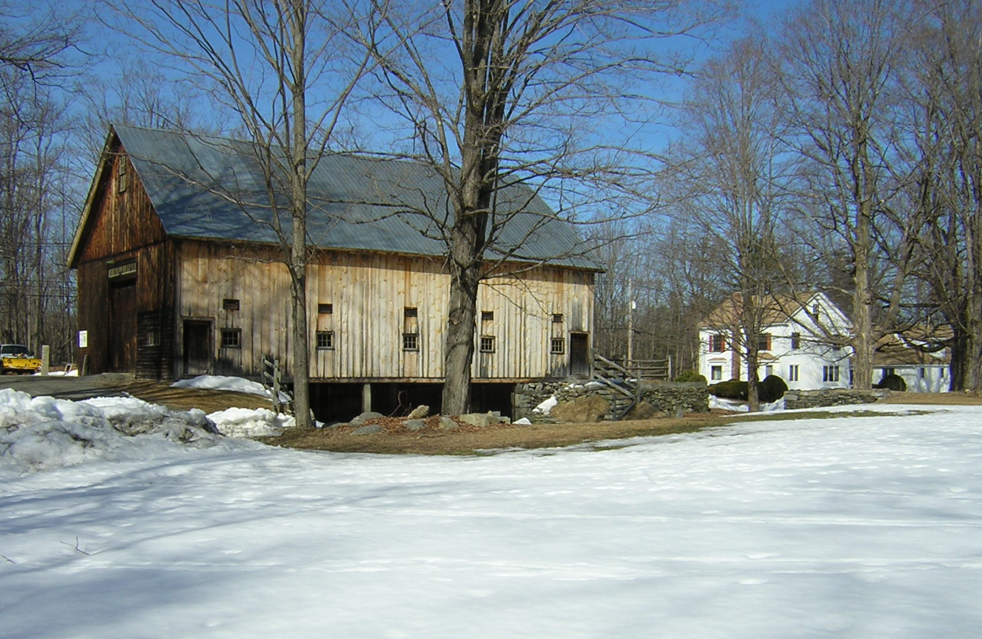

Town of Groton
2016 Demographics Report

LAND USE DEPARTMENT
TOWN OF GROTON
April 11, 2016

COMMUNITY PROFILE
Demographics | 2000 | 2010 | % Change
Sex & Age
Total Population | 9,547 | 10,646 | 11.5%
Male | 4,731 | 5,264 | 11.3%
Female | 4,816 | 5,382 | 11.8%
Median Age | 36.5 | 42.5
% Population 18 years and under | 34.3% | 30.7% | -4.3%
% Population 65 years and over | 7.0% | 9.7% | 2.7%
Households | 3,268 | 3,753 | 14.8%
Total Housing Units | 3,393 | 3,989 | 17.6%
Average Household Size | 2.9 | 2.8
Average Family Size | 3.3 | 3.2
Race/Ethnic Classification
Total Population | 9,547 | 10,646 | 11.5%
White | 9,198 | 9,964 | 8.3%
Black or African American | 32 | 45 | 40.6%
American Indian & Alaska Native | 12 | 7 | -41.7%
Asian | 92 | 293 | 218.5%
Some Other Race (Unspecified) | 6 | 8 | 33.3%
Two or More Races | 96 | 135 | 40.6%
Hispanic or Latino (All Races) | 109 | 193 | 77.1%
Social Characteristics
Housing Characteristics
Total Housing Units | 3,393 | 3,989 | 17.6%
Occupied Housing Units | 3,268 | 3,753 | 14.8%
Owner-occupied | 2,740 | 3,128 | 14.2%
Renter-occupied | 528 | 625 | 18.4%
Vacant Housing Units | 125 | 236 | 88.8%
Avg. Household Size - Owner-occupied | 3.07 | 2.95
Avg. Household Size - Renter-occupied | 2.02 | 1.99

POPULATION

Population Age in Groton 2000-2010
Age Cohort | 2000 | 2010 | % Change 2000 - 2010
Under 5 years | 837 | 517 | -38.2%
5 to 17 years | 2,280 | 2,750 | 20.6%
18 to 24 years | 400 | 384 | -4.0%
25 to 34 years | 968 | 672 | -30.6%
35 to 44 years | 2,155 | 1,485 | -31.1%
45 to 54 years | 1,505 | 2,363 | 57.0%
55 to 64 years | 734 | 1,438 | 95.9%
65 to 74 years | 362 | 584 | 61.3%
75 years and over | 306 | 453 | 48.0%
Total | 9,547 | 10,646 | 11.5%
Source: US Census Bureau

Education Attainment
Geography | High School Degree or Less | Some College | Associate's Degree | Bachelor's Degree | Graduate or Professional Degree
Massachusetts | 36.1% | 16.3% | 7.7% | 22.6% | 17.4%
Middlesex County | 29.3% | 13.3% | 6.1% | 26.1% | 25.1%
Ayer | 36.3% | 20.3% | 7.1% | 23.9% | 12.4%
Dunstable | 25.3% | 13.8% | 7.3% | 30.3% | 23.4%
GROTON | 16.4% | 10.9% | 6.0% | 35.4% | 31.3%
Littleton | 19.3% | 13.8% | 7.4% | 33.1% | 26.5%
Pepperell | 37.6% | 18.9% | 8.6% | 22.6% | 12.4%
Shirley | 50.0% | 20.4% | 5.6% | 17.3% | 6.8%
Townsend | 37.0% | 19.6% | 10.8% | 22.2% | 10.4%
Tyngsborough | 33.0% | 16.4% | 10.9% | 26.3% | 13.5%
Westford | 13.2% | 11.9% | 5.5% | 34.6% | 34.9%
Source: 2010 - 2014 American Community Survey

Median Earnings By Education Attainment | Total Median Earnings | Male Median Earnings | Female Median Earnings
Population 25 years and over with Earnings | $69,050 | $91,806 | $56,047
Less than High School Graduate | $53,162
High School Graduate (includes equivalency) | $42,192 | $49,327 | $36,442
Some College or Associate's Degree | $43,750 | $51,014 | $31,886
Bachelor's Degree | $73,205 | $98,346 | $47,750
Graduate or Professional Degree | $91,898 | $128,565 | $73,678
Source: 2010-2014 ACS

HOUSEHOLDS

Household and Family Income by Geographic Area
 | Households |  |  | Families
Geography | % with Income > $150,000 | Median Income | % Householders 65 & Older Below Poverty Line | Median Income | % of Families With Children Below Poverty Line
Middlesex County | 42.0% | $83,488 | 4.0% | $105,827 | 8.2%
Ayer | 34.6% | $66,630 | 0.0% | $84,539 | 20.8%
Dunstable | 59.3% | $116,125 | 0.0% | $135,234 | 0.4%
GROTON | 57.1% | $116,686 | 0.0% | $133,421 | 2.5%
Littleton | 55.7% | $111,652 | 0.0% | $129,815 | 3.5%
Pepperell | 37.1% | $77,767 | 4.0% | $85,959 | 3.4%
Shirley | 27.7% | $66,453 | 4.5% | $78,398 | 18.3%
Townsend | 38.6% | $81,024 | 2.3% | $93,423 | 1.9%
Tyngsborough | 48.2% | $93,108 | 14.2% | $115,331 | 9.0%
Westford | 54.8% | $125,143 | 5.5% | $144,194 | 2.3%
Source: 2010 - 2014 ACS
HOUSING

Town of Groton
Housing Trends | 2000 | 2010 | 2014
Number of Dwelling Units | 3,393 | 3,989 | 4,260
Average Household Size | 2.9 | 2.79
Median House Value | $278,700 | $471,200 | $426,900
% Change in Median House Value |  | 69.1% | -9.4%
Income Trends
Median Household Income | $83,079 | $123,853 | $116,686
% Change in Median Household Income |  | 49.1% | -5.8%
Rent Trends
Rent | Not Avail. | $1,171 | $1,214
% Change in Rent |  |  | 3.7%
Vacancy Trends
Vacant Housing Units | 125 | 236 | 246
Homeowner Vacancy Rate | 0.8% | 1.8% | 1.7%
Rental Vacancy Rate | 1.9% | 6.8% | 7.5%
Source: US Census, 2006 - 2010 ACS, 2010 - 2014 ACS

Groton's New Construction Building Permits Issued 2004-2014
Year | Single Family Building Permits |  | Two Family Building Permits |  | Multi-family Building Permits |  | Demolitions | Total
2004 | 19 |  | 4 |  | 10 |  | 13 | 33
2005 | 19 |  | 4 |  | 53 |  | 14 | 76
2006 | 14 |  | 6 |  | 0 |  | 12 | 20
2007 | 19 |  | 0 |  | 0 |  | 6 | 19
2008 | 12 |  | 0 |  | 0 |  | 2 | 12
2009 | 21 |  | 4 |  | 0 |  | 4 | 25
2010 | 35 |  | 1 |  | 5 |  | 6 | 35
2011 | 18 |  | 0 |  | 0 |  | 2 | 16
2012 | 25 |  | 1 |  | 0 |  | 2 | 24
2013 | 26 |  | 1 |  | 0 |  | 3 | 24
2014 | 23 |  | 1 |  | 1 |  | 7 | 18
Source: Groton Land Use Department
Median Sales Price of Groton Housing By Type 2005-2015
Year |  | Total Sales |  | Median Sales Price Single Family Homes |  | Median Sales Price Condos
2015 |  | 177 |  | $431,500 |  | $197,250
2014 |  | 189 |  | $412,000 |  | $218,450
2013 |  | 182 |  | $405,000 |  | $214,900
2012 |  | 184 |  | $391,500 |  | $185,000
2011 |  | 117 |  | $371,500 |  | $190,200
2010 |  | 150 |  | $404,000 |  | $165,500
2009 |  | 108 |  | $415,000 |  | $169,900
2008 |  | 92 |  | $399,250 |  | $217,500
2007 |  | 155 |  | $501,450 |  | $312,500
2006 |  | 147 |  | $457,500 |  | $337,500
2005 |  | 188 |  | $472,000 |  | $270,200
Source: The Warren Group

ECONOMY

Civilian Employed Population Sixteen and Over by Occupation
Community | Management, Business, Science & Arts | Service | Sales & Office | Natural Resource, Construction & Maintenance | Production, Transportation & Material Moving
Middlesex County | 52.8% | 14.5% | 20.4% | 5.7% | 6.5%
Ayer | 47.0% | 14.9% | 21.5% | 10.9% | 5.7%
Dunstable | 55.5% | 10.5% | 21.4% | 4.8% | 7.8%
GROTON | 69.3% | 8.9% | 14.9% | 2.9% | 4.0%
Littleton | 56.1% | 12.4% | 19.6% | 5.6% | 6.3%
Pepperell | 43.2% | 18.1% | 24.1% | 7.5% | 7.2%
Shirley | 42.7% | 17.2% | 16.1% | 8.8% | 15.1%
Townsend | 41.1% | 15.1% | 22.9% | 11.9% | 8.9%
Tyngsborough | 44.6% | 11.9% | 22.0% | 11.1% | 10.4%
Westford | 68.1% | 8.9% | 14.1% | 5.2% | 3.7%
Source: 2010 - 2014 ACS

Groton's Labor Force Statistics 2005-2015
Year | Labor Force | Employment | Groton's Unemployment Rate
2005 | 5,326 | 5,147 | 3.4%
2006 | 5,485 | 5,300 | 3.4%
2007 | 5,642 | 5,456 | 3.3%
2008 | 5,664 | 5,384 | 4.9%
2009 | 5,692 | 5,343 | 6.1%
2010 | 5,714 | 5,372 | 6.0%
2011 | 5,728 | 5,363 | 6.4%
2012 | 5,709 | 5,414 | 5.2%
2013 | 5,791 | 5,493 | 5.1%
2014 | 6,007 | 5,750 | 4.3%
2015 | 5,959 | 5,764 | 3.3%
Source: MA Department of Revenue

