### Town of Groton

**Conservation Commission**

173 Main Street

Groton, Massachusetts 01450-1237

Tel: (978) 448-1145

Fax: (978) 448-1115

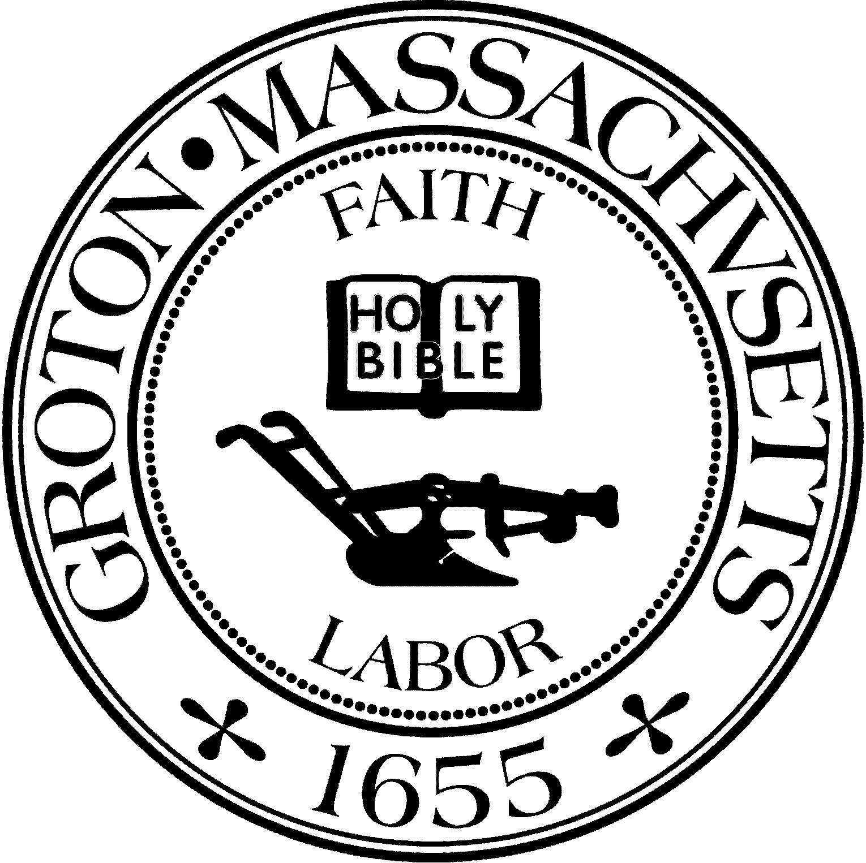

Sargisson Beach Park Ranger

The Town of Groton Conservation Commission is seeking qualified applicants for a part-time Park Ranger position. The Park Ranger will be responsible for assisting with the maintenance and operations at the Sargisson Beach Conservation Area from mid-May until mid-September. The hours are flexible (approx. 12-19 hours/week). The position pays $15/hr.

We are looking for applicants who are responsible and personable, have their own transportation, and enjoy working outdoors. This position involves performing facility maintenance and maintaining a clean parking, trails, and beach areas. Landscaping experience, including the operation of a gas-powered leaf blower, is a plus.

To apply, please complete a Town of Groton job application and deliver to Melisa Doig, Human Resources Director, Town Hall, 173 Main St., Groton, MA 01450 or by email to [humanresources@grotonma.gov](mailto:humanresources@grotonma.gov). For questions please call (978) 448-1145. Job description is available by request.

**Applications due by April 25, 2025**

*The Town of Groton is an Equal Opportunity Employer*