Department of Public Works
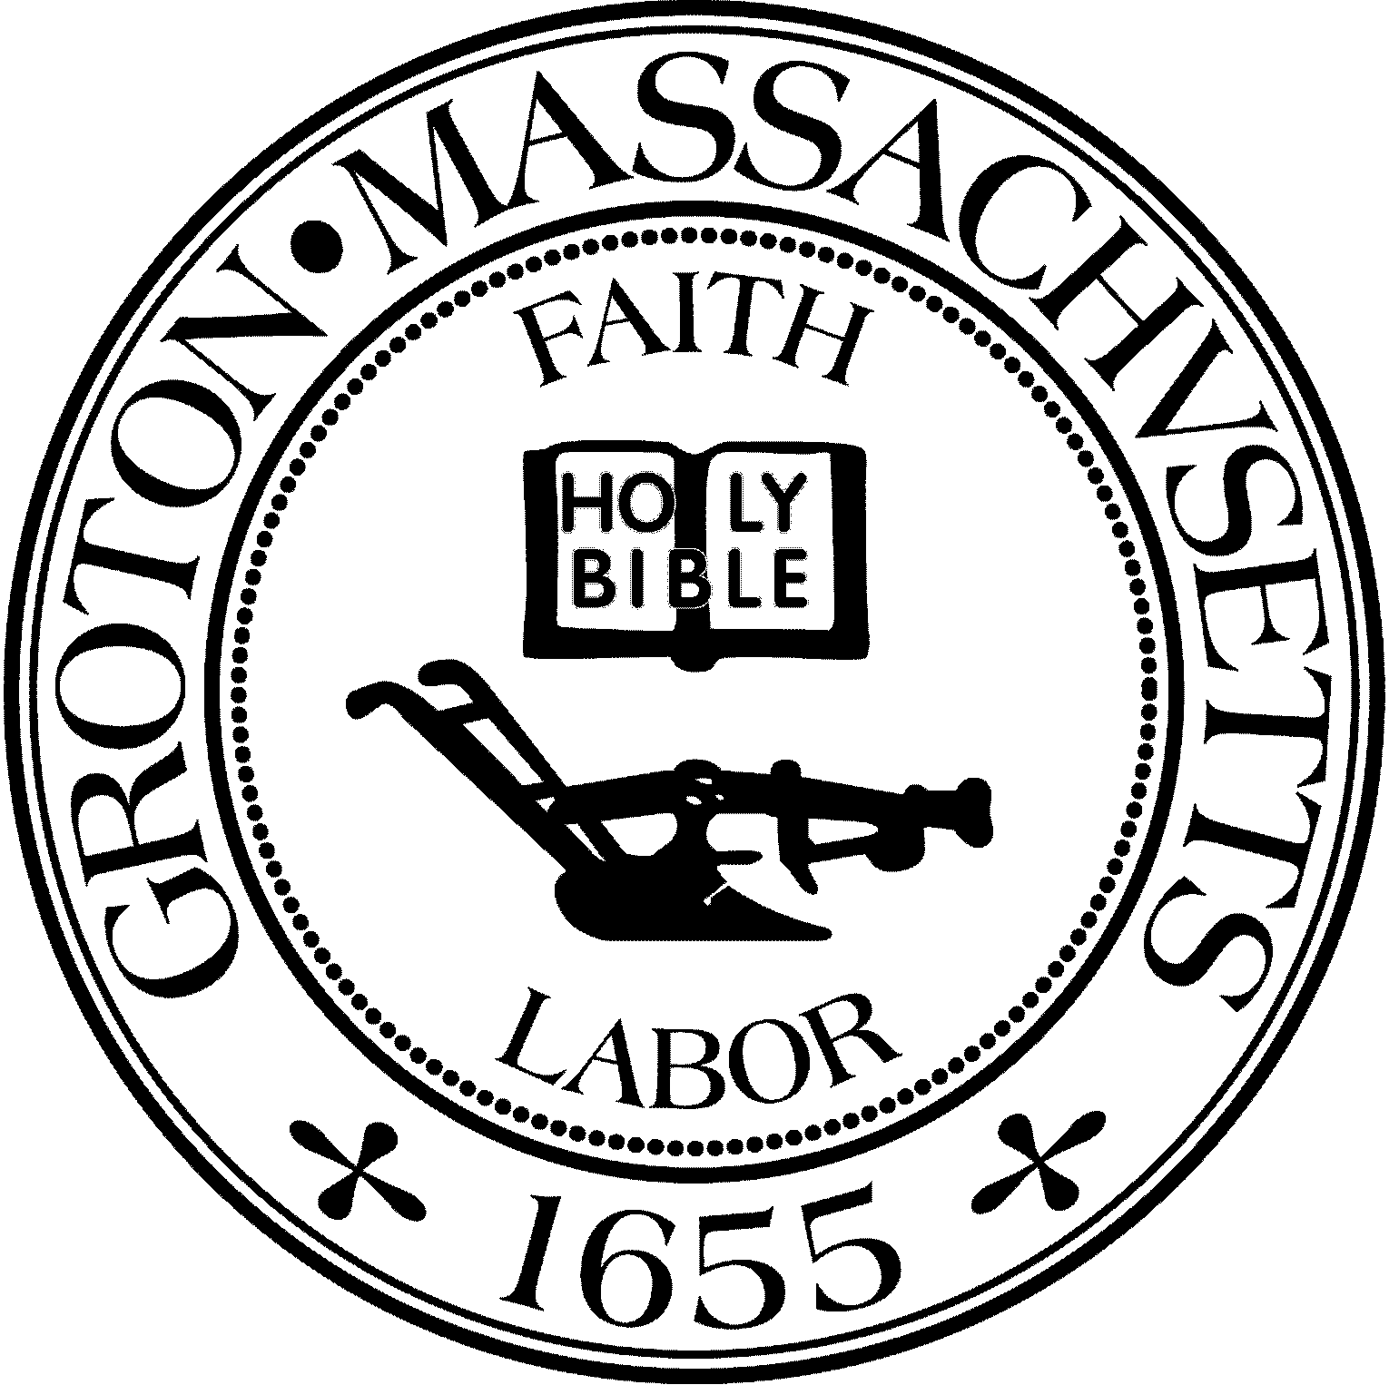

TOWN OF GROTON
173 Main Street
Groton, Massachusetts 01450-1237
Tel: (978) 448-1145
Fax: (978) 448-1115

Custodian II

The Town of Groton Department of Public Works is accepting internal applications for a 40 hour/week Custodian I position. The pay range is $20.81 to $29.73 based on experience.

The Custodian II position performs routine building cleaning duties for municipal buildings and all other duties as required, including mowing and snow clearing.

High School Diploma or equivalent, and driver license are required; must also be able to make basic arithmetical computations; understand and follow oral and written instructions and work independently. Must be able to demonstrate possession of the required knowledge, skills and abilities to perform custodial work. Must have skill in use of hand and power cleaning tools. There is occasional lifting up to 10 pounds, and seldom lifting up to 100 pounds.

To apply, please complete an internal job application and submit to Melisa Doig, Human Resources Director, Town Hall, 173 Main St., Groton, MA 01450 or by email to humanresources@grotonma.gov For questions, please call 978.448.1145. Job description is available by request.

Deadline for application: October 6, 2023

The Town of Groton is an Equal Opportunity Employer

