# **Housing Partnership**

Peter Cunningham, Chair

Anna Eliot

Richard Perini

### TOWN OF GROTON

173 Main Street

Groton, Massachusetts 01450-1237

Tel: (978) 448-1111

Fax: (978) 448-1115

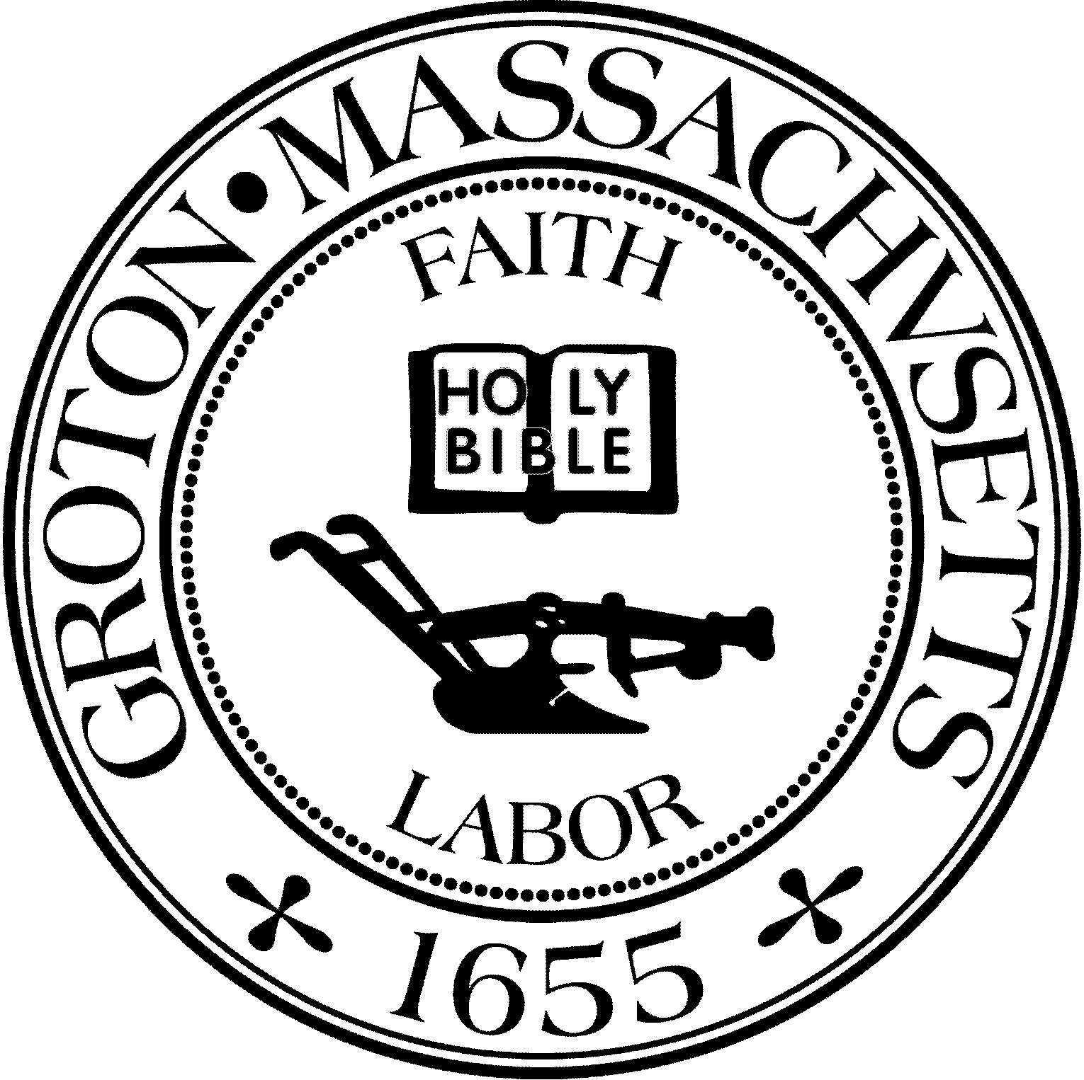

Regular Session Minutes

Date: Wednesday, August 30, 2023

Time: 7:12 pm

Location: Virtual meeting held via Zoom

Members in attendance: Anna Eliot, Rick Perini, Peter Cunningham

Referenced documents: draft minutes from March 22, 2023

Peter Cunningham called the meeting to order at 7:12 pm. Members identified themselves and cameras were turned on for this virtual meeting.

**Minutes**

*Anna Eliot moved to approve the March 22, 2023 draft minutes as presented. Rick Perini seconded and the motion carried (3:0) by roll call vote of Perini – aye, Cunningham – aye, and Eliot -- aye.*

**Heritage Landing Update: 40 homeownership units – 10 are affordable**

Fran Stanley recited a list of the many outstanding items for the project including:

1. Water supply – plan is for municipal water but the developer is weighing many options
2. Nitrogen loading restriction for parcels 249-51 and 57 – RFP issued; many complexities
3. Hill next to ballfields (parcel 248-39) – unclear if Natural Heritage will allow use; also, Article 97 issue
4. Impact on Heritage Landing if Town gains safe harbor – no impact for current application or modification of a granted comprehensive permit. If developer withdraws, then new application may be barred.
5. Light pollution and radio frequency interference (RFI) – MIT Haystack concerns; unclear extent of ZBA authority to place conditions
6. Traffic study – being worked out now, lots of abutter concern
7. Limited information provided for stormwater, septic, civil engineering – Town Counsel to advise on adequacy of current submission in these areas; can ZBA deny the permit on this basis
8. Shooting range nearby – attractive nuisance; perhaps better fencing
9. Extension requested by developer – 3-month extension discussed; will developer want more time

On the topic of water, Peter Cunningham said that water might possibly come from Westford in which case an intermunicipal agreement would be needed for Westford to serve the Heritage Landing development. If MIT Haystack consents to running a water line across its land, then they might also allow the nitrogen loading restriction all in exchange for enforceable light and RFI restrictions.

Anna Eliot explained that she is participating as both a Park Commissioner and a Housing Partnership member with respect to Heritage Landing. Ideally, the Housing Partnership would step in to work with the developer. The Park Commission is interested in parcel 248-39 independent of the Heritage Landing project as the Park Commission has a need to address parking safety at the Cow Pond Brook ballfields.

The Park Commission is working with engineer Matt Waterman. Natural Heritage was approached via a MEPA filing in January 2023. Natural Heritage asked the Park Commission to conduct a botanical study before deciding on the Town’s proposal. Anna Eliot met with the Conservation Commission and that committee is willing to explore the possibility of a land swap if it is advantageous for the Town to remove parcel 248-39 from Article 97 protection. Gaining Natural Heritage input what it might allow the Park Commission to do in the Cow Pond Brook area will be an important consideration for the Town as well as the Heritage Landing developer.

Peter Cunningham commented that gaining permission to restrict 14.5 acres for nitrogen loading did not seem like a high bar. Peter Cunningham added that he thought it was worth continuing in this direction; however, there are a number of factors to resolve before drawing final conclusions. Richard Perini referenced the Affordable Housing Trust’s evaluation of parcels 249-51 and 57. These parcels contain 3 vernal pools and there are onerous conditions for building adjacent to even a single vernal pool. Richard Perini suggested that this land will probably be no more than a non-usable piece of land at the end of the day. The issue with the hill (parcel 248-39) is that turtles go up the hill in the opinion of conservation experts so it is unlikely that the Town will be able to touch it. Anna Eliot explained that the Park Commission was using the $20,000 available to it in capital funds to explore land around the current ballfields further out than just this hill and gave the example of the Bridge Street parcel beyond the transfer station.

The group discussed desired conditions that the Housing Partnership might want to suggest to the ZBA as part of a conditional approval for Heritage Landing. Peter Cunningham said that it seems premature for the Housing Partnership to weigh in until there are more answers to these questions.

**Groton Farms Update: 200 rental units – 50 affordable**

The ZBA has directed its consultant to start drafting the decision. The ZBA is headed in the direction of an approval with conditions.

**Master Plan**

Peter Cunningham asked what the Housing Partnership priorities are for the upcoming Master Plan. Peter Cunningham gave a tour about town to Laura Lind. Lind is the lead Barrett Consulting planner working on the new Master Plan for the Planning Board. Peter Cunningham referenced a missed opportunity for senior affordable housing when there was not much interest from the Planning Board in Jeffrey Brem’s proposed plans for building senior affordable housing at his Main Street site. So, perhaps senior multi-family zoning to allow for more downsizing opportunities.

Anna Eliot expressed interest in offsetting development density with more preservation of open space. Anna Eliot noted that there is a lot of chapter land in town that may be at risk of future development. Peter Cunningham said that apart from Groton Farms and the MBTA Communities zoning there remains outstanding housing need.

Richard Perini said that he has heard a lot of interest in senior downsizing. Richard Perini suggested that the Partnership meet with the Master Plan consultant. Peter Cunningham will ask to schedule a meeting for the Master Plan consultant to meet with the Housing Partnership.

*At 8:07 pm, Anna Eliot moved to adjourn the meeting. Rick Perini seconded and the motion carried (3:0) by roll call vote of Perini – aye, Cunningham – aye, and Eliot -- aye.*

Notes by Fran Stanley