WATER SYSTEM EXPANSION PROJECT
Town of Groton, Massachusetts
Town of Pepperell, Massachusetts
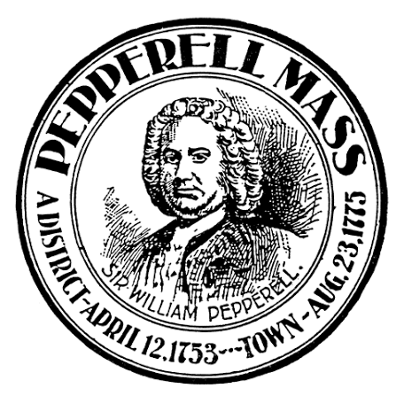

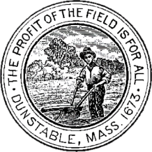
Town of Dunstable, Massachusetts
Selectboard Update
July 2026

Background
In 2021, the drinking water and irrigation wells at Groton-Dunstable Regional High School tested above the Massachusetts Maximum Contaminant Level for PFAS6. Subsequent investigations determined that the contamination originated from aqueous film forming foam used to extinguish a 2003 fire at the School’s athletic track.
The School District retained a Licensed Site Professional to investigate the extent of the contamination and test surrounding private wells. The PFAS-impacted area included portions of North Street, Kemp Street, Groton Street, and Chicopee Row.
In 2022, the Towns of Groton, Dunstable, and Pepperell jointly retained Apex Companies to develop a regional water system solution to service the PFAS-impacted area. The proposed solution would extend the Groton and Pepperell water systems to provide a permanent, safe drinking water supply to the PFAS-impacted area while improving the long-term reliability of both water systems.
In 2023, Town Meetings in all three communities approved funding for the project:
- Groton authorized $16.7 million.
- Dunstable authorized reimbursement to Groton, through debt-service payments, for up to $3.413 million.
- Pepperell authorized $23 million in water-system improvements, including a PFAS treatment facility at the Jersey Street well site and water main extensions toward Dunstable.
Construction was divided into two phases: the first phase servicing the PFAS-impacted area and the second phase connecting the water systems.

Phase 1
Groton received a loan of $12,195,914 through the MA Drinking Water State Revolving Fund to extend public water service along Chicopee Row, Groton Street, Kemp Street, and North Street, including service to Groton-Dunstable Regional High School.
The financing was provided at 0% interest. In December 2025, Groton was notified that 5% of the loan would be forgiven, providing an additional benefit of approximately $609,796.
Before Phase 1 was completed, additional testing in 2025 identified PFAS impacts along Ready Meadow Road, Raddin Road, Hawtree Way, and additional portions of Kemp Street and Groton Street. The Licensed Site Professional has since indicated that the extent of the contamination is now adequately defined.
Through careful project management, coordination among the Towns, and favorable construction efficiencies, the project team preserved approximately $2.1 million within the Phase 1 allocation. These savings allowed Raddin Road, Hawtree Way, and additional work on Kemp Street to be incorporated into the project without increasing the original $12.2 million Phase 1 budget. The remaining newly-impacted areas were incorporated into Phase 2.

Phase 2
Phase 2 will establish an emergency interconnection between the Groton and Pepperell water systems, improving the reliability and resiliency of both communities’ drinking water supplies.
The project includes improvements along Jersey Street in Pepperell, North Street and Ready Meadow Road in Groton, and Groton Street in Dunstable. It will also provide private water service connections to PFAS-impacted properties.
Significant outside funding has further strengthened the project:
- Pepperell secured a $5 million EPA Emerging Contaminants Grant for its portion of the Phase 2 work.
- Groton secured an additional $1 million EPA grant, helping make it possible to provide water service connections to 76 PFAS-impacted properties at no cost to the property owners.
Phase 2 also received favorable construction bids. As a result, available funding can be used to provide curb-to-curb pavement restoration along affected roadways, with final paving anticipated in early 2027.

Project Accomplishments
Through the sustained cooperation of Groton, Dunstable, and Pepperell, the regional water system project is positioned to deliver substantially more than originally anticipated.
In addition to completing the improvements authorized in 2023, the project is expected to provide, with no increase to the project authorization:
- Approximately 9,500 additional linear feet of water main,
- 76 private water-service connections for PFAS-impacted properties, and
- Curb-to-curb pavement restoration along approximately 7.1 miles of roadway.
Through the successful pursuit of a 0% State Revolving Fund loan, loan forgiveness, and state and federal grant funding, the project is expected to reduce the long-term debt service obligations of the three communities below those originally anticipated in the 2023 Town Meeting appropriations, lowering the overall cost to taxpayers.
These accomplishments reflect strong regional collaboration, successful pursuit of outside funding, favorable bidding conditions, and careful stewardship of the funds approved by the three communities.

Next Steps
With Phase 2 now underway, the project team is focused on keeping residents informed throughout construction and the water service connection process.
A dedicated project website has been established to provide residents with construction updates, project schedules, water service connection information, frequently asked questions, and other project resources. The website will be linked from each of the participating Towns' official websites in the coming weeks.
Project Website:
https://storymaps.arcgis.com/stories/080f95d93c0f45198721f1c09e75d418
To provide an opportunity for residents to learn more about the project and ask questions, the project team will host a Community Information Forum at Groton Town Hall on August 6, 2026, at 6:00 PM.
Throughout Phase 2, the project team will continue to provide project updates and direct notifications to impacted residents, including construction notices, scheduling information, and water service connection updates to ensure property owners remain informed as work progresses.

