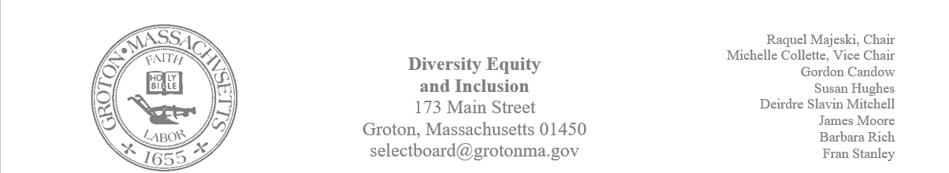
Regular Session Minutes
Date/ Time: May 4, 2023
Location: Town Hall
Handouts:
- Minutes from April 20, 2023
- Draft of a letter for the District Attorney
Members Attending: Deirdre Slavin – Mitchell, Michelle Colette, Raquel Majeski, Barbara Rich, Susan Hughes
Members not in attendance: James Moore, Gordon Candow, and Fran Stanley
Call to order at 5:01
Approving Minutes
Motion: Member Dierdre Slavin Mitchell made a motion to approve the minutes for April 20, 2023.
- Member Susan Hughes abstained due to not being present at the meeting
- Motion passed unanimously
Juneteenth Planning
Member Michelle Collette offered that we consider a Harry Belafonte Golden Book as a part of the Juneteenth celebration activities.
Raquel will provide the links to two children’s books that focus on Juneteenth.
Deirdre will contact the publishers about a bulk rate for the books.
Raquel will follow up with Lawrence Academy to finalize the date for the Juneteenth family activities.
Susan will look into the possibility of securing performer Vance Gilbert as a part of the Juneteenth celebrations and compile a calendar and a list of dates of all the Juneteenth activities.
Michelle made a motion to cosponsor the movie “Blood Brothers” with the GIC on Sunday, May 21st at the Senior Center
- Susan Hughes seconded the motion
- Deirdre is abstained
- The motion passed
Deirdre made a motion to allow Susan to compile a calendar of Juneteenth events and write a grant for the purchase of books to distribute.
- Michelle second that motion
- The motion passed unanimously
Review Forum
The committee discussed the forum that took place Monday night. There was a consensus that there was a good turnout with a diverse group of citizens. Members commented that the forum was designed to have folks share and ask questions in a nonjudgmental way. The hope is to continue providing opportunities for education and dialogue.
Member Fran Stanley submitted a draft of a thank you letter to send to the District Attorney.
Deirdre made a motion to approve the letter and give permission for Fran to send the letter to the District Attorney’s office.
- Michellle seconded the motion
- The motion passed unanimously
Installation on the Nashua River
Becky Pine is assembling a task force to coordinate initiatives, efforts and thinking in regard to native representation in town. The committee acknowledged that Member James Moore is passionate about this project and will be a good representative. Member Raquel Majeski stated that she could serve on the task force as a representative from Lawrence Academy. Susan stated that she could be involved as a representative of the Groton Conservation Trust.
Raquel will follow up with Becky Pine about the next steps.

The meeting adjourned at 6:00 pm.
The next meeting will take place in the Town Hall on June 1st at 5 pm.

