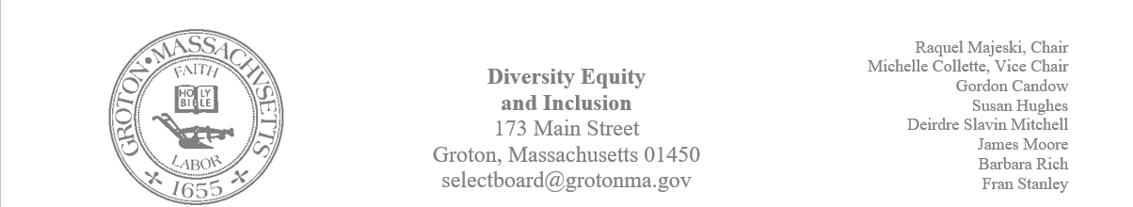
Regular Session Minutes
Date/ Time: April 20, 2023
Location: Town Hall
Handouts: Minutes from March 2, 2023, and March 23, 2023
Members Attending: Deirdre Slavin – Mitchell, Michelle Colette, Raquel Majeski, Barbara Rich, Fran Stanley
Members not in attendance: James Moore, Gordon Candow, Susan Hughes,
Call to order at 5:01
Approving Minutes
Motion: Member Fran Stanley made a motion to approve the minutes from March 2, 2023, and March 23, 2023.
Second: Member Michelle Colette seconded the motion
Motion passed unanimously

GIC Film and Sharon Chandler's film:
The GIC is considering showing "Blood Brothers" on Netflix and they would like our opinion about the film. Raquel will reach out to the GIC and discuss having this as a part of the Juneteenth celebration. Members of the committee agreed to view the film and discuss if we want to partner with the GIC in their efforts to show the film.
Sharon Chandler would like our support in showing A Reckoning in Boston. The hope is to show the documentary at Lawrence Academy on June 15th at 7:00pm. Raquel will send a link to the film and members of the committee are encouraged to watch it to determine if it is the best fit for our charge.
Kindergarten Tuition
The committee discussed ways in which we can support free kindergarten in town. It was determined that we will wait to see what the school board committee is planning on doing to inform our thinking on how best we can assist.
Forum: Hate Crimes/ Hate Incidents
We will send reminders closer to the event. Member Deirdre Slavin – Mitchell will contact the Groton Herald to advertise the forum.
The forum will take place on Tuesday, May 2nd 7pm at the Senior Center
Juneteenth Planning
James and Michelle will lead the Juneteenth Committee.
Raquel will coordinate with Lawrence Academy to host a family friendly discussion for Juneteenth
Raquel will reach out to the Groton Dunstable PTA to see if there is interest in supporting any town efforts.
Fran will get contact information for the Girl Scouts.
Installation on the Nashua River Rail Trail
Brainstorming Outline by Steps provided by Michelle
- Meet with Native American Representatives
  - Lorena Novak (Native American Cultural Council)
  - Andre Strongheart (Nipmuc)
  - To include Becky Pine (Select Board Member)
- Send to Select Board for Approval to Explore Possibilities
- Meet with Historical Commission
- Acquire a Designer
  - Discuss Installation Location
- Acquire an Engineer
  - Possibility of working with Nashoba Tech
- DCR Approval (depending on location)
- Create a Budget
- Money
  - Community Preservation Committee
  - Grants
  - Donation Fundraising
- People Power
  - Artists
    - Perhaps each panel could have a different artist
  - Native American Cultural Counsel
  - Writers
  - Volunteers
  - Friends of the Nashua River Rail Trail
  - Scouts
  - Grant Writers
  - Volunteers can be used for most steps

Our next meeting will take place on: May 4th @ 5 Town Hall
Meeting Adjourned at 5:42

