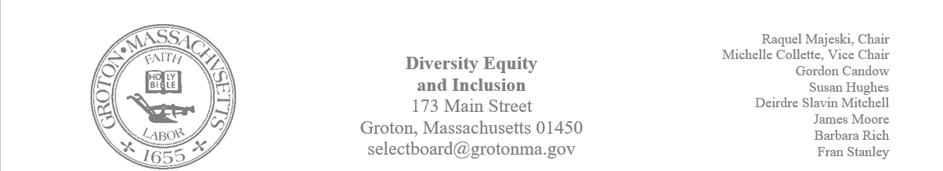
Regular Session Minutes
Date/ Time: March 23,2023
Location: Town Hall
Handouts:
- Minutes from March 2, 2023
- Select Board letter to Commissioner Rice
- Draft of letter of support for the DCR
- Notes on the May 2nd Hate Crimes/ Hate Incidents forum
January 19, 2023, and February 9, 2023
Members Attending: Deirdre Slavin – Mitchell, Michelle Colette, Raquel Majeski, James Moore, Gordon Candow, Barbara Rich, Susan Hughes
Member not in attendance: Fran Stanley
Call to order at 5:30
Nashua Riverwalk Accessibility
Paul Funch was in attendance for the meeting and was able to give information on the riverwalk.
The project has not formally been reviewed, however, The Commission on Accessibility voted to send a letter of support for the project as originally proposed.
- Deirdre made a motion to approve the draft of the letter
- Michelle Seconded
- Motion passed unanimously
Kindergarten Tuition
Dan Twomey was in attendance and provided background on affordable kindergarten.
The committee agreed that this is an issue of equity. The committee brainstormed ways in which they could support the effort of free kindergarten that could be done after the April meeting.
Those ideas are as follows:
- Letter to the editors of the Groton Herald about affordable kindergarten
- Letter to the representatives
- Phone campaign

The meeting was adjourned at 6:15pm.
Next meeting is scheduled Thursday, April 20th at 5:00 in Town Hall.

