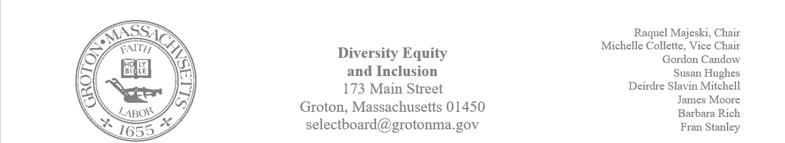
Regular Session Minutes
Date/ Time: March 2,2023
Location: Town Hall
Handouts: Minutes from January 19, 2023, and February 9, 2023
Members Attending: Deirdre Slavin – Mitchell, Michelle Colette, Fran Stanley, Raquel Majeski, James Moore, Gordon Candow, Barbara Rich
Members not in attendance: Susan Hughes
Call to order at 5:03
Approving Minutes
- Motion by member Michelle Collette was made that we ratify all votes taken at the meeting on February 9th.
  - Member Fran Stanley seconded the motion
  - Member Barabara Rich abstained
  - Motion passed
- Member Deirdre Slavin – Mitchell made a motion to approve the minutes from January 19th
  - Member James Moore seconded the motion
  - The motion passed unanimously
- Fran made a motion to approve the minutes from February 9th.
  - Michelle seconded the motion
  - Barbara abstained as she was not present for the meeting
  - Motion passed
Supporting GIC in the showing of the movie Till
Most members of the committee communicated that they watched the movie. All who watched the movie stated that the focus was more on the mother as an activist rather than the events surrounding the death of Emmitt. Discussion focused on the appropriateness of showing the film to a middle school audience. The committee felt that inviting members of the Groton Interfaith Council to an upcoming meeting to discuss the purpose and audience of the film would be a wise next step. In addition to this, the committee decided that having a facilitator to conduct a debrief of the film would be important.
Raquel will reach out to the Groton Interfaith Council and invite them to our next meeting to discuss the plans for showing Till.
Programming for DA Marian Ryan
The Select Board is supportive of our effort to host a community forum to educate on hate crimes. It was determined that the Senior Center may be the best place to host this forum. The committee agreed that including Deputy Chief Rachel Bilecki and Groton Dunstable’s DEI lead in the planning would be important.
Fran will reach out to the DA to schedule a date. Once we have a date, Michelle will secure the Senior Center and the committee will move forward with inviting Deputy Chief Rachel Bilecki.
Accessibility for Nashua Riverwalk Project
A discussion took place about the recent decision made by the Department of Conservation and Recreation (DCR) regarding Paul Funch’s proposal to create an accessible trail to be named in honor of Marion Stoddart. Michelle and Fran provided additional information on accessibility and wetlands protection.
- Deirdre made a motion for the DEI committee to write a letter to the DCR in favor of the restored original trails concept as designed.
  - James seconded the motion
  - Motion passed unanimously
Fran will draft a letter for the committee to discuss at our next meeting.
Community Initiatives
Deirdre and James attended the jubilee concert that took place at the Performing Arts Center
Deirdre attended that jazz brunch that was sponsored by the Chelmsford DEI Committee
Native American Installation
James began a discussion on continuing the work on the native American installation. The hope is to create a timeline that shows how long Groton has been peopled. Most accounts go back 12,000 years. In the past, members of the committee met with the Groton Historical Society and attended zoom lectures from a professor at the University of Lowell.
A working group made up of James and Michelle was formed to continue gathering information and resources about the possibility of an installation.

Our next meeting will take place on March 23rd at 5:00pm in the Town Hall.

