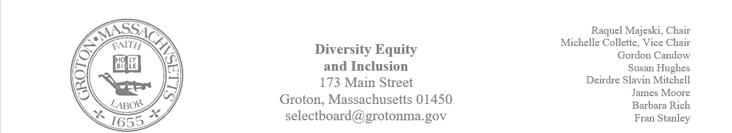
Regular Session Minutes
Date/ Time: February 9,2023
Location: Zoom
Handouts: Draft of the annual report
Members Attending: Deirdre Slavin – Mitchell, Michelle Colette, Fran Stanley, Raquel Majeski, James Moore
Members not in attendance: Susan Hughes, Gordon Candow
Call to order at 5:17
Juneteenth
Member Raquel Majeski began the meeting by introducing the protocol for discussing plans for Juneteenth. Representatives from the following groups were present to brainstorm initiatives for Juneteenth: the town of Chelmsford’s Diversity, Equity and Inclusion Committee, the town of Concord’s DEI Commission, and the town of Groton’s Racial Social Justice Group. The towns discussed the following ideas:
Chelmsford
Stated that an event is being planned that will take place on June 17th 11:00 – 3:00. There will be a dj, vendors highlighting black owned business, and food catered by a black owned restaurant. This is the third year that Chelmsford will host this event. Possible activities will include double dutch, step show, and activities that are highlighting black culture.
Concord
The Commission is less than two years old and there has not been an opportunity to organize a Juneteenth celebration. Community Organized Against Racism is a group that is in Concord that is supporting the dei initiatives in town. They have been active within the last couple of years, and they have a list of events happening throughout the month of June.
Racial Social Justice Group
The Racial Social Justice Group is comprised of 45 members from town who have partnered with other organizations in the town to sponsor an event last year. This year the hope is to use spaces and a local black owned business to think about ways to support Juneteenth.

Folks who attended Chelmsford's event last year stated that they enjoyed it. There were discussions around the needs of the events and the best way to advertise and continuing to connect the town's efforts in educating around this celebration.

The following members mentioned that they would like to support in the following ways:
- Raquel would work with storytelling and children’s education
- Michelle and Owen would work on finding contacts from neighboring towns Including Devens and connect the folks on the base
- Deirdre would like to support in the event planning
- Members of the Chelmsford’s committee will provide notes and playbook from previous year’s events
Partnership with Groton Interfaith Council
The Groton Interfaith Council would like the partnership of the DEI Committee to host a viewing of the movie Till. Members will watch the movie and we will discuss our partnership during our next meeting.
Attending Scouts Meeting
Susan Hughes and Gordon are available to attend the Scouts meeting. James can attend on March 6th.
Annual Report
Members reviewed the draft of the annual report.
- Member James made a motion to approve the annual report for the Select Board
- Second: Member Michelle Colette
The motion passed unanimously

Meeting ended at 6:10 pm

