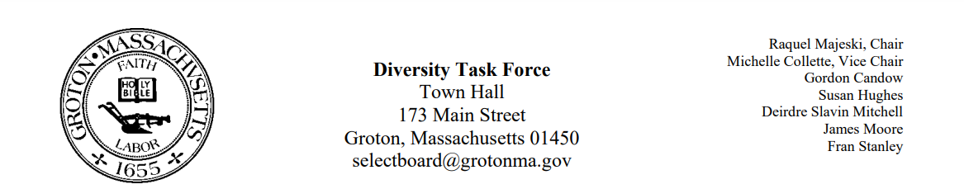
Regular Session Minutes
Date/ Time: January 19, 2023
Location: Town Meeting
Members Attending: Deirdre Slavin – Mitchell, Michelle Colette, Fran Stanley, Raquel Majeski, James Moore
Members not in attendance: Susan Hughes, Gordon Candow
Handouts: Minutes from January 5, 2023, and November 10, 2022
Call to order at 5:00
Approve Minutes
- Member James Moore made a motion to approve minutes from January 5, 2023
  - Member Deirdre Slavin - Mitchell second the motion
  - Motion passed unanimously
- Member James Moore made a motion to approve the minutes from November 10, 2022
  - Michelle second the motion
  - Motion passed unanimously
Process for reporting hate crimes and incidents
Discussion took place regarding how we can support the school system’s diversity committee. We agreed that we did not want to overstep our charge in decision making or suggestions for other groups.
Deirdre made a motion to suggest to the Selectboard to do the following: In moments of hate incidents and hate crimes, the Selectboard will make a statement to condemn the incident and recognize the victimized community excluding incidents that take place in the school.
- Member Fran Stanley seconded the motion
- Motion passed unanimously
Member Michelle Colette made a motion to recommend to the Selectboard to do the following: On a yearly basis, the selectboard will hear a report from the DEI committee on incidents of hate and hate crimes occurring within the town.
- James seconded the motion
- Motion passed unanimously

Juneteenth Plans
We will invite the diversity committees and groups from neighboring towns to attend our next meeting on Thursday, February 9th at 5 on zoom to plan Juneteenth initiatives.

All committee members are invited to attend the board meeting on February 13^{th at} 7pm.

