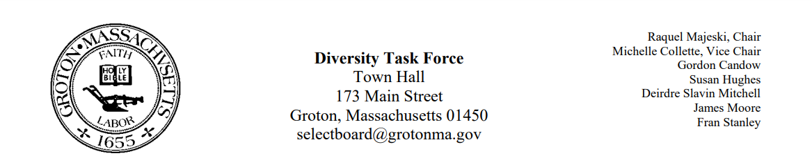
Regular Session Minutes
Date/ Time: November 10, 2022, at 4:00
Location: Town Meeting
Members Attending: Deirdre Slavin – Mitchell, Michelle Colette, Fran Stanley, Raquel Majeski
Members not in attendance: Susan Hughes, Gordon Candow
Handouts: Minutes from October 13, 2022, and September 22, 2022
Call to order at 4:04
Approve Minutes
- Deirdre made a motion to approve the minutes from September 22,2022. Michelle seconded the motion The motion passed unanimously
- James made a motion to approve the minutes from October 13, 2022. Michelle seconded the motion. Motion passed unanimously. James and Deirdre abstained because they did not attend the meeting.
Hate Crimes and Incidents
- Member James stated that he envisioned us creating a response to be sent from the select board when incidents take place.
- Discussion continued about the idea of how best to offer a statement and communicate out so the victims would feel supported. There were feelings that the selectboard should communicate when there is both a hate incident and if it elevates to a hate crime.
The committee concluded by thinking about the best next steps for moving a recommendation forward to the selectboard. The recommendation possibilities are as follows:
- In moments of hate incidents and hate crimes, the Selectboard will make a statement to condemn the incident and recognize the victimized community
- The DEI committee will educate the community about why this incident victims and call the victims in

Next Meeting December 8th
- Melinda Stewart featuring DEI Musical to come
- Owen Shuman Juneteenth Celebration
Meeting adjourned at 4:55pm

