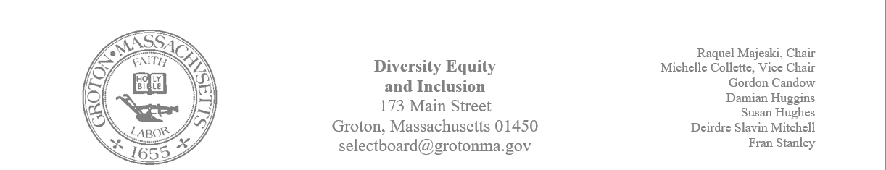
Regular Session Minutes
Date/ Time: January 30, 2024
Location: Town Hall
Handouts:
- Minutes from January 9, 2024
- RSJG MLK Celebration Debrief
- Women’s History Celebration (Draft)
Members Attending: Michelle Collette, Raquel Majeski, Deirdre Slavin – Mitchell, Fran Stanley, Damian Huggins and Susan Hughes
Members not in attendance: Gordon Candow
Guest: Natasha Huggins: Megan Donovan: Prescott Community Center
Call to Order: 4:03pm
Agenda
Approve minutes
- Fran moved to approve the minutes from January 9th
- Michelle seconded the motion
- The motion was unanimously approved
Review MLK Celebration
Raquel provided the debrief that the RSJG presented, and the committee agreed with their feedback. Discussion took place about accessibility to the timeline installation upstairs. Wayfinding was noted as a problem given that there weren’t arrows directing folks inside and throughout the event. Folks noted that water was not available throughout the event.

Begin planning for Women's History Month
After discussing the draft of plans, the committee decided not to move forward with a women’s history month event.
Member Susan Hughes will work with the library to obtain resources to inform women’s history month.
Raquel will submit a list of children’s literature that informs Women’s History Month
Begin planning for Juneteenth
The committee discussed having an opportunity to host a conversation about Juneteenth at the Prescott Center on Sunday, Juneteenth 16. Susan and Raquel will develop a framework on a coffee and conversations
The Historical Society will do a reading at 6:00 pm on Wednesday, June 19th
The committee discussed a community gathering that will take place behind the library. The following information was discussed:
- Damian will research kite flying and food/ food trucks
- Susan will write a blurb for the herald
- We will organize music/ a concert
- Fran will reserve the space
- The committee will investigate 1860s children’s games
Discussion of Hidden Conversations
Michelle suggested the following text for the committee to read: Unveiling America's Hidden Conversations

Meeting adjourned at 5:10pm

