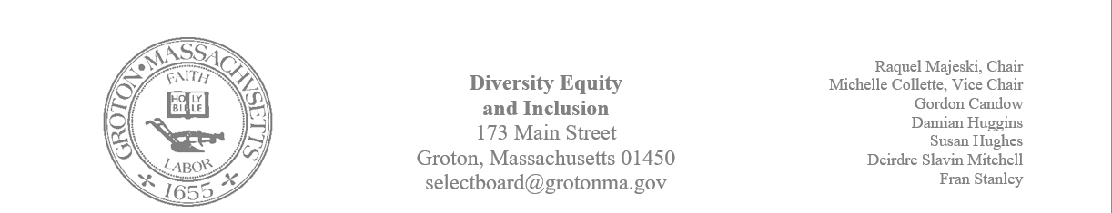
Regular Session Minutes
Date/ Time: January 4, 2024
Location: Town Hall
Handouts:
- Kelly Roberge’s resume for the jazz trio
- Member Deirdre Slavin – Mitchell's draft of bulletin board information
- Lunch and Learn flyers for the Groton Senior Center
- A draft of the committee’s annual report

Members Attending: Michelle Collette, Raquel Majeski, Deirdre Slavin – Mitchell, Fran Stanley, Susan Hughes, and Damian Huggins
Members not in attendance: Gordon Candow
Guest:
Natasha Huggins: RSJG, Owen Shuman: RSJG, Megan Donovan: Prescott Community Center, Nadia Madden: GIC, Judy Andersen
Call to Order: 4:03pm
Agenda
Anti – Hate Efforts in Town
Member Raquel Majeski informed the group that a subcommittee will meet to brainstorm the best next steps in planning a community education opportunity for the town that focuses on the Israel – Hamas War.
Lunch and Learn
Member Michelle Collette informed of the upcoming community education series that will take place at the Groton Center on February 28th at noon.
Annual Report
Member Fran Stanley drafted the annual report. The report was distributed and will be reviewed during our next meeting.
Native Installation and Land Acknowledgment
Raquel informed the group that a subgroup will meet to plan the next steps with a native installation and land acknowledgment.
MLK Celebration
The committee and guests discussed next steps in planning for the Dr. Martin Luther King town celebration. The following information was discussed:
- Member Deirdre Slavin – Mitchell described her vision for the timeline. The group agreed with her vision for the timeline and space.
- The group reviewed Kelly Roberge’s resume and agreed to move forward with his trio. It was decided that Owen Shuman would follow up with Groton Hill Music.
- It was decided that Michelle would move forward in contacting Lou Gaskins.
- Raquel will contact the Groton Herald to get the blurb of the event advertised in the paper.
- Michelle will contact Josh Degen about attending the upcoming meeting to discuss the menu for the event.

Meeting adjourned at 5:15

