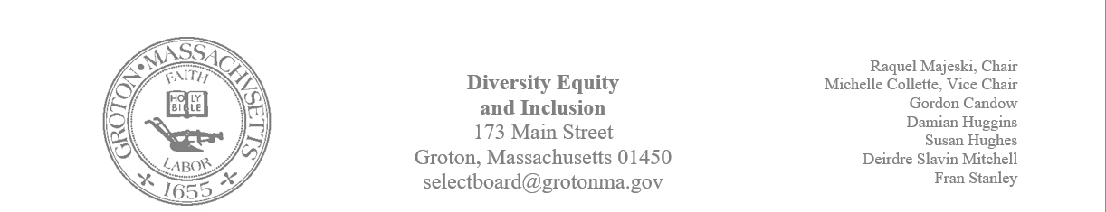
Regular Session Minutes
Date/ Time: December 19, 2023
Location: Town Hall
Handouts:
- Minutes from December 5, 2023, print out of Becky Pine’s email about changing the name of the school and adjusting the time of the Select Board meeting
Members Attending: Michelle Collette, Raquel Majeski, Deirdre Slavin – Mitchell, Fran Stanley
Members not in attendance: Susan Hughes and Gordon Candow
Guest: Owen Shuman: RSJG, Megan Donovan: Prescott Community Center; and Nadia Madden: GIC
Call to Order: 4:03pm
Agenda
Member Michelle Collette made a motion to accept the minutes from December 5, 2023.
Fran Stanley second the motion.
The motion passed unanimously.
Discuss naming the middle school
Members of the committee read the email from Becky Pine asking for our support in advocating for the school's renaming. Raquel Majeski reminded the committee that we voted that we would not intervene in decisions of the school board. Michelle reminded the committee that they may still advocate as citizens. A decision was made not to comment on the renaming of the school.

Consider letter for support for Affordable Housing Trust’s CPC application
A discussion took place about the work that the affordable housing trust does in the community. Members provided anecdotal and factual evidence to support the work.
Michelle made a motion to wholeheartedly write a letter of support and authorize Raquel to sign it on the committee's behalf.
Deirdre seconded the motion.
The motion passed unanimously.

Discuss adjusting the start tie to the select board meeting
The committee discussed if commenting on the time of the meetings was a diversity, equity, and inclusion issue. Members advocated for both sides of the argument and agreed that if the minutes were posted and open meeting laws were obeyed, the committee should not weigh in on the start time of the meetings.

Plan for MLK
- The committee and guests discussed plans for the MLK celebration. The plans and action steps are below:
- The group agreed to incorporate the themes of the civil rights movement and the focus of MLK into the timeline.
- The group discussed extending the timeline display throughout black history month.
- Owen Shuman will do the interview for Lou Gaskins. Groton Channel can help with the interview.
The next meeting will take place on January 4th Thursday @4
Meeting Adjourned 5:09

