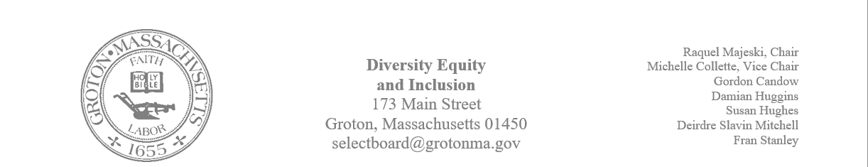
Regular Session Minutes
Date/ Time: December 5, 2023
Location: Town Hall
Handouts:
- Minutes from November 28, 2023
Members Attending: Michelle Collette, Raquel Majeski, Deirdre Slavin – Mitchell, Fran Stanley, and Gordon Candow
Members not in attendance: Susan Hughes
Guest: Owen Shuman: representing the RSJG, Megan Donovan and Stephen Lane: representing Prescott Center; Sharon Chandler: representing Marigold; Nadia Madden: representing the GIC, and Phil Francisco: representing Groton Hill Music
Call to Order: 4:03pm
Agenda
Member Deirdre Slavin – Mitchell made a motion to accept the minutes from the November 28, 2023
Member Michelle Collette seconded the motion.
The motion passed unanimously.
Native Installation
Member Raquel Majeski shared the message below from an email sent from Becky Pine:

Our next Anti-Hate Anti- Bias Task Force meeting is scheduled for Thursday, December 14 at 10am. Our next meeting will continue the celebration and recognition of our Native American community members.

We will learn about the history of the Hassanamisco Band of Nipmuc, one of New England’s most historic and largest native communities and impactful ways to honor Tribal Land and Native American culture throughout Middlesex County.

Kindly register for our next meeting using the link below and receive the meeting ZOOM link.
https://us02web.zoom.us/meeting/register/tZwof-yqrz4tEtM-PT9bGo6H1DAfLqcibbYx

Planning: Martin Luther King Jr. Celebration
A discussion about the event took place and the following action steps were decided:
Sunday, January 14th – Sunday, January 21st – A timeline installation will be displayed at the Prescott Center.
- Megan Donovan scheduled the necessary spaces for the event to take place.
- Sharon, Deirdre, and Nadia (GIC) will form a working group to develop the timeline. The timeline will highlight the unsung heroes of the era.
Sunday, January 21st from 12-3 at Prescott
- Community members will be able to view the installation timeline throughout the day.
- Community members will be able to donate socks to Catie’s Closet during the 12 –3 window of time. Michelle will work with the organization to provide details on the service.
- Food will be offered from 12-1 at a cost to participants in the kitchen/ dining area of Prescott. Michelle will contact black owned restaurants and vendors to inquire about offering their services for this event.
- Storytelling and crafts will take place from 12:30 – 1:30. Raquel will offer her business, Kelly’s Tales, free of charge for a portion of the time. Owen will contact additional storytellers.
- A video of Lou Gaskins and Dr. King’s speech at the Groton school will be shown on a loop. Michelle will reach out to Lou and work with the History Center for the best videos to show and/ or for any suggestions on recordings to use.
- Phil Francisco will reach out to Groton Hill to determine if they are able to provide music or information about music during this era throughout the event.
Owen Shuman will write a grant proposal for the event to the Commissioner of Trust Funds.

Meeting adjourned at 5:10.

