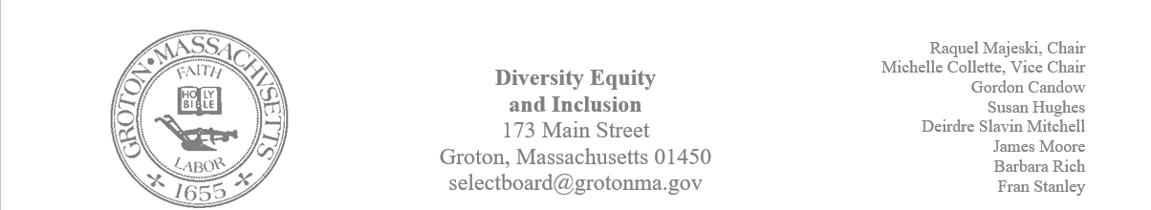

Regular Session Minutes
Date/ Time: September 14, 2023
Location: Town Hall
Handouts:
- Minutes from June 22, 2023
Members Attending: Michelle Collette, Raquel Majeski, Deirdre Slavin – Mitchell and Fran Stanley
Members not in attendance: Susan Hughes and Gordon Candow
Guest: Phil Fransico, Groton Hill Music
Call to Order: 5:01 pm
Approving Minutes
Motion: Member Michelle Collette made a motion to approve the minutes from June 22, 2023.
- Member Raquel Majeski second the motion
- Member Deirdre Slavin Mitchell abstained
- Motion passed unanimously
Committee Membership, Meetings, and Composition
The committee discussed ways in which we can accommodate members who have hearing loss. Michelle as ADA coordinator will reach out to a perspective member to discuss accommodations that are needed for them to feel as if they can be an active member.
Members have conflicts with our Thursday meetings. We will now meet on Tuesdays at 4.
We discussed creating a calendar to assist with planning for events and topics. Suggested focus for calendars is as follows:
- Fall: LGBTQ History, Hispanic Heritage, and Indigenous People
- Winter: Black History Month
- Spring: Women’s History
- Summer: Juneteenth
LGBTQ History Month
The committee discussed opportunities for community education and engagement for LGBTQ history month. Raquel shared that she will be doing storytelling at Prescott and reading the book Pride The story of Harvey Milk and the Rainbow Flag as a part of a diversity book series for children.
Motion: Member James Moore made a motion to support the Diversity Book Series for Children
- Deirdre seconded the motion
- Motion passed unanimously
Raquel stated that Lawrence Academy will offer community wide Gender Spectrum training on October 25th.
Michelle suggested that in addition to the zoom training, possibly training could take place at the senior center. Raquel and Michelle will connect about dates/ times for the training.
Deirdre will create a calendar of events for the Groton Herald.

The next meeting will take place in the Town Hall on Tuesday, October 17th at 4.

