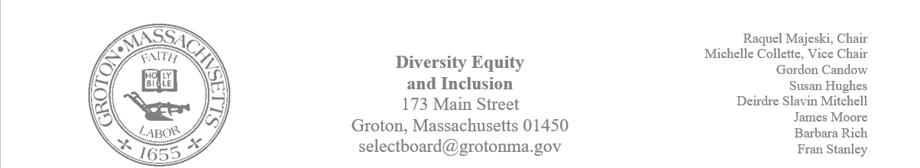
Regular Session Minutes
Date/ Time: June 22, 2023
Location: Town Hall
Handouts:
- Minutes from June 1, 2023
- An article explaining LGBTQ History Month in October
Members Attending: Michelle Collette, Raquel Majeski, Susan Hughes, James Moore, Barbara Rich, and Fran Stanley
Members not in attendance: Deirdre Slavin – Mitchell
Guest: Phil Fransico, Groton Hill Music
Call to Order: 5:00 pm
Approving Minutes
Motion: Member Michelle Colette made a motion to approve the minutes from June 1, 2023.
- Member James Moore second the motion
- Member Barbara Rich and Member Gordon Candow abstained
- Motion passed unanimously
Juneteenth
The committee reviewed the activities that took place in town to recognize Juneteenth. The consensus from the group was that the Kevin Harris concert and the A Reckoning in Boston film and discussion was well attended
As we look ahead to planning for next year, we will do the following:
- Be mindful of the dates for events as folks are beginning to use Juneteenth as a long weekend and may not be around to participate
- Connect initiatives to maximize attendance
- Continue to outreach to neighboring towns
- Continue to provide moments of reflection and education such as a discussion after a film
- Continue to use the Groton Herald as an opportunity to provide education about the holiday
Resources for the unhoused
As a follow up to the film, Fran offered resources for folks who are unhoused. Raquel sent an email to the committee so that they can have access to the resources.
Master Plan Planning
Phil Fransisco extended an invite for our committee to be involved in the Master Plan Planning Committee. Phil will attend our committee meetings to keep us updated on the next steps with the planning committee and the initiatives at Groton Hill Music.
October: LGBTQ History Month
The committee discussed the desire to do something in the month of October to recognize the focus of the month and provide opportunities for discussion and education.
The action steps are as follows:
- Raquel will check with the library to see if they are planning any activities for the month
- Raquel will work on a date to offer a community wide Gender Spectrum training
- Committee members will look into a film/ documentary that would serve as a tool for education and discussion. The ideal film/ documentary would offer an opportunity to bring the filmmaker and/ or a person from the film to the discussion.
- An invitation for partnership will be extended to other committees/ groups. Raquel will reach out an invite committees/ groups to the next meeting.

The next meeting will take place in the Town Hall on Thursday, August 17th at 5 pm.

