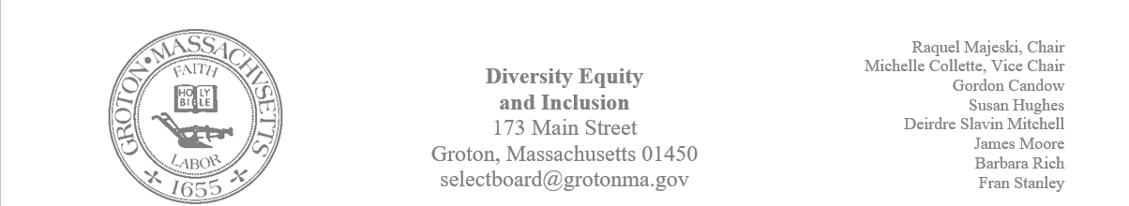
Regular Session Minutes
Date/ Time: June 1, 2023
Location: Town Hall
Handouts:
- Minutes from May 4, 2023
- Draft of a letter of support from Destination Groton
- Calendar of events for the recognition and celebration of Juneteenth 2023
Members Attending: Michelle Colette, Raquel Majeski, Susan Hughes, James Moore, and Fran Stanley
Members not in attendance: Deirdre Slavin – Mitchell, Barbara Rich and Gordon Candow
Guest: Greg Sheldon and Max Hosett
Call to order at 5:00
Approving Minutes
Motion: Member Fran Stanley made a motion to approve the minutes from May 4, 2023.
- Member Susan Hughes and James Moore abstained due to not being present at the meeting
- Member Michelle Colette second the motion
- Motion passed unanimously
Destination Groton
Guest Greg Sheldon provided an overview of the goals for the Destination Groton Committee and encouraged folks to check out the website: destinationgroton.com. The goal of the committee is to leverage the visitors that are coming because of Groton Hill Music and the other assets of town. The hope is to have our support in the committee moving forward to write a grant for funds to develop a Groton Gathering space. This space would be implemented along the rail trail.
A draft of a letter of support to Mark Haddad for the purpose of moving forward with a grant was provided for review of the committee.
- Motion: Michelle moved to send a signed draft of the letter as amended to Mark Haddad
- Member James Moore seconded a motion
- Motion passed unanimously

Juneteenth Events
A calendar of events was reviewed by the committee.
LGBTQ Pride Month & Recognition
Guest Max Hosett asked about the town’s recognition of Pride Month. We will add this topic to our agenda for discussion for our upcoming meeting.

The next meeting will take place in the Town Hall on June 22nd at 5.

