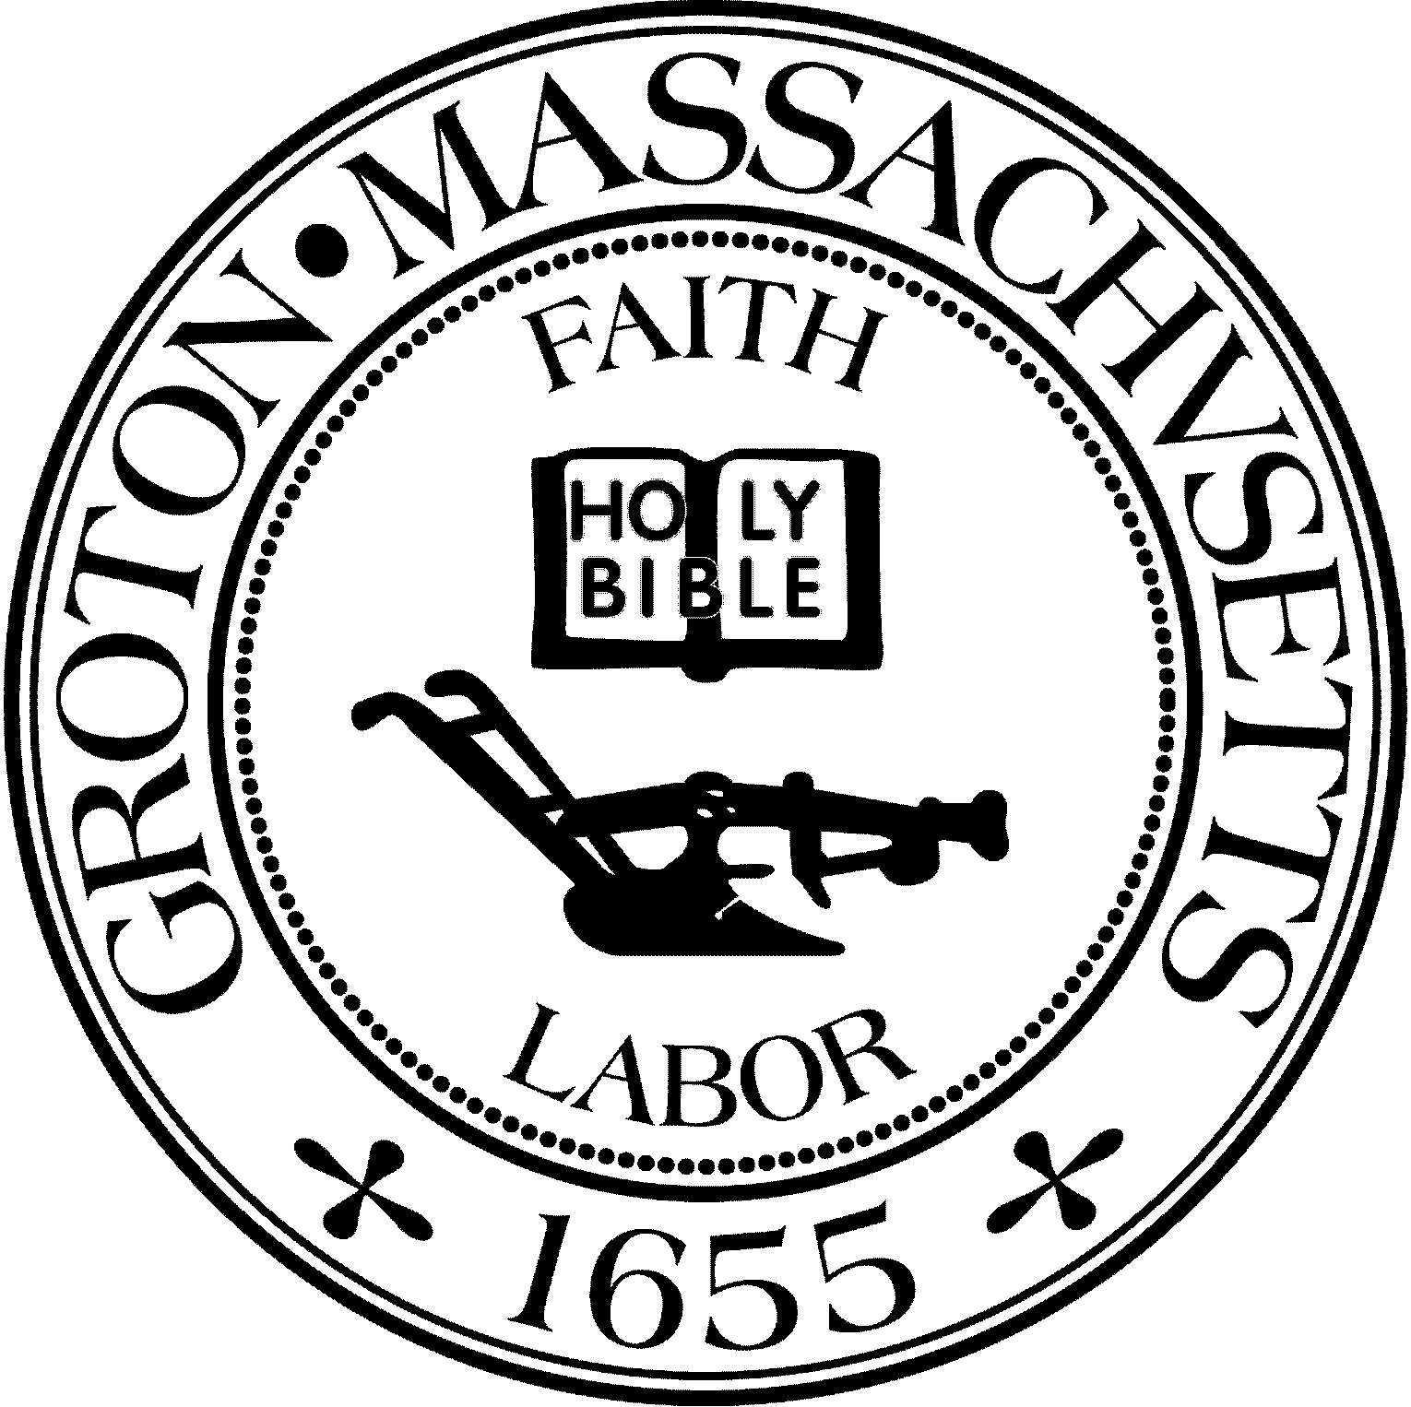
Town Manager
Mark W. Haddad

TOWN OF GROTON
173 Main Street
Groton, Massachusetts 01450-1237
Tel: (978) 448-1111
Fax: (978) 448-1115

Destination Groton Committee
Greg Sheldon, Chair
Jeff Gordon, Vice Chair
Julie Platt, Clerk
Brian Bolton, Member
Joni Parker-Roach, Member
Joni Parker Roach, Member

Destination Groton Committee Meeting
Wednesday, February 28, 2024

Minutes

Present: Greg Sheldon, Jeff Gordon, Brian Bolton, Joni Parker-Roach, Julie Platt

Guests: Tim Hess, Karen Tucker-Barisano, Phil Francisco

- Guest Tim Hess and Station Avenue Design Guidelines
Tim Hess visited to discuss the creation of the Station Avenue Design Guidelines which became the Town Center Overlay District. This work was completed from 2008-2014. Tim was on the Town of Groton Planning Board at the time, has since moved to Maynard and become civically involved there and helped Maynard become a Cultural District.
DISCUSSION: How can Groton become “proactive vs. reactive” when it comes to planning business areas in town?
-There was also a “retail leakage report” in 2011 Master Plan / Station Avenue study.
-What is the municipal stance toward businesses in Groton?
-Are there missed opportunities from the private schools in Groton?
-Traffic: Road structure through Groton creates a “bowtie” which is a bottleneck. Can a parallel road be created for more business frontage which would equal more space to expand retail?
-Groton could become a Cultural District which would create synergy to economic growth - more things happen together. There is a commitment to report every 5 years.
-Is there a “Town Model” (another town in Massachusetts) that might work for Groton to learn from as an example?
Tim has agreed to join DGC at the Business Forum soon 4/12. Would like to have his portion be a conversation, not just a speech. GSheldon will interview Tim.

2. Updates:
- DGC presentation Article 12: At the 2/26/24 Select Board meeting, the Select Board and Finance Comm. approved the article for 15K request to be placed on the Town Meeting Warrant.

B. Revolution 250 / America’s 250
KTucker-Barisano has contacted the Revolution 250 office and provided details on beginnings of plans in Lexington and Concord. JParker-Roach is working with her. Research will continue.

C. DGC/GBA April12, 2024 Business Forum
JGordon sent an email list of possible invitees.
ACTION ALL: Please review and make additions / comments.

D. Grant Writing Working Group
A “Letter of Interest” will be drafted for the One Stop Grants as a letter of introduction.

E. Communications and Marketing Working Group
-YouTube admin has been fixed and now all DGC videos are on the YouTube channel and will be linked to the DG website. Work continues on the “Open for Business” section of the DG website.
-Town wide Events Calendar - to be discussed with the GVC
-Draft of the Business Forum invitation will be sent prior to next meeting.

F. DLTA 2024 MRPC letter:
-GSheldon has drafted a letter to Glenn Eaton of MRPC to *******

G. North Central MA Tourism breakfast, Friday, March 8
-GSheldon, JGordon, BBolton will attend a Tourism breakfast hosted by North Central MA Chamber of Commerce. Cost is $45/person
Megan Donovan, Prescott Community Ctr will also attend
4. Upcoming DGC meetings

Wednesday 3/6 4:30 - 6:30 PM
Location: Prescott Community Center, Room 108
-JPlatt will ask Megan Donovan, Executive Director, Prescott Community Center to join and discuss ideas for Groton Visitor Center and Groton Town Event calendar, also overlaps between DGC and GVC.

Upcoming meeting Wednesday, March 13, 4:30-6:30pm location TBD

5. Meeting Adjourned, 3:40pm

Respectfully Submitted,

Julie S. Platt
Clerk
Destination Groton

