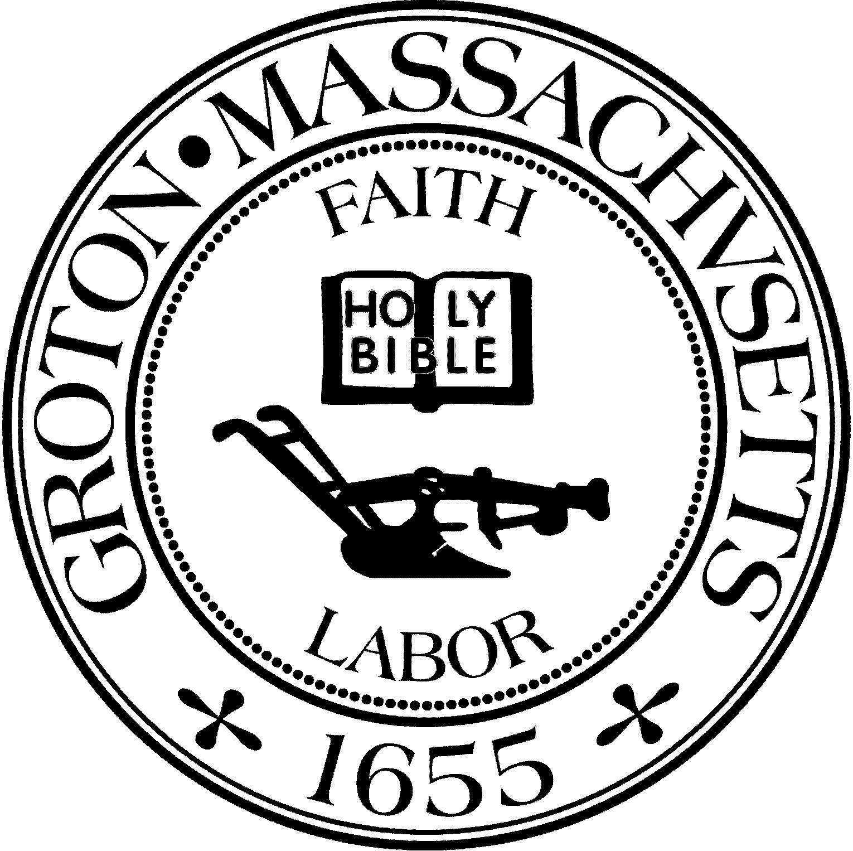
Town Manager
Mark W. Haddad

TOWN OF GROTON
173 Main Street
Groton, Massachusetts 01450-1237
Tel: (978) 448-1111
Fax: (978) 448-1115

Destination Groton Committee
Greg Sheldon, Chair
Jeff Gordon, Vice Chair
Julie Platt, Clerk
Brian Bolton, Member
Joni Parker-Roach, Member
Joni Parker Roach, Member

Destination Groton Committee Meeting
Wednesday, February 20, 2024

Minutes

Present: Greg Sheldon, Jeff Gordon, Brian Bolton, Joni Parker-Roach,
Julie Platt

Guests: Judy Anderson, Anna Eliot, Karen Tucker-Barisano

- Review and Approve Minutes:
Postponed - Committee needs to review minutes from February 7 and February 13.

2. Updates:

A. Select Board Board / Finance Comm. Public Hearing 7 pm 2/26/24 Destination Groton will be Town Meeting Warrant Article 9. GSheldon noted that DG current budget is $15K. Would like to request another $15K for FY2025. Current money in DG budget is $9,762.44. Are there future expenditures that need to be considered for the remainder of FY2024? DISCUSSION: What may be needed for the website updates and hosting? Will there be a matching grant to apply for? Should DG return $6000 to Town if money is not needed? Can the money be used for: photography, videos, website, Commemorations Committee, ,marketing an event with Food Trucks, Groton Visitor Center and/or Groton Event Calendar? DGC would like to be conscientious with the Town’s budget.

B. America’s 250th Commemoration / Celebrations
GSheldon suggests a combined meeting with the group. KTucker-Barisano has done research regarding the 250th. There is much information to be found for the towns of Lexington and Concord. No events have been detailed, however “shell websites” have been set up for information to be added and marketed to the public and visitors.
DISCUSSION: What kinds of events could Groton hold? Collaboration could be held with Historical Commission and / or Groton History Center? Can a long lasting monument or plaque be created to commemorate Groton’s role in the founding of the USA?

C. GBA and DGC Business Forum, Friday, April 12.
Does the event have a name? KTucker-Barisano suggested: Groton Business Forum: Creating Business Opportunities for Economic Growth.
All liked the “action” words.
Price to be determined- $30.00/per person or $40.00/per person.
Does the Forum need Sponsorships? Program is being reviewed, JGordon will open and close the event. Forum to be proactive in driving ideas for business opportunities in Groton. JAnderson stated DGC needs more manpower or members. GSheldon said the Forum needs an “ASK”.
DISCUSSION: Groton’s Master Plan, zoning and collaboration with the Planning Board. DGC attendance at the Planning Board meeting on 3/14/24 will be important.

D. Grant Writing Working Group
JParker-Roach, Molly Singer from MRPC, KTucker-Barisano,
Are reviewing One Stop Grant funding opportunities and are creating partnerships in the community

E. “Letter of Interest” to One Stop Community Partners:
GSheldon would like to insure a letter is submitted prior to 4/30/24

F. Communications and Marketing Working Group
BBolton has distributed a social media plan to DGC. Marketing group members need to be added to the YouTube channel as Admins.

3. MRPC and DLTA deliverables
ACTION: Committee to review the list of items needed and add if needed.

4. Vision Plan outline discussion:
GSheldon would like this report to be in place prior to April 12 Business Forum. KTucker-Barisano noted that the Vision Plan is continually on the bottom of the agenda and has suggested DGC commit one session to drafting an outline and specifics with help via A/V equipment if needed.

Meeting adjourned 3:30pm

Respectfully submitted,

Julie S. Platt
Clerk
Destination Groton

