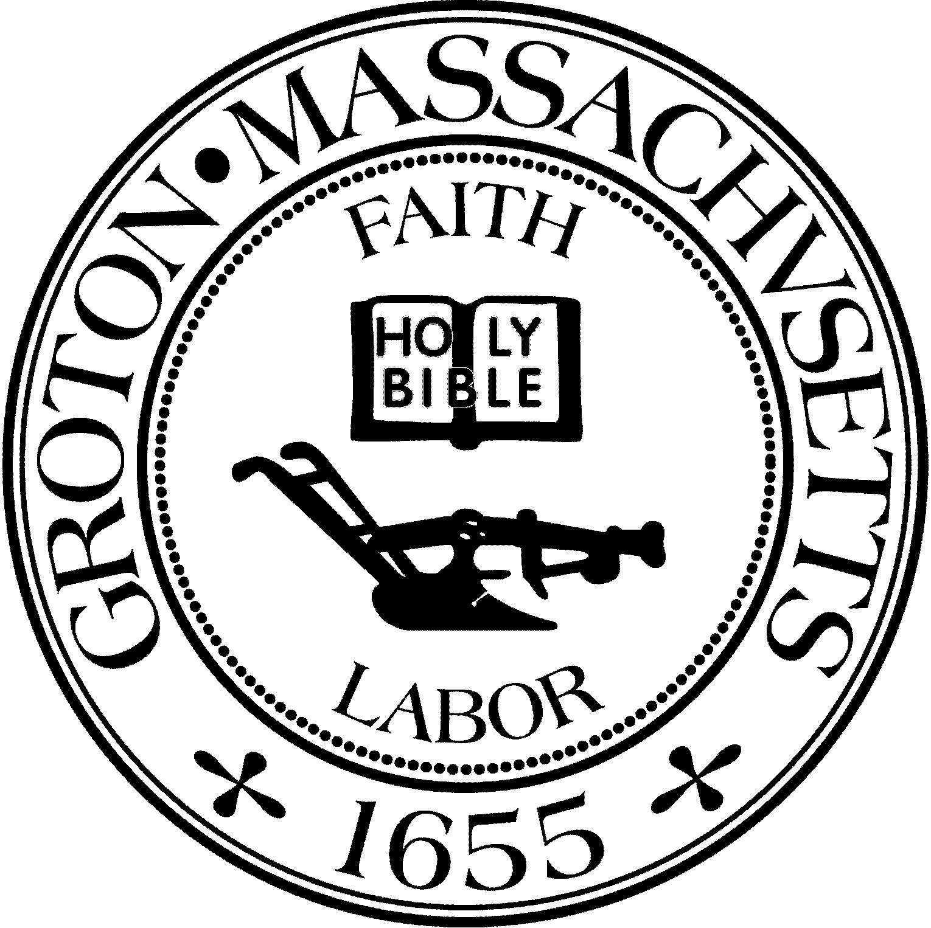
Town Manager
Mark W. Haddad

TOWN OF GROTON
173 Main Street
Groton, Massachusetts 01450-1237
Tel: (978) 448-1111
Fax: (978) 448-1115

Destination Groton Committee
Greg Sheldon, Chair
Jeff Gordon, Vice Chair
Julie Platt, Clerk
Brian Bolton, Member
Joni Parker-Roach, Member
Joni Parker Roach, Member

Destination Groton Committee Meeting
Tuesday, February 13, 2024

Minutes

Present: Greg Sheldon, Jeff Gordon, Brian Bolton, Joni Parker-Roach, Julie Platt

Guests: Judy Anderson, Phil Francisco, Karen Tucker-Barisano

1. Updates:

-America 250th Don Black
Don Black will convene the Celebrations and Commemorations committee on March 4. DGC will be invited to share thoughts at a future meeting.

-DGC/GBA 4/12/24 Town Conference
-Conference needs a name
-JGordon created an invite list for the conference and will share with the committee.
Russ Burke from Planning Board will join as a panelist for “Town” panel
GSheldon has left a message for Tim Hess, for Keynote speaker
JParker-Roach would like to determine details/jobs/actions needed for conference.

-Grant Writing Working Group
Need more people for this working group. Molly Singer putting together a list of possible grants to apply for this round of One Stop - FY2025
-JPlatt wondered about something tangible for Town of Groton such as a “skyline identifier” for the top of the Bates Land trail.

-Communications and Marketing Working Group
BBolton said group is ready to help with DG conference on 4/12- Hubspot can send invites - collect responses - streamline name tag creation

-DLTA 2024 MRPC application
GSheldon and JGordon were able to meet with MRPC team of Karen Chapman, Tracy Murphy, Ryan Doherty. Discussion revolved around scope of work DGC requested that DGC would like fulfilled.
Karen Chapman encouraged a renewed application.
Action: To focus on a set of deliverables no later than June 2024
JPlatt suggested we need to provide a list of names and numbers and question of people we want MPRC to contact.

3. MA Development Zoom for debrief of Commonwealth Places =
Guests: Annabelle Rondon / Corlis Melchoir
Also joining: Molly Singer, grant writer, MRPC
Discussion regarding the completion for FY2024 grants: only $500,000 available to grant with many, many applications.
-DGC application feedback was good, many liked however our grant request was only in planning stages. Shovel-ready projects have higher rank.
Anabelle Rondon would like to find a group/grant that might be able to help DG with what we are working on
Relationship building is important in grants to make the case and understand need
If we are in alignment or working with another State of MA agency, please let grant people know. Showing progressive steps to help One Stop team visualize need/proposal helps a grant application.
Everyone on the Zoom call thanked Anabelle and Corlis for their feedback and information.
ACTION: JPlatt to write a thank you email

Post Zoom discussion:
What the next One Stop grants to try to apply? All grant applicants should rite a review letter which is due during April.
Question: Is there a committee in Groton that needs a grant or that might collaborate on a grant?

4. Meeting adjourned 3:50pm

Next meeting February 20, 2024

Respectfully Submitted,
Julie S Platt
Clerk
Destination Groton

