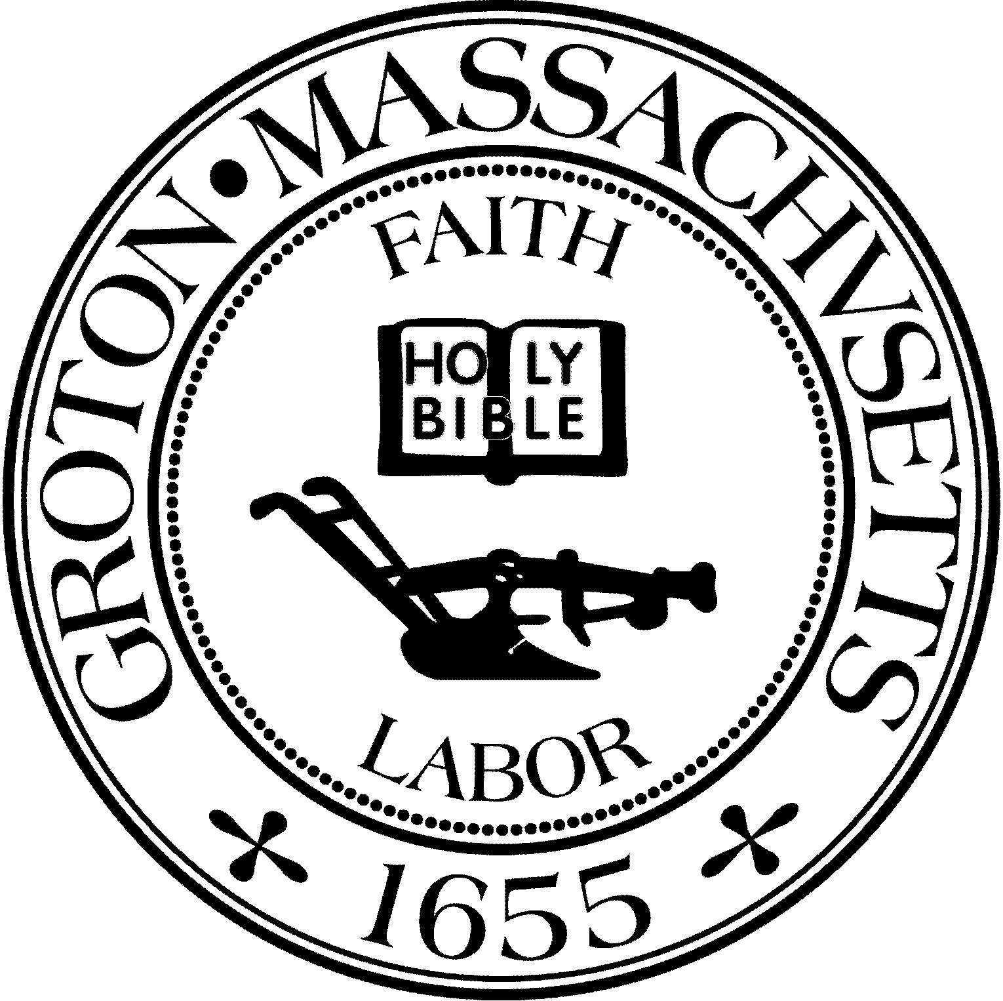
Town Manager
Mark W. Haddad

TOWN OF GROTON
173 Main Street
Groton, Massachusetts 01450-1237
Tel: (978) 448-1111
Fax: (978) 448-1115

Destination Groton Committee
Greg Sheldon, Chair
Jeff Gordon, Vice Chair
Julie Platt, Clerk
Brian Bolton, Member
Joni Parker-Roach, Member
Joni Parker Roach, Member

Destination Groton Committee Meeting
Wednesday, February 7, 2024

Minutes

Present: Greg Sheldon, Jeff Gordon, Julie Platt, Brian Bolton

Guests: Judy Anderson,Karen Tucker-Barisano

- Review and Approve Minutes
-Motion made by Bolton to approve the Minutes from January 31, 2024. Motion 2nd by JGordon. Minutes approved by unanimous vote.

2. Updates:
-One Stop Grant Commonwealth Places review: Week of 2/12 there is a possibility of meeting with One Stop MA grant team for feedback on DGC submission in June 2023, GSheldon to coordinate.

-Master Plan Feb. 6 meeting review:
*March 14 will be the 3rd Public Forum for the Master Plan
The planners have included the MRPC statistics that were presented by Tracy Murphy to DGC.

-America 250th Don Black: No updates.

-DGC/GBA 4/12/24 Town Conference Friday, April 12
JGordon is collating an email list for distribution.
Panelists were discussed: Town Panel: Takaski Tada, Mark Haddad, Tracy Murphy.
Business Panelists: John Amaral, Lisa Fiorentino, others to be asked.
Discussion about title of the conference and need for an action verb.
Discussion regarding possible Keynote Speaker Tim Hess. All agreed that GSheldon would invite Tim Hess to be the Keynote Speaker.
Disussion regarding Station Ave. development and how GELD remained on Station Ave which changed the plan for development.
ACTION / TO DO LIST:
Invitation / mailing Press release and photos
Nametags Program
GBA Posters Contact Speakers (in process)
Banner
GBA members to have complementary invitation

-Grant Writing Working Group
Joni contacting Molly Singer, grant writer

-Communications and Marketing Working Group
BBolton and group will be proposing changes to the website; namely an “Open for Business” tab on the Main menu. This will include “Why Groton”, "Success Stories” and “How to…” which will be directly linked to Town of Groton website. Information on the 5 economic zones in Groton: West Groton, Four Corners, Mill Run Plaza area, Country Club/CVS area, Groton Center
BBolton proposed that DGC spend no more than $400 with a website specialist to help optimize the Destination Groton website.
Motion made to approve proposal made by GSheldon, 2nd by JGordon.
Motion was approved with a unanimous vote of the committee.

-DLTA 2024 MRPC application or extension
GSheldon described next steps. The baseline report of retail leakage has been drafted. There are many items on the request list for MRPC information that have not been fulfilled: i.e. There no interviews with Groton Hill Music, Town officials, Chambers of Commerce.
Traffic reports have not been provided.
Need to re-apply to DLTA Grant for 2024 with more specific requests.

2. Historical Society Draft Letter of Support
GSheldon described ask from Historical Society for a letter of support for CPC grant money. DG Committee voted for unanimous support as the Historical Society showcases Groton’s history.

3. Vision Plan outline discussion
ACTION for ALL: Vision Plan Outline has been provided. Please make time to add to the outline with either notes/thoughts. Sit and write a paragraph or two.Think about what needs to be communicated / advised to include in report.

Meeting Adjourned: 3:20pm

Next meeting will be with One Stop Grant committee representatives via Zoom call week of 2/12/24

Respectfully Submitted,

Julie S Platt
Clerk
Destination Groton Committee

