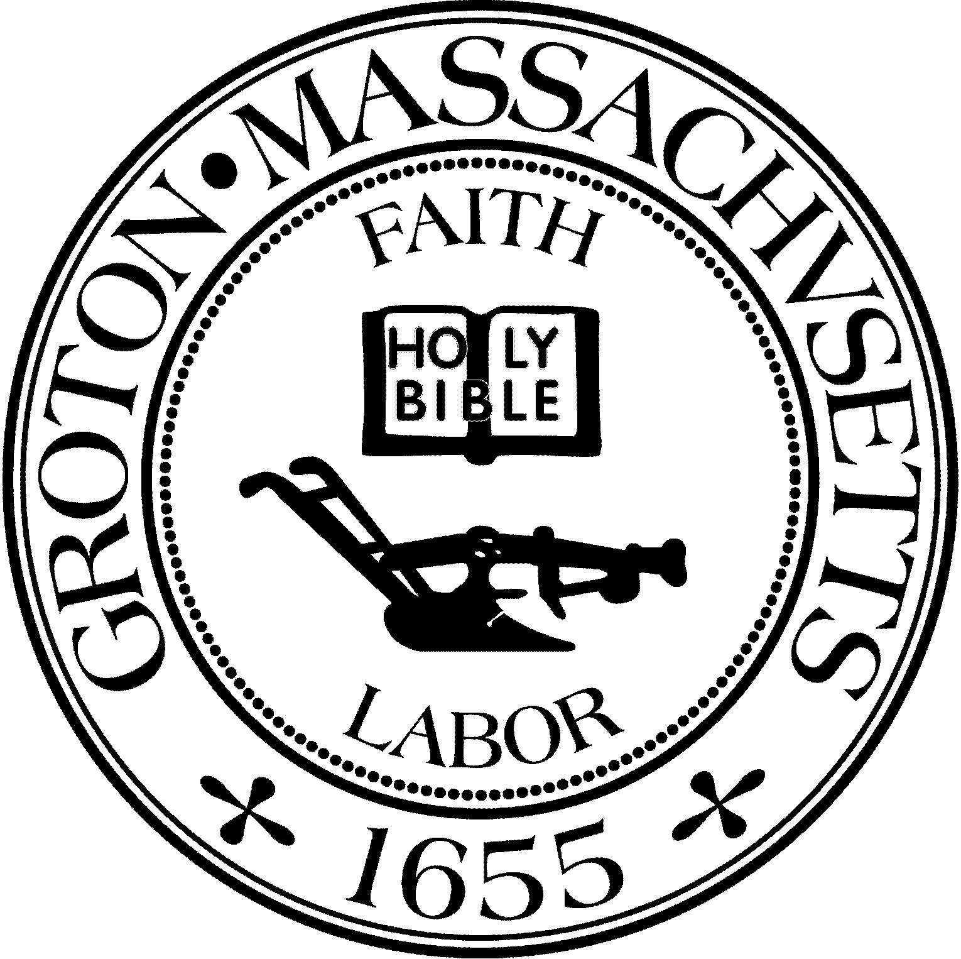
Town Manager
Mark W. Haddad

TOWN OF GROTON
173 Main Street
Groton, Massachusetts 01450-1237
Tel: (978) 448-1111
Fax: (978) 448-1115

Destination Groton Committee
Greg Sheldon, Chair
Jeff Gordon, Vice Chair
Julie Platt, Clerk
Brian Bolton, Member
Joni Parker-Roach, Member
Joni Parker Roach, Member

Destination Groton Committee Meeting
Wednesday, January 31, 2024

Minutes

Present: Greg Sheldon, Jeff Gordon, Brian Bolton, Julie Platt
Guests: Judy Anderson, Scott Blumsack, Phil Francisco, Tracy Murphy

- Review and Approve Minutes: Motion made by BBolton and 2nd by JGordon to approve minutes from January 24, 2024. Minutes approved unanimously.

2. Updates:
-MA Development Commonwealth Places debrief
GSheldon has reached out to Anne Gobi to ask for follow up.

-Revolution 250 and USA 250 Don Black:
GSheldon has spoken to Don Black and Don Black plans to convene the
Commemorations and Celebrations Committee

-DGC/GBA Town Conference: Destination Groton Local Business Summit
Date of Conference is Friday, April 12, 2024. JGordon has announced the Summit to GBA members via a Constant Contact email. Overall idea is to boost momentum and businesses to Groton and open communication. JPlatt inquired about invitations to local businesses to participate in conference.
Town Panel needs to be contacted. Asked Tracy Murphy if she would participate. She agreed. A broader view could be taken by inviting developers to the conference such as those who own the land/pads at 4 Corners. Short discussion about who the Keynote speaker may be.
ACTION: GSheldon to contact Roy Nascimento and Melissa Fetterhoff to ask if they will join panel. JGordon to contact John Amaral, Lisa Fiorentino, Jayson Gilberti
Instagram Influencer
JGordon has reached out to Alaina Pinto, a local Instagram influencer. Alaina will talk more to JGordon about what she can do that is Groton specific.

-Groton Event Calendar:
JGordon and GSheldon have spoken to Ashley from Groton Cable TV who is looking for a new “face of Groton” for Groton Events. They asked if any DGC members were interested. JPlatt will talk to Groton Visitor Ctr group.

-Social Media strategy:
BBolton distributed a document stating the Content, Engagement and posting frequency for DG Instagram and FB pages. Idea that might be helpful is posting more about the Economic areas of Groton: Four Corners, West Groton CVS area, Groton Center and Mill Run.

3. MRPC Economic and Traffic Data presentation
-Tracy Murphy, Senior Planner from MRPC presented a Retail Leakage Study. Murphy started with a page of disclaimers and source information to help reader understand parameters of information.
Discussion: How does Groton capture the growth and some retail demand that this data shows? DGC to highlight the gap of businesses needed in Groton. Murphy mentioned to look into MassWorks for local infrastructure projects. Does Groton need a zoning audit? Do additional overlay zones need to be created?
The framework and message of this report needs to be shared with the Planning Board and Master Plan consultant.
PFrancisco stated that more communication with Planning Board is welcome.
JAnderson suggested a memo can be written to Planning Board with key points of what DGC has been researching and learning from MRPC studies.

Meeting Adjourned at 3:40pm

Next Meeting February 7, 1:30pm

