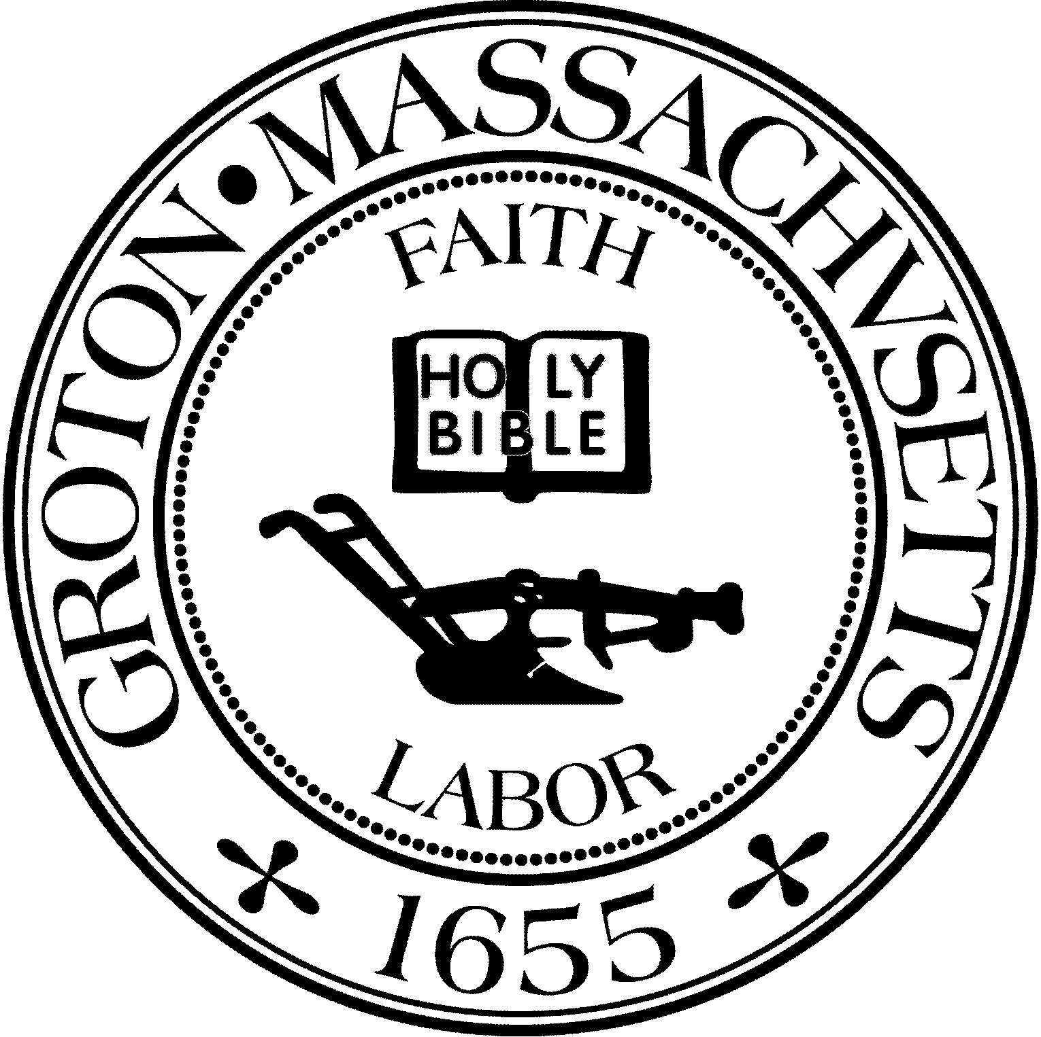
Town Manager
Mark W. Haddad

TOWN OF GROTON
173 Main Street
Groton, Massachusetts 01450-1237
Tel: (978) 448-1111
Fax: (978) 448-1115

Destination Groton Committee
Greg Sheldon, Chair
Jeff Gordon, Vice Chair
Julie Platt, Clerk
Brian Bolton, Member
Joni Parker-Roach, Member
Joni Parker Roach, Member

Destination Groton Committee Meeting
Wednesday, January 24, 2024

Minutes

Present: Greg Sheldon, Jeff Gordon, Julie Platt, Joni Parker- Roach,
Brian Bolton

Guests: Judy Anderson, Karen Tucker-Barisano

- Meeting Minutes: Motion to approve minutes from 1/20/24 by JParker-Roach, 2nd by BBolton. Minutes from 1/10/24 approved unanimously.

2. Updates:
MRPC Data Analysis Report
-Tracy Murphy to join DG Committee during regular meeting on 1/31/24
-GSheldon has asked for the report to be emailed to him to share with DGC so Committee members are not seeing information for the first time.
-GSheldon to invite Takaski Tada to 1/31/24 meeting
ACTION: All Committee members to read and formulate questions once MRPC report is emailed, bring thoughts and questions to 1/31/24 meeting.

Regional Six Town Group with Representative Scarsdale
-Group with representatives from 1st Middlesex District met on 1/19/2024.
-Idea is to highlight the region within North Central MA
-Discussion of collaboration on a regional website - one site- each town linked
-Could Roy N. Include all on North Central or should it be it’s own website/landing page
-Coalition around Tourism/Business/ Regional issues
-Rural small towns of Massachusetts
-JGordon asked BBolton for his opinion of $1200/town estimate is a reasonable cost for website or if it most likely be a higher cost.
-BBolton suggests that creating a budget is difficult to predict as each town may have different content
-JAnderson stated all towns in this region are having budget issues

Grotonfest Spring into Summer at Prescott Community Ctr.
-Scheduled for Sunday, May 19
-Should DGC have a booth for $50.00
-All decided that visibility is a good idea

One Stop Grant Debrief
-GSheldon trying to set up 1 hour Zoom call to debrief/ hear feedback about the Commonwealth Places grant submitted in 2023.
-Need to update chart of grant opportunities
ACTION: JParker-Roach to call Molly Singer and ask if Grant Opportunities for Groton chart from last year can be updated.

Destination Groton Business Forum:
-Date needs to be adjusted from March 27 - all decided to try for week of April 8.
-Discussion regarding keynote speaker and message DGC is trying to send
-Discussion about Town Overlay District in practice vs. design process
-Goal is to try to create new economic revenue streams for Groton
-Invite list of GBA members from JGordon and also curated list of invitees`
ACTION: JGordon to contact Michelle Collette to invite her to a DGC meeting to inform the Committee about the Town Center overlay history/process/context.

Marketing Working Group
-BBolton reported that the newsletter distribution was a success
-38% open rate which is very good
-Unique clicks on stories / articles can be tracked which is helpful
-GSheldon asked if we can post on social media as well as DG website and DG page on Town of Groton website?
-GSheldon inquired if recording from Groton Regional Tourism Conference can be posted on websites also

3. 10 Year Strategic Vision Plan
-Once MRPC data analysis has been shared, writing can begin
-We have Survey results: “This is what we hear”
-We have Data results: “This is what facts we have gathered”
-ACTION: All DGC members to read the North Central regional plan emailed
-Due date for report to be March 26, 2024
-Will present findings to Destination Groton Business Forum
-Present to Town at Fall 2024 Town Meeting

Meeting adjourned 2:30pm

Next meeting January 31, 2024

Respectfully Submitted,

Julie S. Platt
Clerk

