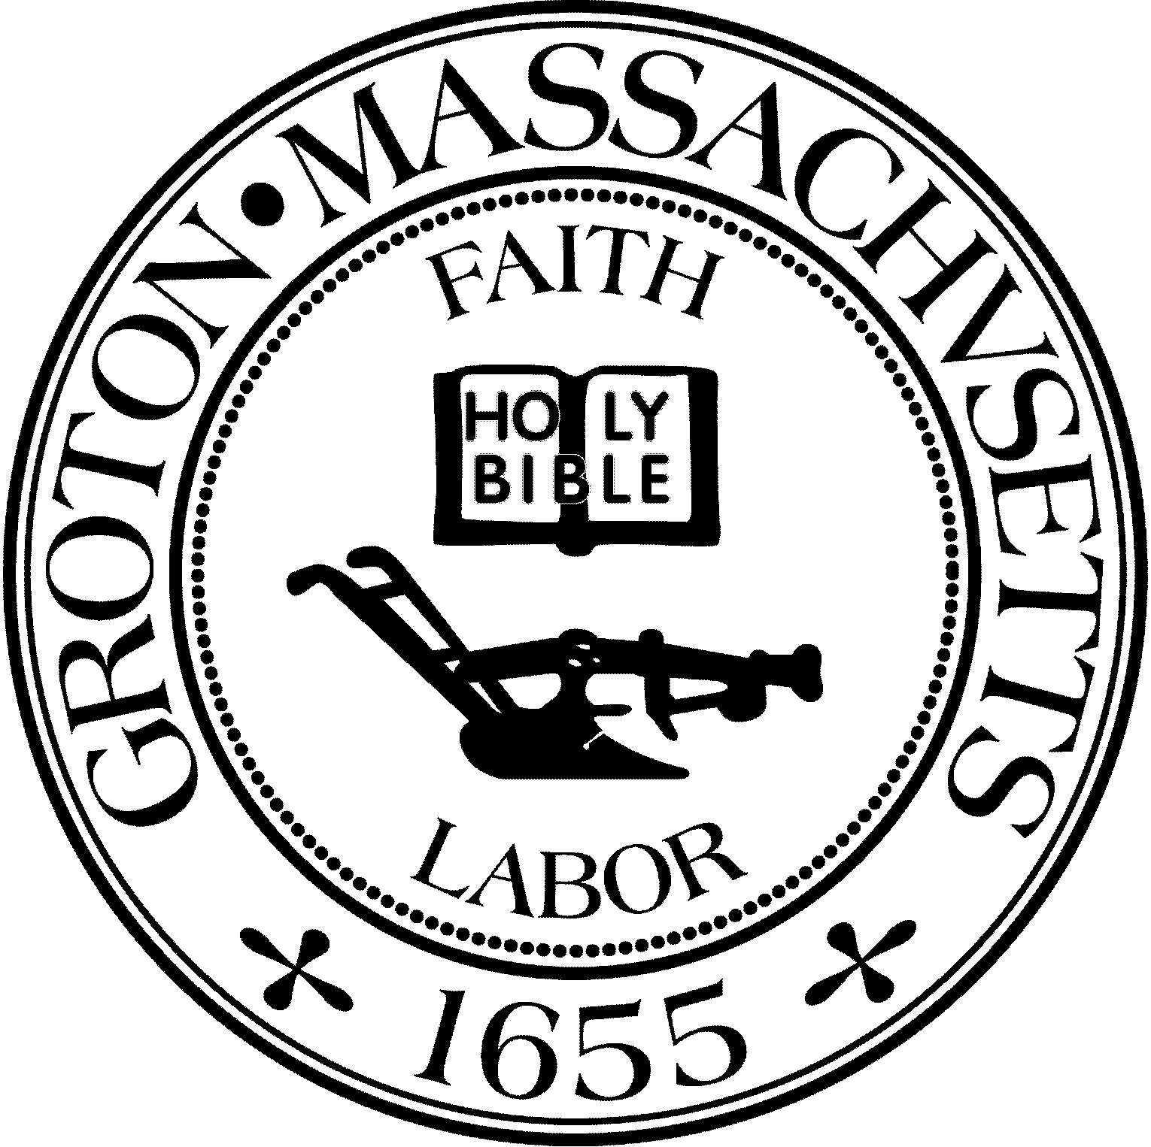
Town Manager
Mark W. Haddad

TOWN OF GROTON
173 Main Street
Groton, Massachusetts 01450-1237
Tel: (978) 448-1111
Fax: (978) 448-1115

Destination Groton Committee
Greg Sheldon, Chair
Jeff Gordon, Vice Chair
Julie Platt, Clerk
Brian Bolton, Member
Joni Parker-Roach, Member
Joni Parker Roach, Member

Destination Groton Committee Meeting
Wednesday, January 10, 2024
1:30 pm

Minutes

Present: Greg Sheldon, Jeff Gordon, Joni Parker-Roach, Julie Platt, Brian Bolton
Guest: Judy Anderson, Karen Tucker-Barisano

- Meeting Minutes: Motion to approve minutes from 1/3/24 by JParker-Roach, 2nd by BBolton. Minutes from 1/3/24 approved unanimously.

2) Updates:
MA Development Commonwealth Places / One Stop Grant Application
- A debrief meeting regarding the FY 24 application is available and the Committee agreed to try for a Zoom call on if the committee would like feedback on why application was denied.
ACTION: GSheldon to ask One Stop for a debrief on Zoom Call Thursday, 1/25/2024 between 1pm-4pm

Destination Groton Business Forum, March 27, 2024
-Discussion regarding the overall plan for the Business Forum to be held at The Groton Inn.
-GBA and Destination Groton are the Hosts
-All GBA Members to be invited as part of their GBA Membership
-Looking for local Sponsors to help defray the costs
-Breakfast meeting - Charge for invited guests TBD current thought is $30/per person
-Theme: Focus on local businesses
-Program: Destination Groton overview, Town Officials Q&A, Local Business discussion / inspiration
-Keynote speaker possibilities: Glenn Eaton- MRPC, Alan Manoian- Ayer, or Tim Hess
-All invites to be sent through Hubspot which has DGC database

Letters of Support for CPC Funds
-Three letters of support from DGC have been sent: Housing Authority, Sustainability Commission, Trails Committee.
-Historical Commission letter on hold at their request

Spring Town meeting?
-No need for Destination Groton to make a presentation

Don Black and revolution250.com
-Don Black to organize a meeting with Destination Groton to discuss the possibilities

Grant Writing Working Group
-JParker-Roach asked Joshua Vollmar help with topic history and background if needed. Joshua agreed to help.
ACTION: All DG Committee please visit the One Stop for Growth website
https://www.mass.gov/guides/community-one-stop-for-growth
To review the new FY 2025 Grant opportunities

Marketing and Communications
-BBolton stated a newsletter draft is in process.
Next up will be a social media discussion for the Mar/Com group.
A link to the YouTube videos will be
ACTION: JPlatt to draft January 2024 DG Newsletter in Hubspot, BBolton to send a draft to DG Committee in order to email week of Jan. 15

3) MRPC Economic and Traffic data presentation and discussion
-Tracy Murphy will return to DGC meeting on 1/24 with final report.
-Preparation needs to be done by all committee members:
-Read the North Central Economic Development plan
-Review Governor Healy’s plan

-DGC interested in what the data shows to include in a 10 Year projection report to show demand and business needs.
-JGordon would love a spreadsheet or projection of growth chart that is easy to read and digest for all.

Meeting adjourned at 3:20pm

Next Meeting 1/24/2024, 1:30pm

Respectfully submitted,
Julie S. Platt
Destination Groton
Clerk

