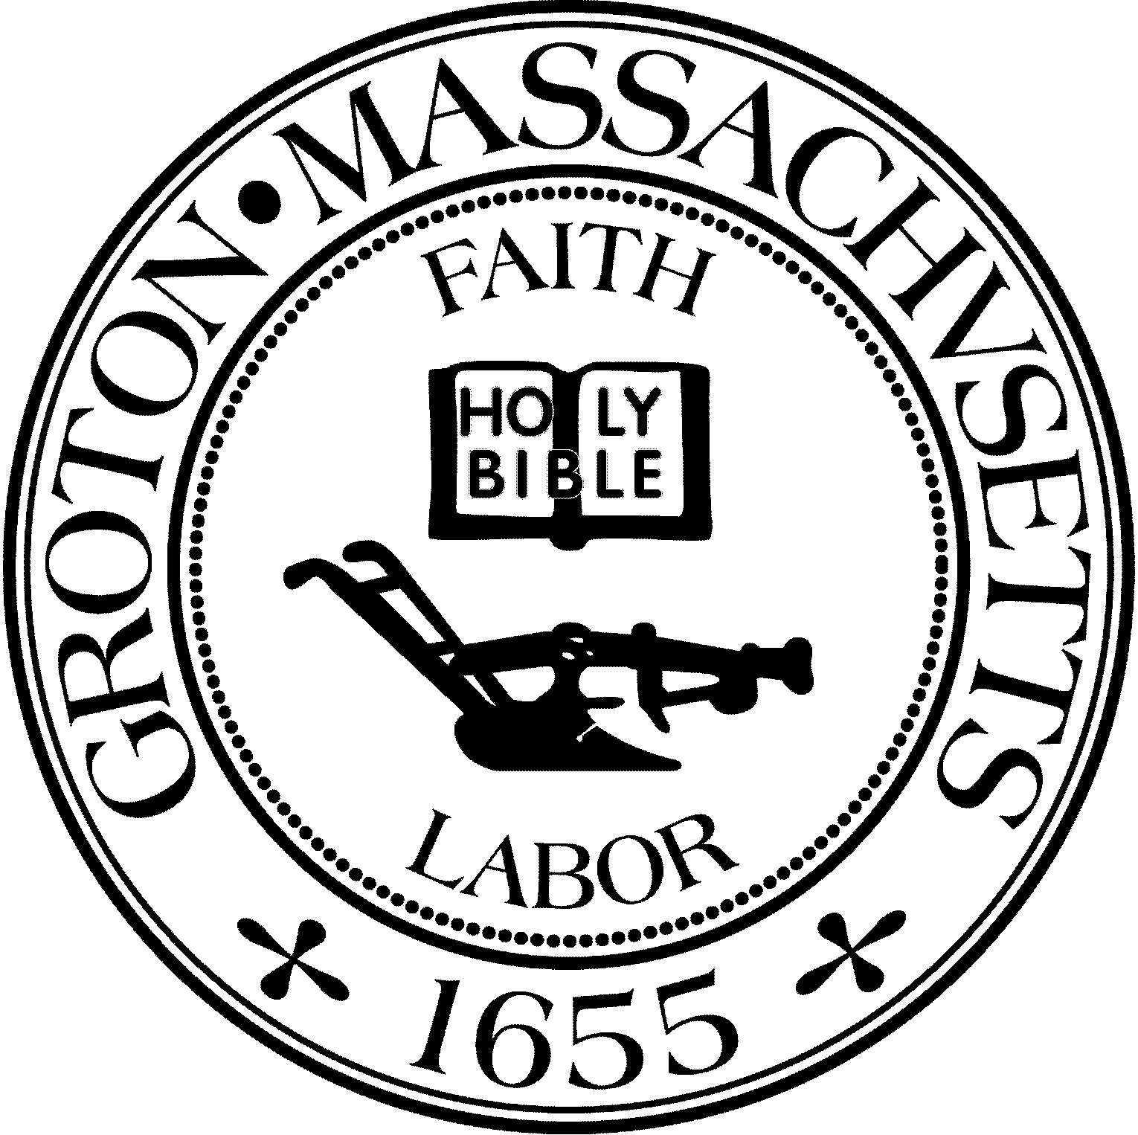
Town Manager
Mark W. Haddad

TOWN OF GROTON
173 Main Street
Groton, Massachusetts 01450-1237
Tel: (978) 448-1111
Fax: (978) 448-1115

Destination Groton Committee
Greg Sheldon, Chair
Jeff Gordon, Vice Chair
Julie Platt, Clerk
Brian Bolton, Member
Joni Parker-Roach, Member
Joni Parker Roach, Member

Destination Groton Committee Meeting
Wednesday, January 3, 2024

Minutes

Present: Greg Sheldon, Jeff Gordon, Joni Parker-Roach, Julie Platt, Brian Bolton
Guests: Judy Anderson, Ken Ferris, Anna Eliot

- Review and Approve Minutes from December 20, 2023
Motion to approve minutes by JGordon, 2nd by JParker-Roach. Unanimous approval.

2. Updates:
A) Six Town Collaboration meeting, Friday, 1/19/24, 11:00am, Townsend:
Rep. Scarsdale’s 6 town collaborative group will be meeting with Roy Nascimento and Melissa Fetterhoff. The overall idea is to support marketing the region. Current thought is to assess a fee for creating a website.
Q: If money is assessed to Groton, what budget would it come from? Destination Groton or other/
Q: What is the value added to Destination Groton and how would a new website affect DG or dilute DG?
Q: Would money spent on another website be the best use of DG (or other) funds?
A: All good questions to be asked at the meeting on 1/19/2024

B) MA Development Commonwealth Places:
GSheldon has reached out to Mass Development for a debrief regarding DG One Stop application to learn more about how to develop idea and what may have been needed for the application.

C) CPC Letters of Support
Four Town Committees have requested letters of support from Destination Groton. JPlatt suggested we discuss the relevance to DG with each request.

*Sustainability Committee: Requests money to begin a pollinator corridor in Groton. Link to DG is to promote sustainable Groton and retain Groton resources. Motion made to Approve Letter of Support by JParker-Roach, JPlatt 2nd. Motion passes with Unanimous support.

*Affordable Housing Trust: Requests funds for building up cash reserves in order to purchase property for housing. Link to DG is to keep Groton a vibrant community and hub of the region. Motion made to Approve Letter of Support: by JPlatt, JParker-Roach 2nd. Motion passes with Unanimous support.

*Groton Trails Committee: Requests funding for trail maintenance. Link to DG is our support for the Groton Trails Network, and the funding secured by DG for Trails Committee in 2023. Motion made to Approve Letter of Support by JGordon, JParker-Roach 2nd. Motion passes with Unanimous support.

*Historical Commission: Seeks funds to begin process of preserving Bancroft Castle on Gibbet Hill. Link to DG is that Bancroft Castle is to preserve a Groton “landmark”. Motion made to Approve Letter of Support by GSheldon, JGordon 2nd. Motion passes with Unanimous Support.

D) DGC/GBA 2/7/24 Town Conference
All agree that conference date should be moved to March. Tentative date: Wednesday, March 27, 2024. Conference needs: Theme, Presentation, Program and DG’s desired Outcome.
ACTION: JGordon to meet with GSheldon, Monday, 1/8/24 to formulate a plan.

E) Grant Writing Working Group
JParker-Roach has been in touch with Molly Singer who is looking into Revolution250 grant application. JParker-Roach and JPlatt suggested that grants will be paramount for Groton. JParker-Roach would like a larger Grant team.
ACTION: JParker-Roach to chat with Molly Singer about next steps

F) Communications and Marketing Working Group
BBolton stated there is a meeting on 1/5/24. Updates continue for the website with news, media and links to videos. Instagram and Facebook are linked now.
JPlatt suggests the #hashtags need to be reviewed and added to posts.
Destination Groton January Newsletter is being created by JPlatt and topics will include a 2023 Review, Groton Trails Network grant, Upcoming Events. Draft to be sent to committee prior to sending.
3. DLTA 2024 MRPC application (1/24/24)
GSheldon has reached out to Karen Chapman from MRPC to re-submit the application for data collection project. Application is due 1/24/24.

4. MRPC Economic and Traffic Data
Tracy Murphy, Senior Planner for MRPC sent three attachments on 12/21/23.
TMurphy has stated that the report will be ready by 1/12/2024. When will it be possible to meet with her to review? DGC decided that 1/24/24 will have all committee members present.
ACTION: GSheldon to invite Tracy Murphy to DGC meeting 1/24/2024.

5. Vision Plan outline discussion
GSheldon presented an outline for Ten Year Action Plan for DGC to review.
Outline was discussed. Organization of the information is in alignment with DGC charter. JPlatt asked where in the report will the topic of Infrastructure be addressed? Question regarding how to point new businesses or developers to Groton- is it appropriate to create a section of the DG website for local business development? Question regarding placing dollar amounts on DGC recommendations?
Additional ideas to keep in mind while writing the report are private schools, weddings, and equestrian population.
Answers: Current thought is to put recommendations in the “Findings and Conclusions” section of the Ten Year Action Plan. Placing dollar amounts on recommendations discussion to be continued.

6. Meeting Adjourned: 3:15pm

Next meeting: January 10, 2024 1:30pm

Respectfully Submitted,

Julie S. Platt
Clerk
Destination Groton

