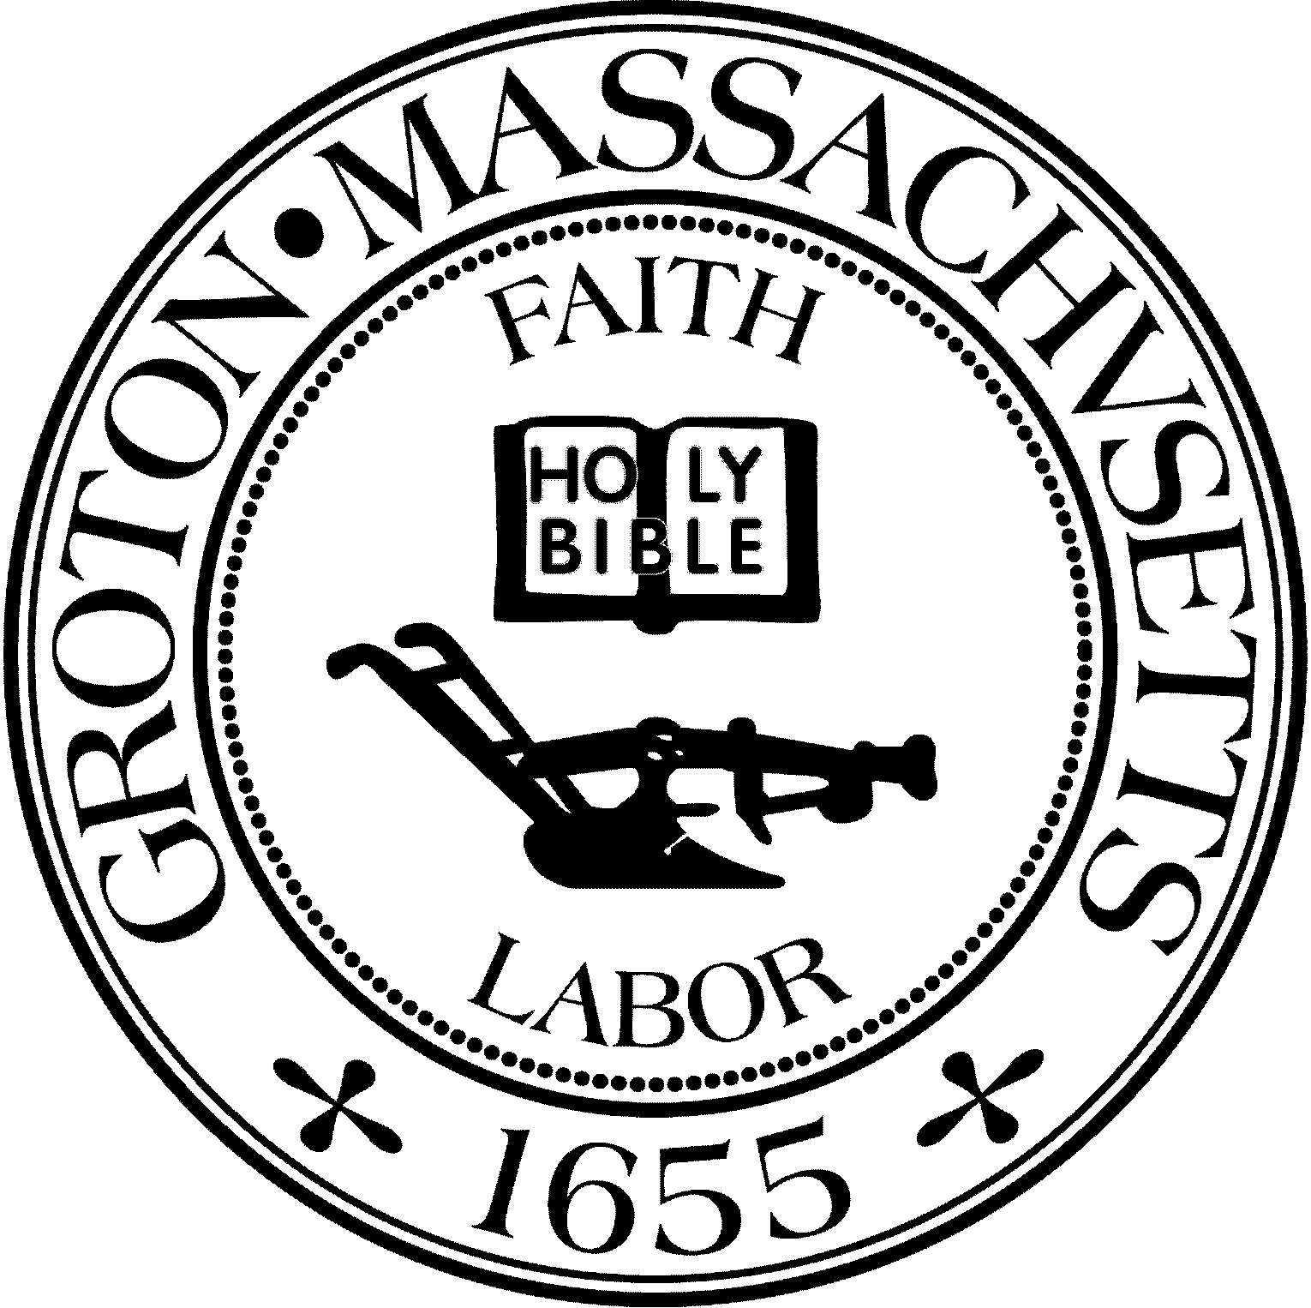
Town Manager
Mark W. Haddad

TOWN OF GROTON
173 Main Street
Groton, Massachusetts 01450-1237
Tel: (978) 448-1111
Fax: (978) 448-1115

Destination Groton Committee
Greg Sheldon, Chair
Jeff Gordon, Vice Chair
Julie Platt, Clerk
Brian Bolton, Member
Joni Parker-Roach, Member
Joni Parker Roach, Member

Destination Groton Committee Meeting
Wednesday, December 20, 2023
1:30 pm

Minutes

Present: Greg Sheldon, Joni Parker-Roach, Julie Platt, Brian Bolton
Guest: Judy Anderson

- Meeting Minutes: Minutes were distributed via email. No additions or corrections. -GSheldon moved the minutes be approved in 3 separate motions for 11/22/2023, 11/29/23 and 12/13/2023. JParker-Roach 2nd in all motions.
-Minutes approved unanimously and will be submitted to Town Clerk

2) MA Development Commonwealth Places / One Stop Grant Application
-GSheldon had spoken with Anne Gobi regarding the application for 25 Station Avenue kiosk development. There was no award granted however, a debrief regarding the application is available if the committee would like feedback.
ACTION: GSheldon to ask if there can be a debrief at Mass Development in Devens in early 2024.

3) CPC Draft Letters of Support by 1/11/24
There are currently 4 town committees asking for letters of support for their CPC grant applications. Committee can see the connection between Destination Groton and 3 of the applications. All present would like to discuss with entire committee in. 2024.
- Sustainability Commission
- Affordable Housing Trust
- Trails Committee
- Historical Commission
ACTION: GSheldon will draft 3 letters of support (Sustainability, ACT and Trails Committee. BBolton will draft letter of support for Historical Commission.

3) DGC/GBA 2/7/24 Town Conference
-JPlatt stated the Conference needs a name
-BBolton wondered about the agenda and timing of the conference
-All decided to table discussion until all Committee members are present

4) Grant Working Group
-JParker-Roach and GSheldon agreed there need to be more members on the team. JPlatt. Mentioned Jennifer Moore, who may have some background in grant writing area. Molly Singer is looking into the. Revolution250 application.

5) Marketing and Communications
-BBolton stated there have been small updates to the website. A newsletter will be planned for January 2024. Hubspot software will be very helpful for data management. Current mailing list is 380 people. Where to put videos from the conference and other?
ACTION: BBolton to link videos to Destination Groton YouTube site
JPlatt to draft January 2024 DG Newsletter in Hubspot.

6) MRPC Economic and Traffic data presentation and discussion
-Tracy Murphy from MRPC joined the group with a presentation regarding the data collected by MRPC from Esri about Groton residents, demographics, spending habits and projected retail / restaurant needs in the community.
-Data presented included: Median age, Retail and Demand outlook, spending trends.
-Tracy agreed that data from local restaurants would be helpful.
-Questions: Who will inquire with local Groton businesses (MRPC or DGC?)
How to quantify the numbers of people that visit Groton trails?
-Whare kind of dollars are leaving Groton?
-Town has to determine which businesses it desires to allow to invest
-Where are the areas in Groton where economic investment can lead to a walkable area? 4 Corners? 500 Main Street? Groton Center?

-DGC interested in what the statistics show to include in a 10 Year projection report to show demand and business needs.
-JPlatt stated that perhaps DGC spend more time and energy with grant writing due to the nature of the Town budget for the upcoming FY2025

Meeting adjourned at 3:05pm
Next Meeting 1/3/2024

Respectfully submitted,
Julie S. Platt
Clerk

