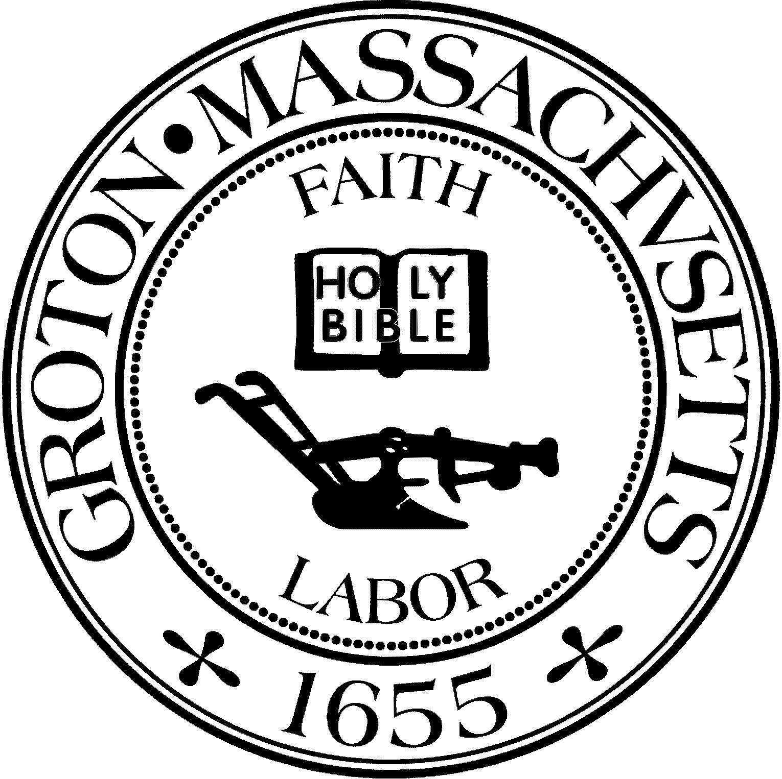
Town Manager
Mark W. Haddad

TOWN OF GROTON
173 Main Street
Groton, Massachusetts 01450-1237
Tel: (978) 448-1111
Fax: (978) 448-1115

Destination Groton Committee
Greg Sheldon, Chair
Jeff Gordon, Vice Chair
Julie Platt, Clerk
Brian Bolton, Member
Joni Parker-Roach, Member
Joni Parker Roach, Member

Destination Groton Committee Meeting
Wednesday, December 13, 2023
First Floor Meeting Room, Town Hall
1:30 pm - 3:30 pm

Minutes

Present: Greg Sheldon, Joni Parker-Roach, Julie Platt
Guest: Judy Anderson

1. Updates:
A) Anne Gobi tour of Prescott Community Center 12/8:
-Director of Rural Affairs was in Groton touring on 12/8 with Rep. Margaret Scarsdale. GSheldon recommended that Prescott Community Center be toured in Groton.
-JParker-Roach stated that Executive Director of Prescott Comm. Ctr Megan Donovan did an excellent job with the tour, highlighting the needs and opportunities at Prescott.
-Anne Gobi emailed GSheldon recounting she enjoyed the “eclectic mix” of business and arts at Prescott Community Ctr.
-GSheldon referred to the 4 entities in town that have the potential to make an impact on visitation / visibility: Destination Groton, Groton Business Association, Prescott Community Ctr, Groton Visitor Ctr. JPlatt added the Groton Inn.
Discussion: Anne Gobi’s visit opens up potential collaboration with Office of Rural Affairs.

B) GBA Town Conference, 2/7/24
-No updates

C) 250th Anniversary - revolution250.org
-Tabled until 2024, however Grants Working Group can review the application for funding

D) Letters of Support for CPC applications:
- Sustainability Commission: Has asked for letter of support for Pollinator Trail
- Affordable Housing Trust: Has asked for a letter of support from Destination Groton. Is Destination Groton’s charter a match for the Housing Authority’s proposal? Need more information and discussion among all 5 DGC committee members.
- Trails Committee: Has asked for letter of support for a CPC grant of $11,275.00 in tools for trail maintenances. DG Committee members present agreed it would be positive to support the Trails Committee.

3. Working Group Update: Communications and Marketing
-Request from GSheldon to inquire about adding a sentence or two to the VisitMA website. VisitMA.com
-JAnderson mentioned an arts review in December 11 Boston Globe - performance at GHMC.
-

4. Working Group Update: Grant Writing
-JParker-Roach has a Zoom call with Molly Singer MRPC grant writer. 12/14/23, 3 pm, at Prescott Community Center. Important to review the revolution250.com application for funds.

5. Ten Year Action Plan Update
GSheldon has been in contact with MRPC RE: economic data analysis, Traffic Study: 12/20/23 Possible meeting date to review.
Discussion RE: Walkable Town Center: should include sidewalks on both sides of the street.

6. Meeting adjourned 3:30pm:

Next Meeting 12/20/23 if MRPC can attend.

No meeting 12/27/23

Respectfully Submitted,
Julie Platt
Clerk

