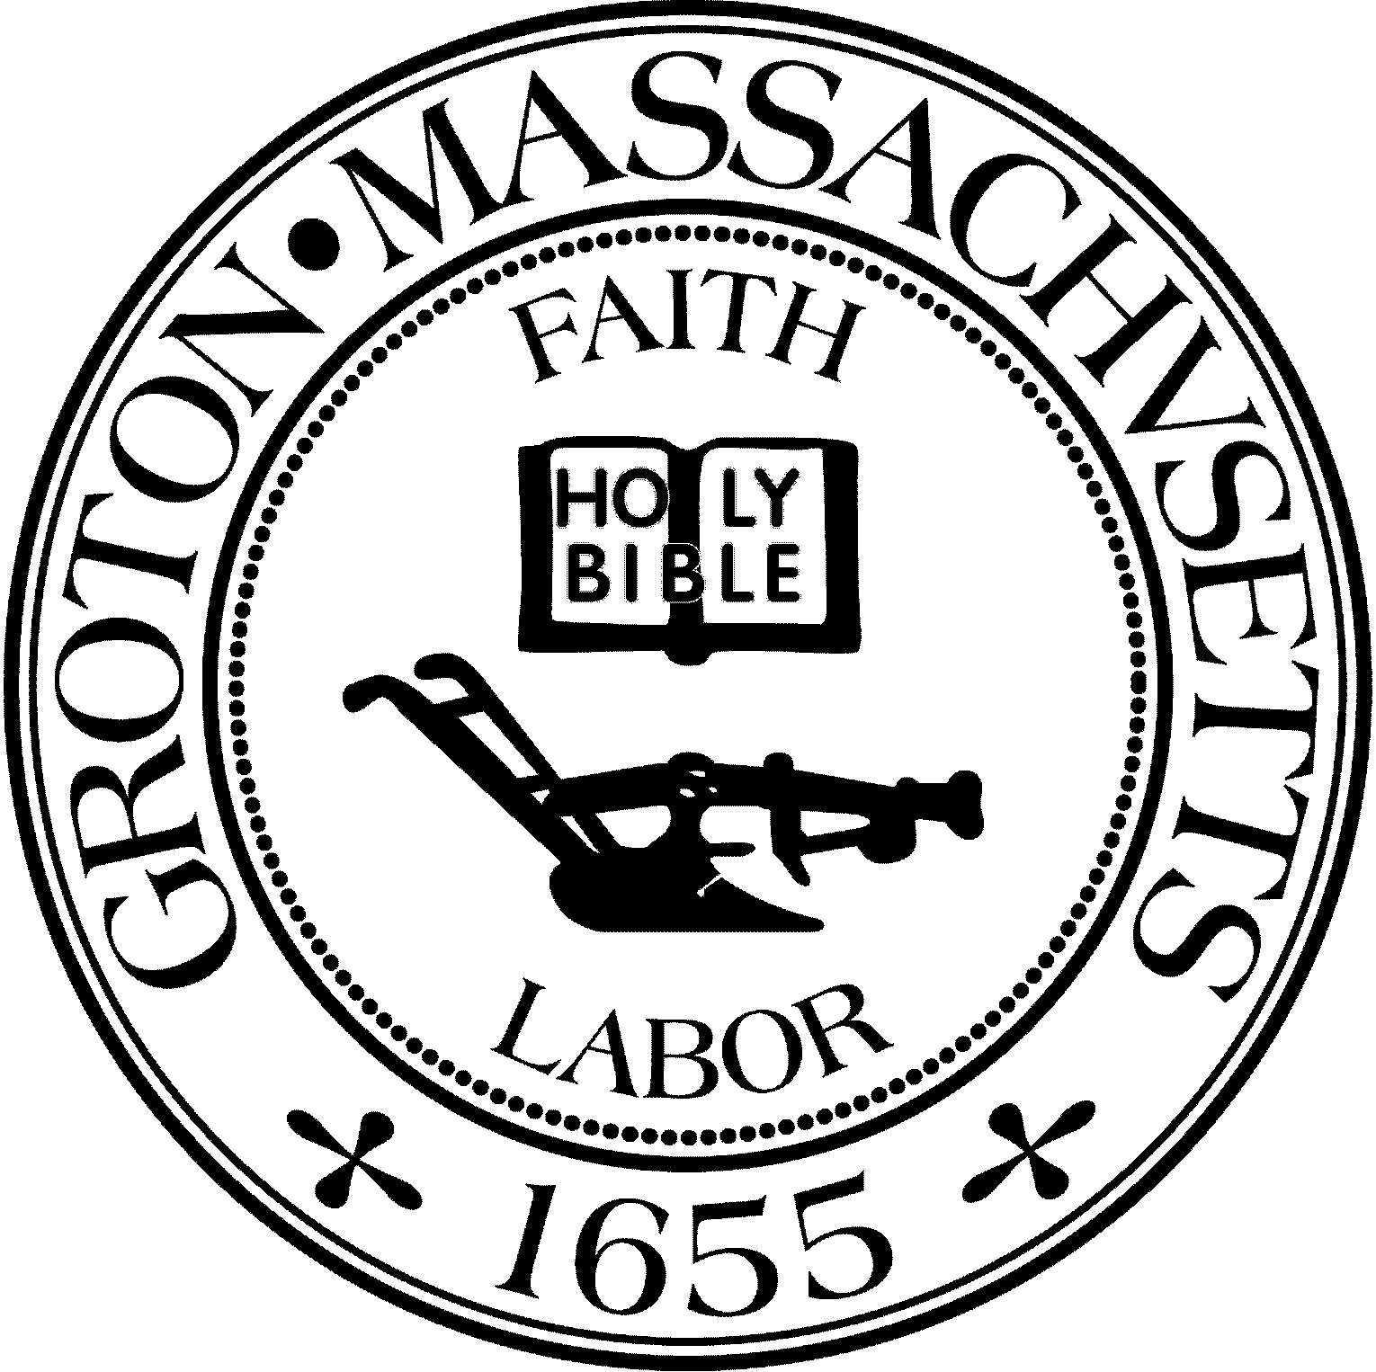
Town Manager
Mark W. Haddad

TOWN OF GROTON
173 Main Street
Groton, Massachusetts 01450-1237
Tel: (978) 448-1111
Fax: (978) 448-1115

Destination Groton Committee
Greg Sheldon, Chair
Jeff Gordon, Vice Chair
Julie Platt, Clerk
Brian Bolton, Member
Joni Parker-Roach, Member
Joni Parker Roach, Member

Destination Groton Committee Meeting
Wednesday, November 22, 2023
Minutes

Present: Greg Sheldon, Jeff Gordon, Joni Parker-Roach, Brian Bolton, Julie Platt
Guest: Judy Anderson

- Review and Approve Minutes 11/8/23:
-Motion made to approve by JGordon, 2nd by JParker-Roach. Minutes approved by unanimous vote.

2. FY24 Budget:
GSHeldon reported that current FY24 expenditures are$9868.66
-Are there other expenditures that need to be addressed?
-BBolton mentioned that DGC could upgrade the Hubspot membership to help with extra forms/ ease of managing the database and mailing list.

3. Programs: -
A) Groton Business Association Town Conference or Business Summit:
-JGordon is taking the lead on this event and proposed a date of February 7 at the Groton Inn.
-JPlatt mentioned that Karen Tucker-Barisano might be a good person to ask for help and suggested JGordon ask her.
-Idea for conference is to be same time frame as Nov. 1 conference. Different agenda and possibly break-out groups.

B) Groton Regional Tourism Conference Follow-up:
-JGordon has sent an email with links to the videos created by AJ Peckonis from the Nov. 1 conference. Please watch the videos.
-Post conference survey results: 12 people have responded.
-Please watch GSheldon, Chair on Cronin’s Corner (FATV on demand) and also GSheldon on Rep. Margaret Scarsdale’s Groton Channel show.

C) 250th Anniversary Sub-Committee Update:
-GSheldon to reach out to Don Black, Chair of Celebrations and Commemorations Committee for Groton, to describe the opportunities and possible projects that could be funded with money from the State of MA.
-Ideas: JAnderson believes that the Celebrations and Commemorations Committee should lead this effort. Other ideas are that other entities in town could be involved such as the Groton History Center and/or the Groton Historical Commission.
-Funds/Events/Monuments and grants for signage were all mentioned.
-There is a website: Revolution250.org for more state information.

D) Regional Economic and Community Development
-Rep. Scarsdale has created an economic and community development group for Middlesex District #1.That group meets once per month. GSheldon has been attending and reports that many of the surrounding towns would like to duplicate Destination Groton’s efforts for their towns. Sheldon will keep DGC informed of the group’s progress.

4. Working Groups: Open discussion
Communications and Marketing group:
-BBolton is leading the group and focus is DG website, highlighting Groton and what it has to offer.
-Discussion regarding how do/will Groton Visitor Ctr and the Destination Groton websites work together.
-Is there a business aspect to the Destination Groton website?
*Requests to update the DG Website:
-Edit Goldring Piene/Matisse information
-Add information re: Groton Lakes Association
-Add Groton Regional Tourism Conference information: link Cable coverage and photo montage
-Groton Herald article re: Groton Trails Network, letters to Editor
-Repost Nashboa Valley Living magazine issue featuring Groton
-Rep Scarsdale Cable interview 11/29/2023 with Greg Sheldon
-link MOTT website https://business.visitma.com/.
-A “Request for Website Update” form will be created for those situations where an update is requested and/or needed to document changes to webstite
This working group will also be developing a Social Media: Campaign Plan (Marketing message, merchandise)

Grant Writing Working Group:
-JParker-Roach is working with this group and MRPC grant writer Molly Singer, Judy Romatelli, and GSheldon.
-The work is to Identify grants, schedule when to apply, draft narratives, support grant writing efforts.

Ten-Year Action Plan:
-GSheldon is coordinating this working group which will create a narrative around economic data from MRPC, analysis of that information, Traffic Study, Vision, Findings, and Recommendations to the Town of Groton.

5. MRPC update: Awaiting information

6. Meeting Adjourned: 3:15pm

Next Meeting 11/29/23

Respectfully submitted,
Julie Platt
Clerk
Destination Groton

