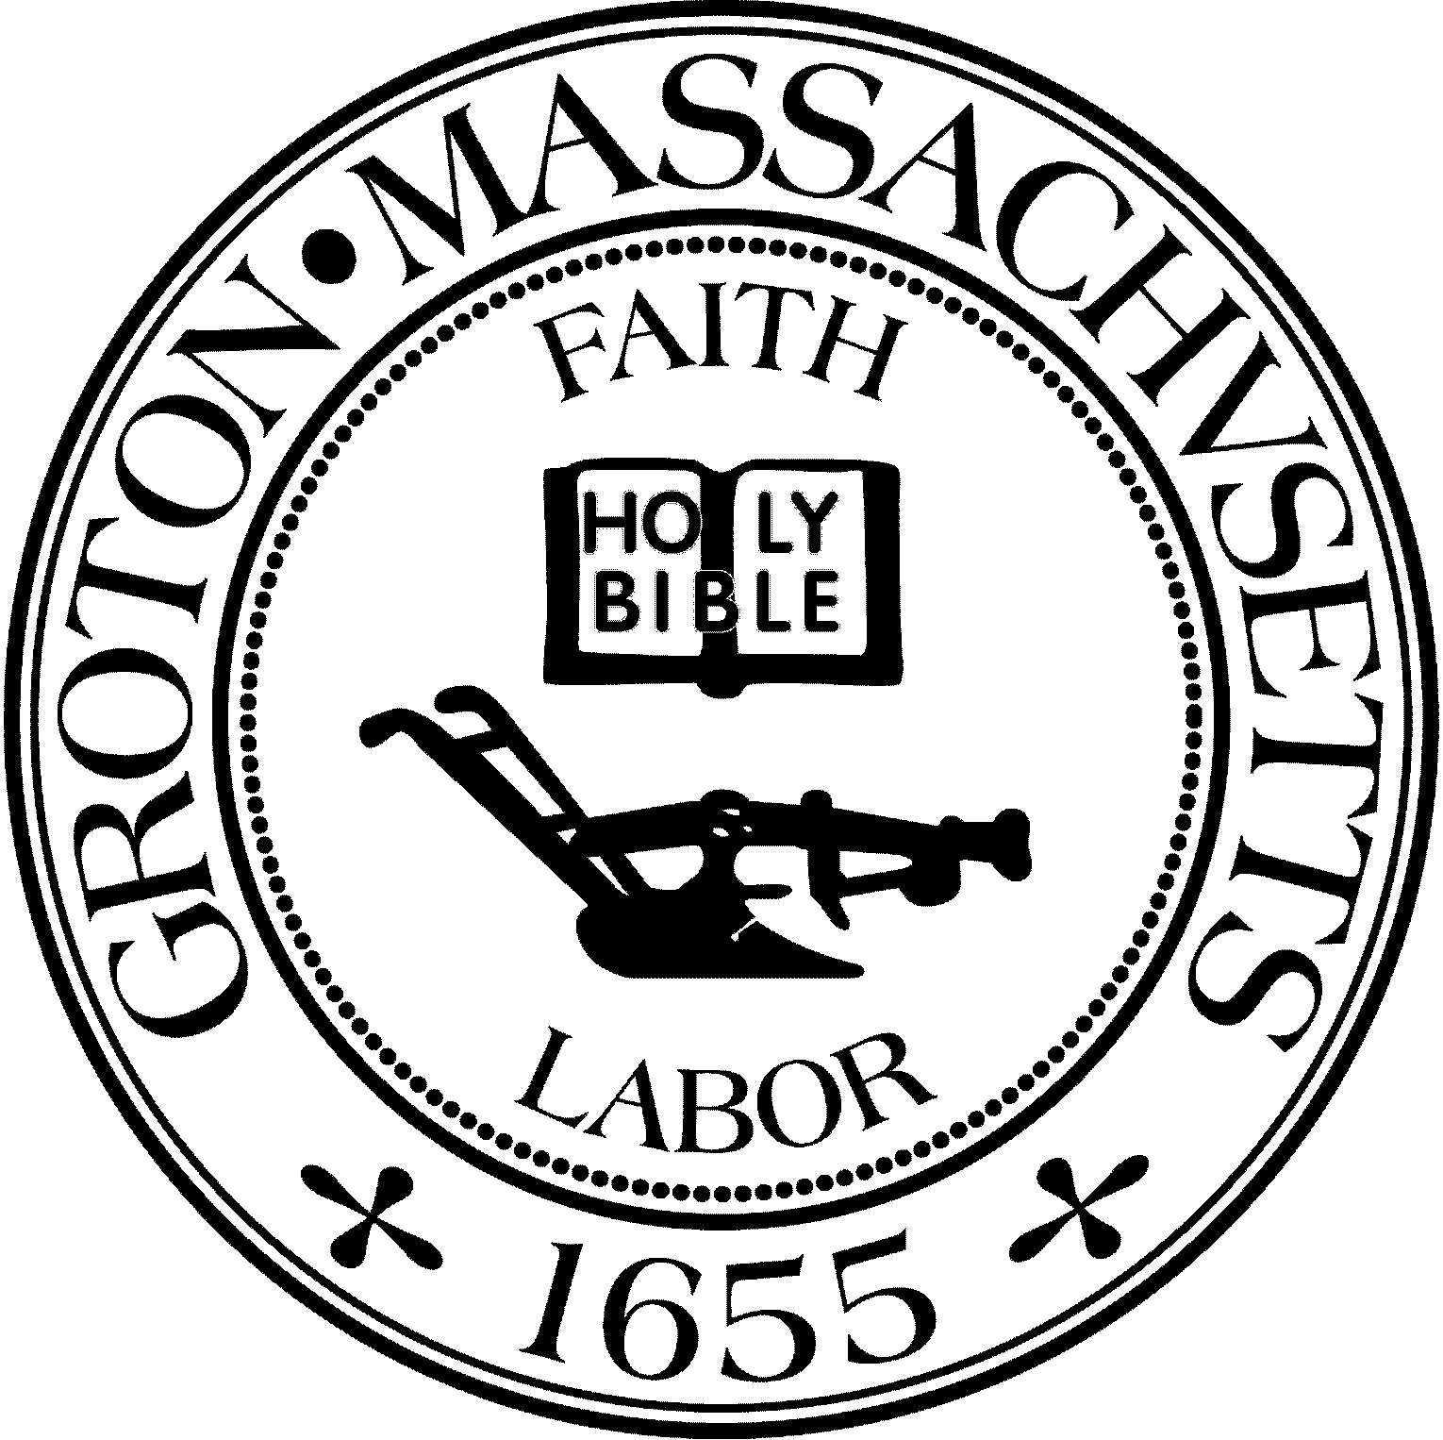
Town Manager
Mark W. Haddad

TOWN OF GROTON
173 Main Street
Groton, Massachusetts 01450-1237
Tel: (978) 448-1111
Fax: (978) 448-1115

Destination Groton Committee
Greg Sheldon, Chair
Jeff Gordon, Vice Chair
Julie Platt, Clerk
Brian Bolton, Member
Joni Parker-Roach, Member
Joni Parker Roach, Member

Destination Groton Committee Meeting
Wednesday, November 15, 2023
Groton Electric Light Conference Room
Minutes

Present: Greg Sheldon, Jeff Gordon, Brian Bolton, Joni Parker-Roach, Julie Platt
Guests: Ken Ferris, Patrick Parker-Roach, Judy Anderson

- FY24 Budget Review
-Current funds collected via Square:
Merchandise (hats or shirts) $ 49.46 Fees to Square: $ 2.10
Donations (from registrations) $ 106.21 Fees to Square: $ 3.76
Conference Registrations $1436.89 Fees to Square: $53.11
Totals: $1592.56 Fees to Square: $58.97
-Square charges 3.28% of each sale - no way to get around it
-Town Treasurer confirmed that dollars from online sales are sent to the DG Gift Fund.

2. Programs:
- GBA Town Conference: Discussion regarding a Local Business Summit. This would be a conference similar to the Regional Conference to create a sense of community for all local businesses, allow for feedback and discussion regarding results from the Public Forums held in 2022 and online surveys from 2023. Program could include the MRPC, Groton Planning Board, representative from Destination Bolton?
Earl Carter Collection: GSheldon has had very brief conversations with Earl Carter regarding his extensive collection. Earl may be interested in chatting with DGC. In a dialog with the Groton History Center, DGC became aware that Earl Carter is interested in keeping his collection together. Some of the challenges include insuring the collection, temperature and fire control. GSheldon is interested in making local State representatives, Anne Gobi, Kate Fox and Congresswoman Lori Trahan aware of the collection and perhaps obtaining funds. JPlatt suggested that other towns that have such museums could be contacted to research how/when/funds. Earl Carter’s collection will be mentioned in the DG Ten Year Action Plan.

- 250th Committee Celebration: GSheldon drafted a letter to all Town Committees. JAnderson suggested that DGC could encourage the Town of Groton Celebrations and Commemorations committee chair, Don Black, be informed of the “charge” given by the Select Board. All DGC committee members agree that the language should be that DGC has become aware of state funds available for the upcoming 250th Anniversary of the US. Kate Fox, MOTT, said an online application for such funds is being set up. DGC would only like to be a catalyst to move the planning forward for the correct entities/committees in the Town of Groton to establish a 250th Celebration group, as the the 250th Celebration not in the purview of Destination Groton.

3. Organize Working Groups: Open discussion
Communications and Marketing: BBolton would like to propose a process for updating the DG website. Social media and marketing should point back to website as it will be the best way to describe DG. There is still money in the FY 24 budget to promote the town of Groton via magazines or advertising. JPlatt suggested that there has been a desire from DG to be included in travel magazines however some magazines such as Yankee or others may require advertising to be featured. JPlatt offered to inquire with Barbara Scofidio, local travel writer/marketing specialist.
Social media needs to be “all the same tone or voice”.
-Discussion regarding the following updates to the website: Edit Goldring Piene information, add information regarding the Mountain/Lakes Association; Press Release for the DG Tourism Conference; link Cable coverage and photo shots to website and Facebook (Kirsta/Steve); Groton Herald article; letters to Editor (Greg/Paul); repost Nashoba Valley Living magazine article. BBolton, JPlatt, PParker-Roach expressed interest in Marketing subcommittee. Plan to meet Friday, 11/17/23 from 12-1pm.
- Grant Writing: JParker-Roach, Barbara Scofidio and Judy Romatelli with the help of Molly Singer from MRPC - Identify grants, schedule, draft narrative, support.
- Ten-Year Action Plan: GSheldon would like to write up the ROI for Groton along with the Economic data analysis, Traffic Study, Vision, Findings and Recommendations from MRPC. Help from all will be needed. JParker-Roach and JAnderson suggested the name of a person for GSheldon to call and ask about interest in helping write the DG Action Plan.

5. MRPC update: Will DGC be able to extend our contract past 12/31/23 as Scope of Services has not been sufficiently facilitated from MRPC? GSheldon is trying to obtain the answer to that question.

Adjournment 3:30pm

Respectfully Submitted,
Julie Platt
Clerk
Destination Groton

