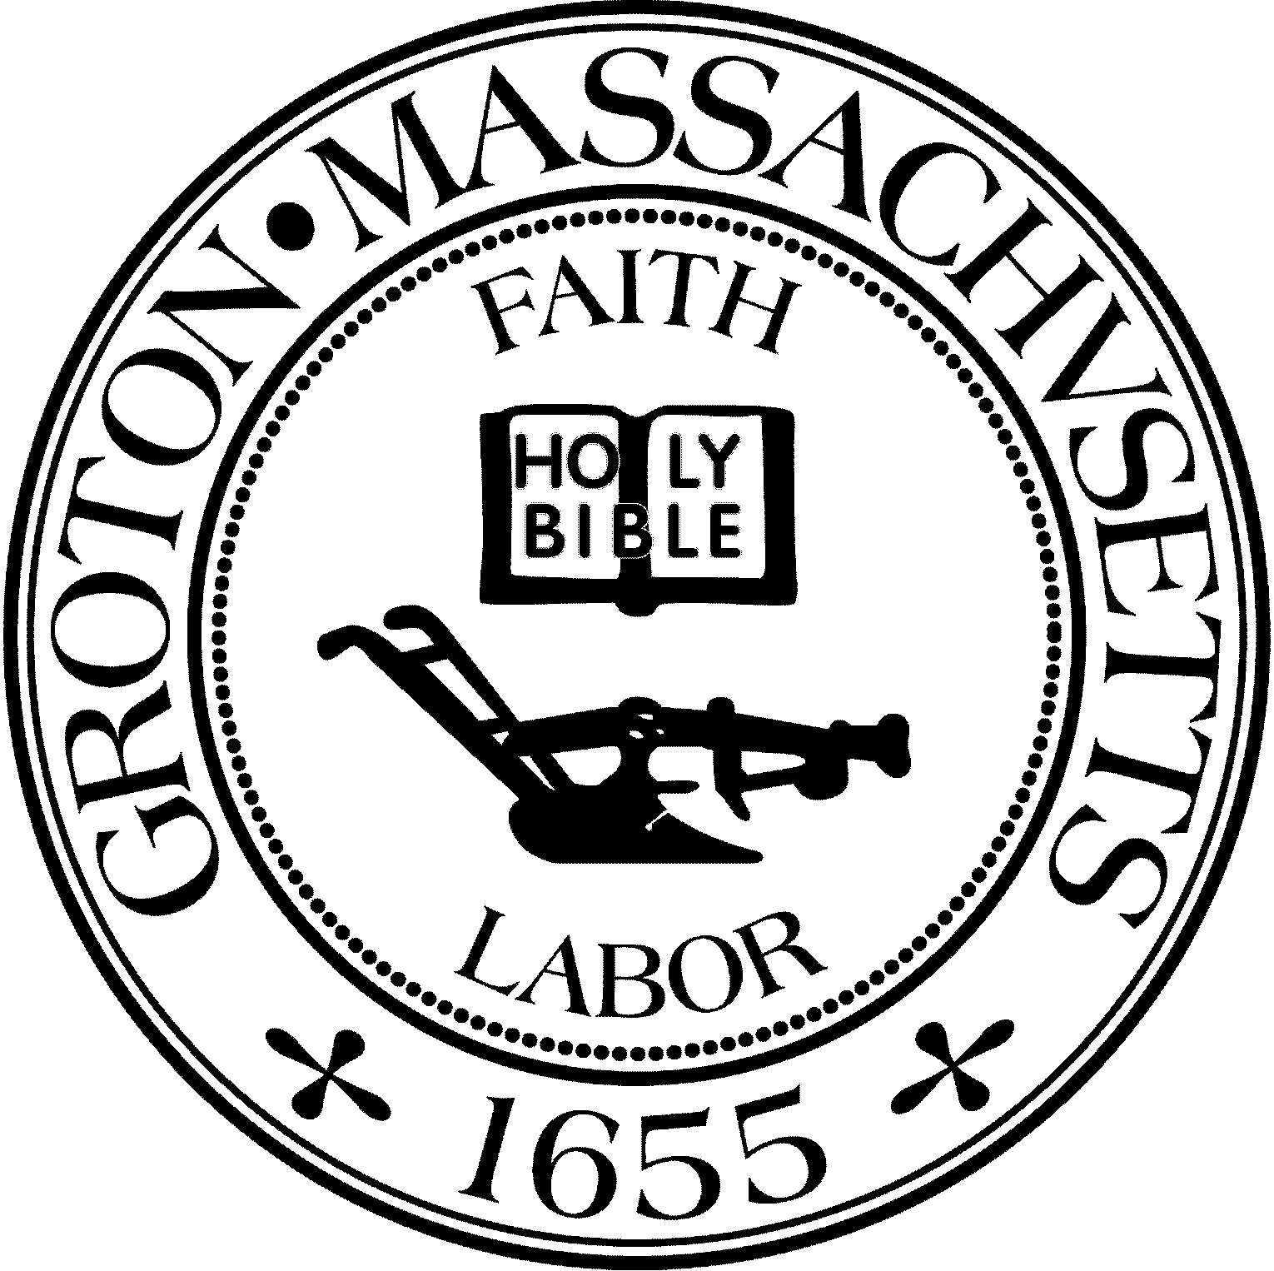
Town Manager
Mark W. Haddad

TOWN OF GROTON
173 Main Street
Groton, Massachusetts 01450-1237
Tel: (978) 448-1111
Fax: (978) 448-1115

Destination Groton Committee
Greg Sheldon, Chair
Jeff Gordon, Vice Chair
Julie Platt, Clerk
Brian Bolton, Member
Joni Parker-Roach, Member
Joni Parker Roach, Member

Destination Groton Committee Meeting
Wednesday, November 8, 2023

Minutes

Present: Greg Sheldon, Jeff Gordon, Brian Bolton, Joni Parker-Roach, Julie Platt
Guests: Judy Anderson, Karen Tucker-Barisano, Patrick Parker-Roach, Scott Blumsack

- Review and Approve Minutes 10/18/23 and 10/25/23
Minutes from 10/18/2023 approved unanimously.
Minutes from 10/25/23 approved unanimously.

2. DGC reorganization:
-Motion made to nominate Greg Sheldon as Chair byJPlatt. Seconded by JGordon. Approved Unanimously
Motion made to nominate Jeff Gordon as Vice Chair by JParker-Roach, Seconded by GSheldon. Approved unanimously.
Motion made to nominate Julie Platt as Clerk, seconded by JParker-Roach. Approved unanimously.
-Re-organization stands until June 30, 2023.

3. Regional Tourism Conference debrief:
- Thank you emails to and from Kate Fox, Anne Gobi, Lisa Fiorentino, Mark Haddad, Margaret Scarsdale, Roy Nascimento, Becky Pine, Holly Varney, Russ Harris.
- Press/social media: Article written for Lowell Sun/Nashoba Valley Voice/ Fitchburg newspaper. To be published.
- Steve Lieman and Groton Herald
- -Barbara Scofidio to write an article
- Video is online courtesy of the Groton Channel
Survey to attendees: ACTION items:
-Generated by BBolton to send via Hubspot
-Karen Tucker-Barisano will help write it
-Google forms with questions- JPlatt will create and send to Bolton
-Content of message: Thank you for attending, permission to share the participant list and emails, subscription, Ask for feedback, link to Groton Channel

Conference:
82 people attended, 36 Paid attendees, 40 comp.

Next steps (GBA) and Local Business Summit
-JGordon suggestion to have a meeting for local businesses
-Goals: To create a shared vision, include ALL Groton businesses
-When is best to hold conference?
-During the writing of the Strategic Plan? After the writing of the Strategic Plan?
-Consensus is in early 2024
-
4. Organize Working Groups- GSheldon
Welcome new participants: Karen Tucker- Barisano, Scott Blumsack
GSheldon described the focus areas for Working Groups:
- Grant Writing- Molly Singer from MRPC is available to committee
- Communications and Marketing- Social Media plan and website
- 250th U.S. Anniversary- DGC to bring together other Town groups
- Ten-year Action Plan recommendations from Destination Groton

6. Adjournment at 3:15pm

Next meeting November 15, 2023 1:30pm

