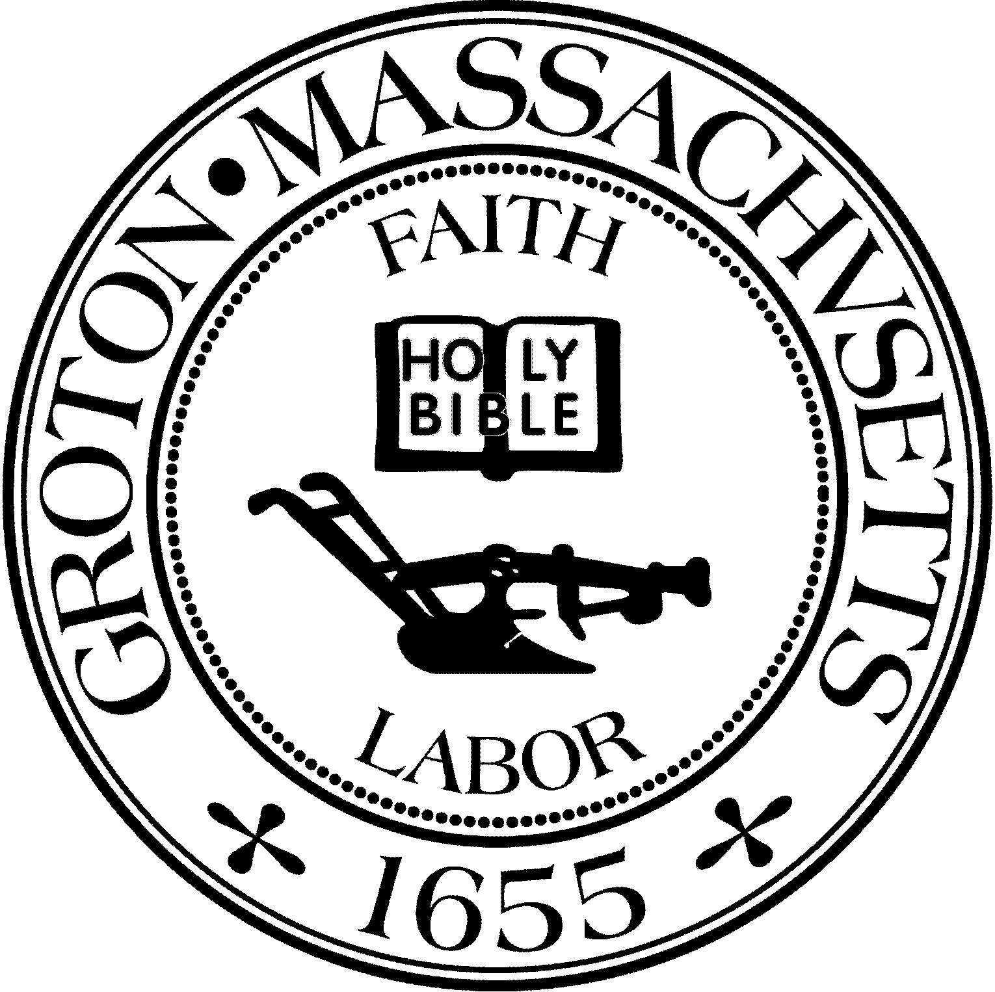
Town Manager
Mark W. Haddad

TOWN OF GROTON
173 Main Street
Groton, Massachusetts 01450-1237
Tel: (978) 448-1111
Fax: (978) 448-1115

Destination Groton Committee
Greg Sheldon, Chair
Jeff Gordon, Vice Chair
Brian Bolton, Member
Julie Platt, Member
Joni Parker Roach, Member

Destination Groton Committee Meeting
Wednesday, October 25, 2023
Prescott Room, Groton Inn
128 Main Street
1:30 pm - 3:30 pm

Minutes

Present: Greg Sheldon, Brian Bolton, Joni Parker-Roach, Julie Platt
Guests: Judy Anderson, Ashley Doucette, Holly Varney, Melissa Fetterhoff (20 minutes)

- Conduct walk through with Holly Varney of The Groton Inn
-Conference details were discussed regarding placement of tables, programs, extra seats, microphone, projector, Presenter podium and chairs for speaker panel.

- Jen Moore 5K Turkey Trot social media assistance
-JPlatt to follow up with Jen Moore to suggest local outlets for the 5K Turkey Trot advertising and see how/if Destination Groton can help

- Tourism Conference update:

- RSVPs to date
-Comp list remains stable, and Paid list is changing. JPlatt to contact JGordon for final report.

- Submit final number to Groton Inn
-RSVP Final Count with “Ins and Outs” is 82.

- Review To-Do-List
-Folders, nametags printing final arrangements need to be made by 10/30/2023
Setup for Conference at 2pm on 10/31/23 at The Groton Inn.

- Adjournment 3:15pm:

