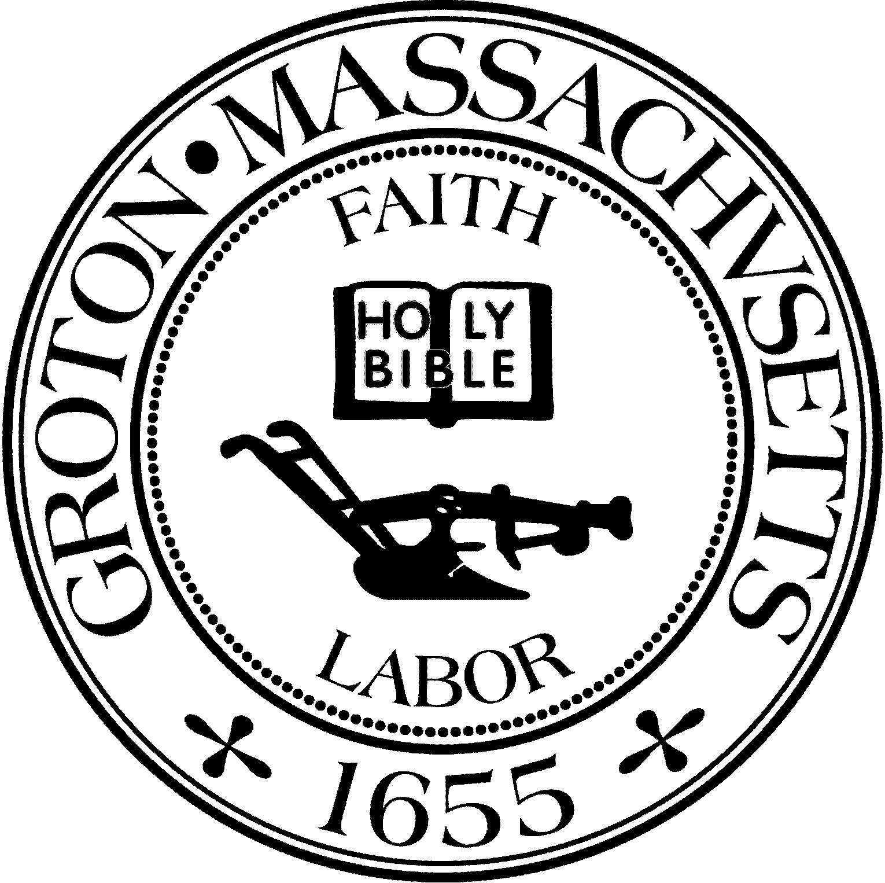
Town Manager
Mark W. Haddad

TOWN OF GROTON
173 Main Street
Groton, Massachusetts 01450-1237
Tel: (978) 448-1111
Fax: (978) 448-1115

Destination Groton Committee
Greg Sheldon, Chair
Jeff Gordon, Vice Chair
Julie Platt, Member
Joni Parker Roach, Member
Destinatio

Destination Groton Committee Meeting
Wednesday, October 11, 2023
Town Hall 1:30 pm - 4:05 pm

Minutes

Present: Greg Sheldon, Jeff Gordon, Joni Parker-Roach, Julie Platt
Guest: Judy Anderson

- Review and approve Minutes 10/4/23
-JGordon made a motion to accept the Meeting minutes from 10/4/23.
-JParker-Roach seconded. Vote taken: Unanimous in favor of the motion.

2 DGC vacancy Interviews (3) 1:30 pm - 4:05 pm
20 minute interviews and interest conversations with guests:
Judy Rometelli, Ken Ferris, Brian Bolton.

3. Tourism Conference update: To-Do-List
-DGC reviewed TO DO list for conference on 11/1. Current item is RSVPs from invitation list. Each DGC member agreed to reach out to invitees assigned to encourage a response.

4. Select Board briefing 10/16/23 in person.
GSheldon and JGordon will attend. Topics to be announced to Selectboard include:
-Invitation to attend the 10/20/23 $15,000 Check Presentation, 1 pm, General Field
(Senator John Cronin will present the check to the Groton Trails Committee)
-Announce the 11/1/23 Tourism Conference at the Groton Inn
-Announce the opportunity for the. Town to form a 250th USA Anniversary Committee
-Distribute Destination Groton Hats/T-Shirts

5. Adjournment 4:50pm

Respectfully Submitted, Julie S. Platt, Member
Destination Groton Committee Meeting
Wednesday, October 11, 2023
Zoom 7:00 pm- 8:30 pm
https://portal.grotonma.gov/public/meetings/14495

Agenda

1. 7 pm Zoom vacancy Interviews (2)

2. MRPC update

3. Adjournment: next meeting 10/18

