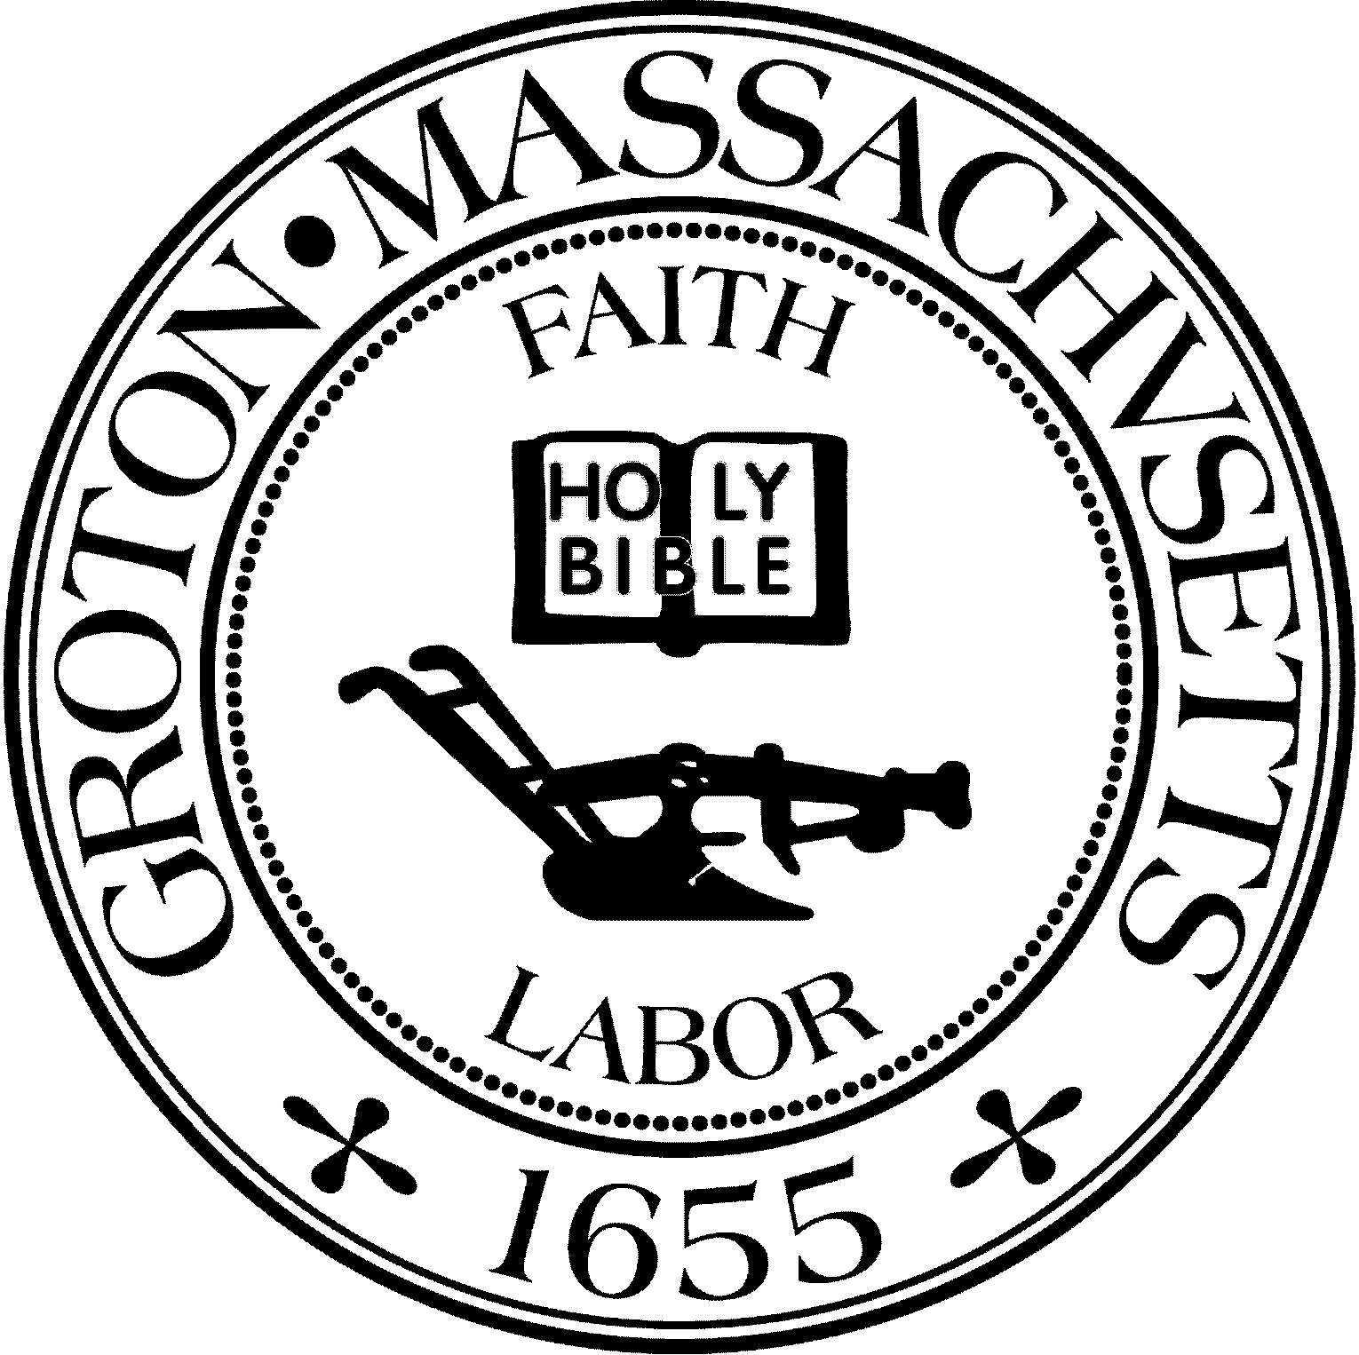

TOWN OF GROTON
173 Main Street
Groton, Massachusetts 01450-1237
Tel: (978) 448-1111
Fax: (978) 448-1115

Destination Groton Committee
Greg Sheldon, Chair
Jeff Gordon, Vice Chair
Julie Platt, Member
Joni Parker Roach, Member
Town Manager
Mark W. Haddad

Destination Groton Committee Meeting
Wednesday, September 27, 2023
Minutes

Present: Greg Sheldon, Joni Parker-Roach, Julie Platt
Guests: Judy Anderson, Nancy Muller

Meeting opened at 6:35pm

1. Approve previous Minutes 9/20/23
Motion made by JParker-Roach, Seconded, Minutes approved unanimously

2. Grotonfest:
- GBA invoice was signed off by GSheldon and Paid.
Details: JParker-Roach: table, banner, easels, merchandise display, decor
GSheldon: handouts, GBA posters, Interest form, Happenings for Groton Herald
JGordon: Merchandise sales- QR code for purchasing merchandise
JPlatt: table, set up, breakdown, transport
Set up/coverage/breakdown: All
Hats and Tshirts will be sold in person and online. All merchandise that is sold in person, proceeds go to the Destination Groton Gift Fund. T-shirts that are sold online, proceeds go to the Destination Groton Gift Fund. Hats that are sold on line, proceeds go to the Town of Groton.

3. $15 K Check presentation: October 20, 1pm, General Field
Senator Cronin will be present and will invite Reps Scarsdale, Sena.s
DGC to invite the Town Manager, Select Board, Trails Committee, Media
Press release to be written in preparation of the event.

4. Regional Economic and Community Development Discussion organized by Rep. Margaret Scarsdale), September 19, 2023.
- Participants from towns in her district met to discuss local issues including tourism,
business opportunities and Destination Groton. GSheldon represented Destination Groton.
- Jock Snaith from Townsend Historical Society reached out for Townsend to be included on the Destination Groton website. JPlatt responded with an offer of placement on the “Region” tab on the Destination Groton website, with reciprocal website mention.
- Group will meet monthly under Rep. Scarsdale’s direction

5. Groton Regional Tourism Conference Update:
- JGordon in charge of RSVP for paid attendees - no update as he was not present Current: 6 RSVPS
- JPlatt reports 10 responses from Complementary list
- Invitation List / Email responses: A Reminder will be sent out Friday 10/6/23 with a RSVP deadline of 10/13/23.
- Program : JParker-Roach working on this with Barbara Scofidio
- Flyer has been created by GSheldon and will be used at Grotonfest
- Banner: Created by J&S Business Products, Ayer, and will be used at Grotonfest

6. MRPC update: No updates

7. Working Groups to be formed:
-Grant writing, Communications, Vision - Strategic Plan report
and Regional / Economic which will be a wider group of participants
8. Distribute Merchandise - Town Hall staff at a future date?, Hats and shirts to the Select Board hopefully on 10/2/23

9. Next meeting will be Wednesday, 10/4/23 during the afternoon. Try to aim for Wednesday afternoons going forward.

10. Other Business:
-Commonwealth Spaces grant will be announced during October 2023.

Adjournment: 8:20pm

