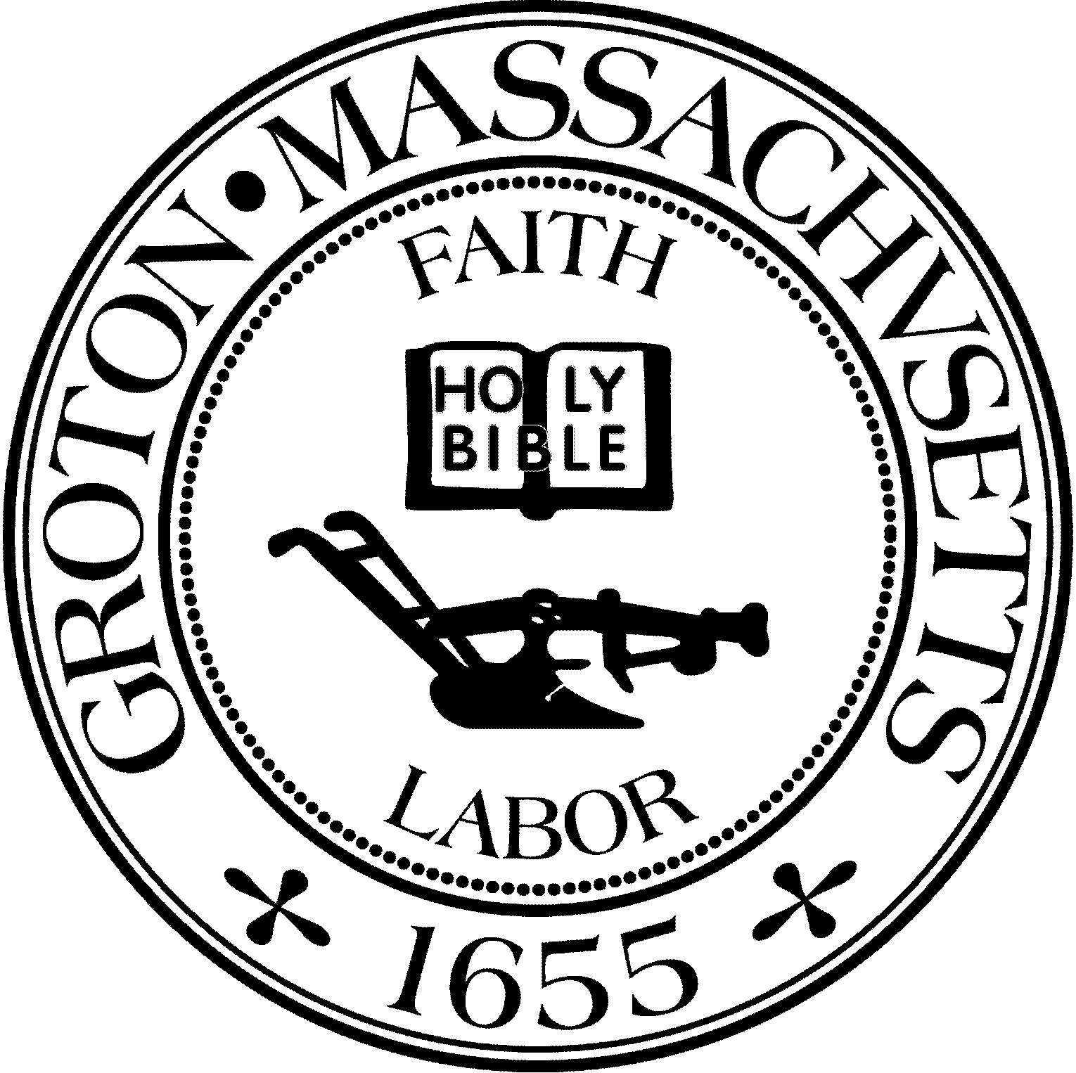
Town Manager
Mark W. Haddad

TOWN OF GROTON
173 Main Street
Groton, Massachusetts 01450-1237
Tel: (978) 448-1111
Fax: (978) 448-1115

Destination Groton Committee
Greg Sheldon, Chair
Jeff Gordon, Vice Chair
Mairi Elliot, Clerk
Julie Platt, Member
Joni Parker Roach, Member

Destination Groton Committee Meeting
Wednesday, September 20, 2023

Minutes:
Present: Greg Sheldon, Jeff Gordon, Joni Parker-Roach, Julie Platt
Guest: Phil Francisco

1. Approve Minutes:
- JPlatt stated that Mairi Elliot plans to submit minutes from January to the dates when JPlatt began taking meeting minutes
ACTION: Still need: August 8, September 6. Whomever takes minutes, submits them to the Town Clerk after the minutes have been approved.

2. DGC Vacancy Interest:
-2 responses to openings.
-There are more potential candidates. Committee will not decide or interview until after Grotonfest or 10/1/23.
ACTION: Vacancy forms to be brought to Grotonfest.

3. Grotonfest:
-GBA invoice for $150.00 has not been received, therefore has not been paid.
-Details: GSheldon and JParker-Roach to provide tables.
Tableclothes: JParker-Roach
Banner: JParker-Roach
Clipboards or Notebooks:
Tent: JParker-Roach
Decor (Mums, hangers for t-shirts, flowers etc): JParker-Roach, JPlatt
Committee Vacancy Forms: GSheldon
Handouts to be printed: GSheldon
Booth 101 - Social Media and also printed ad “Groton Happenings” in Groton Herald
Volunteers: JParker-Roach has HS volunteers for booth.
Computer and monitor for website to be provided by PParker-Roach.
TShirt / Hat Sales via Squarespace QR code

4. Groton Region Tourism Conference Update:
-48 Paid invites have been emailed - JGordon keeping track of RSVP’s
-Note that those responding with 2 are allowed only one seat
-Comp. Invites will be emailed this week - JPlatt will keep track of RSVP’s
Discussion: Should Ayer and Shirley government representatives be invited?
There are some Ayer and Shirley businesses invited. Decisionto invite Alan S. Manoian, Ayer Economic Development and Sherry Anders, Shirley Greenway Committee.
-A deadline needs to be advertised for RSVP to generate responses.

5. MRPC update:
-Traffic counts were taken for concert on September 8. The Data analysis, schedule of information, in a holding pattern.

7. Communications Plan:
-Social Media - Promote booth and t-shirts / hats on FB
-DGC Committee Booth 101 at Grotonfest to be advertised in newspaper
-Press release about the Regional Tourism Conference to be written after Grotonfest

8. Squarespace:
Hannah Moeller verified that Squarespace works and that items sold can only be non-taxable.
ACTION: JGordon to generate monthly Squarespace summary for Hannah Moeller.

9. Adjournment 3:15pm

Next Meeting Wednesday, September 27, 6:30pm, Town Hall

