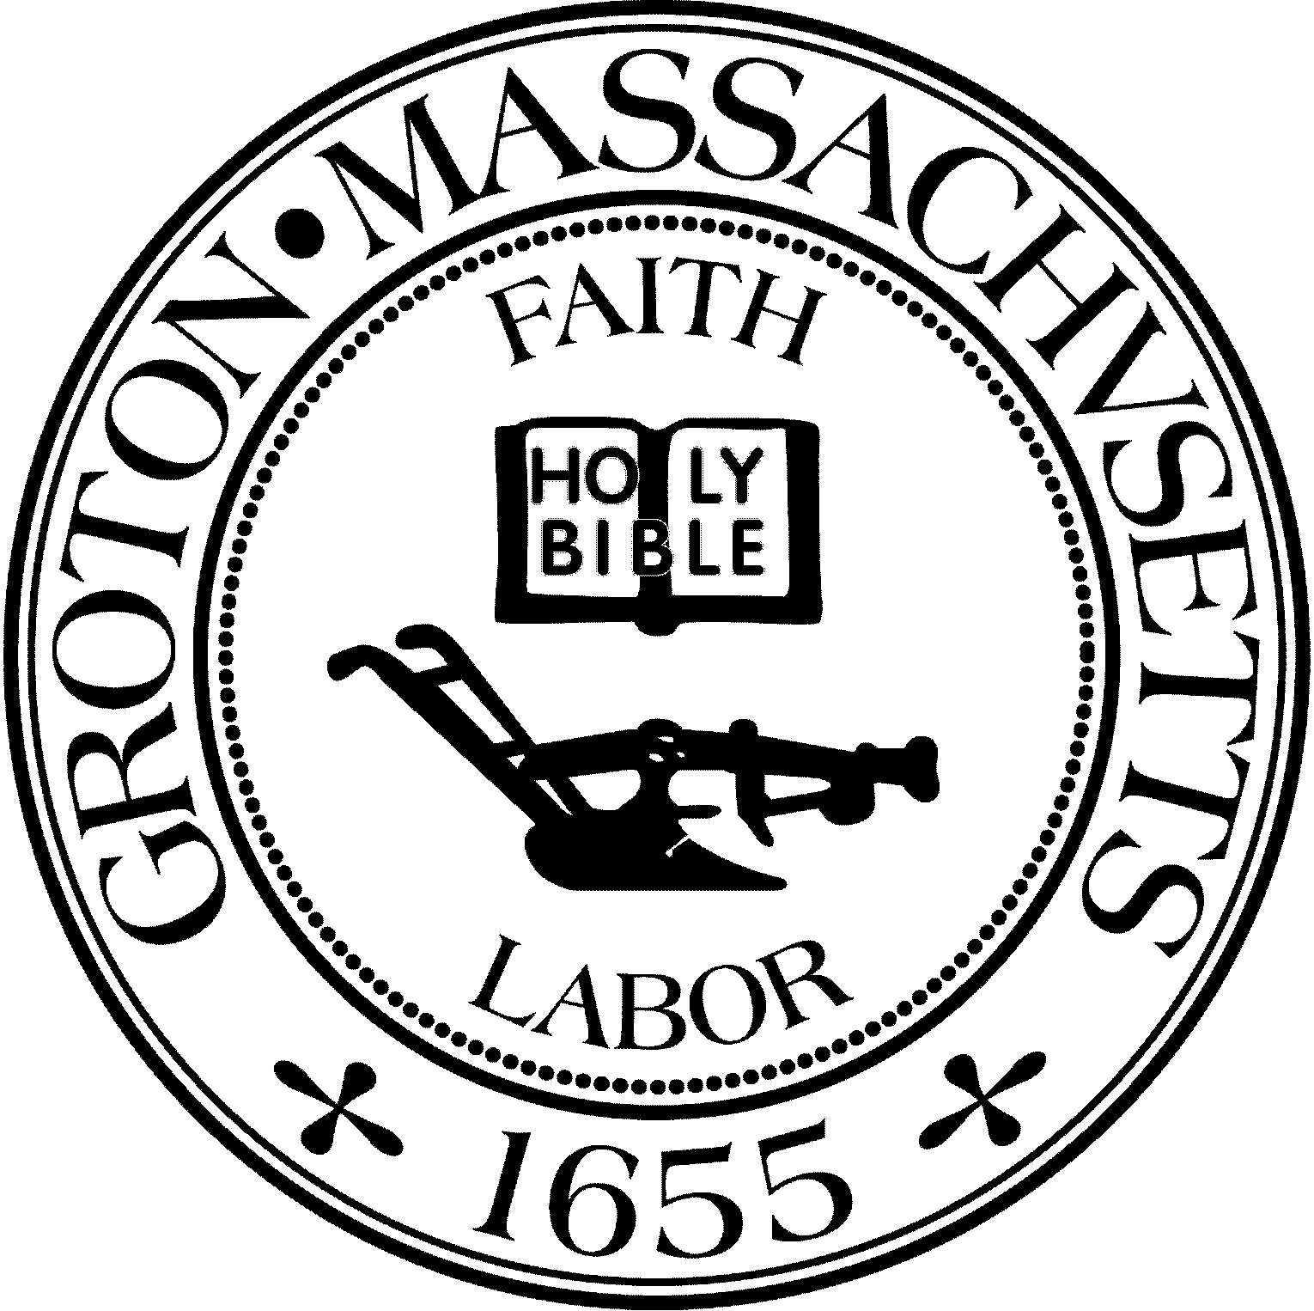
Town Manager
Mark W. Haddad

TOWN OF GROTON
173 Main Street
Groton, Massachusetts 01450-1237
Tel: (978) 448-1111
Fax: (978) 448-1115

Destination Groton Committee
Greg Sheldon, Chair
Jeff Gordon, Vice Chair
Mairi Elliot, Clerk
Julie Platt, Member
Joni Parker Roach, Member

Destination Groton Committee Meeting
Wednesday, September 13, 2023

Minutes:
Present: Greg Sheldon, Jeff Gordon, Joni Parker-Roach, Julie Platt
Guest: Patrick Parker-Roach

1. Approve Minutes (recent past and review since January)
- JPlatt stated that Mairi Elliot plans to submit minutes from January to the dates when JPlatt began taking meeting minutes
ACTION: Still need: August 8, September 6. Whomever takes minutes, submits them to the Town Clerk after the minutes have been approved.

2. Cronin's Corner:
-GSheldon appeared on a taping of “Cronin’s Corner” for Fitchburg Cable TV (FATV).
Episode to be broadcast in October on local cable channels.

3. DGC Vacancy Interest:
-2 responses to openings.
-There are more potential candidates. Committee will not decide or interview until after Grotonfest or 10/1/23.
ACTION: GSheldon to write to potential candidates to inform them of timeline.
4. Groton Region Tourism Conference Update:
-Point of Sale: We have a SquareSpace site. destination.square.site. This will be a Point of Sale for Conference payments and sale of hats and tshirts.
Thanks to Hannah Moeller for sending the information.
ACTION: JGordon will set up site for Conference registrant information and payments.
PParker-Roach suggested perhaps there could be a “Donation” area on the site. All agreed it is a good idea.
-Invitation: JGordon and GSheldon have finalized the invitation wording and layout.
ACTION: GSheldon to email Invitation to 2 groups, from Sheldon’s town email.
ACTION: JPlatt to send Google response list to PParker-Roach to embed in Blue group invitations. JGordon to set up Squarespace for Green group invitations.

-List: Becoming more refined: RNascimento from NCMCC has sent a list of 15 invitees.
Waiting for MFetterhoff from NVCC and list of 20 invitees.
-Sponsors: NVCC agreed to be a sponsor for the Conference.
ACTION: JPlatt to contact Groton School regarding potential candidate for invite.
-Program, Flyer, Banner: Information needs to be disseminated via a flyer/handout.
Banner to be created for use at Grotonfest and Conference. Program needs to be designed and quoted by J&S.
ACTION: JParker-Roach to contact appropriate vendors and get quotes.

IDEA: JGordon and GBA / Destination Groton to potentially host a Local Business Summit for Groton based business. More discussion based, Groton focused.

5. Grotonfest:
-GBA invoice for $150.00 has not been received, therefore has not been paid.
-Details: GSheldon and JParker-Roach to provide tables.
Banner, handout to be printed.
MORE: JParker-Roach has potential HS volunteers for booth. Computer and monitor for website to be provided by PParker-Roach.
QUESTIONS: Tent needed? Decorations such as mums/pumpkins/balloons/ etc?
Set up time?/coverage/breakdown, merchandise, media, handouts?, mailing list signup, sign about DGC vacancy?

6. MRPC update:
-Traffic counts were taken for concert on September 8. The Data analysis, schedule of information, in a holding pattern.

7. Communications Plan:
GSheldon to present hats / t-shirts to Select Board hopefully at 9/18/23 meeting. Also note invitation to Groton Tourism Conference.
JGordon to be taped on Around Town, Thursday, 9/14 wearing a Groton: Enjoy the Experience t-shirt. Possibly a hat.
ACTION: Social media to be discussed in detail with JGordon, JPlatt, PParker-Roach.

7. Adjournment 3:30pm

Next Meeting Tuesday, September 19, 6:30 pm

