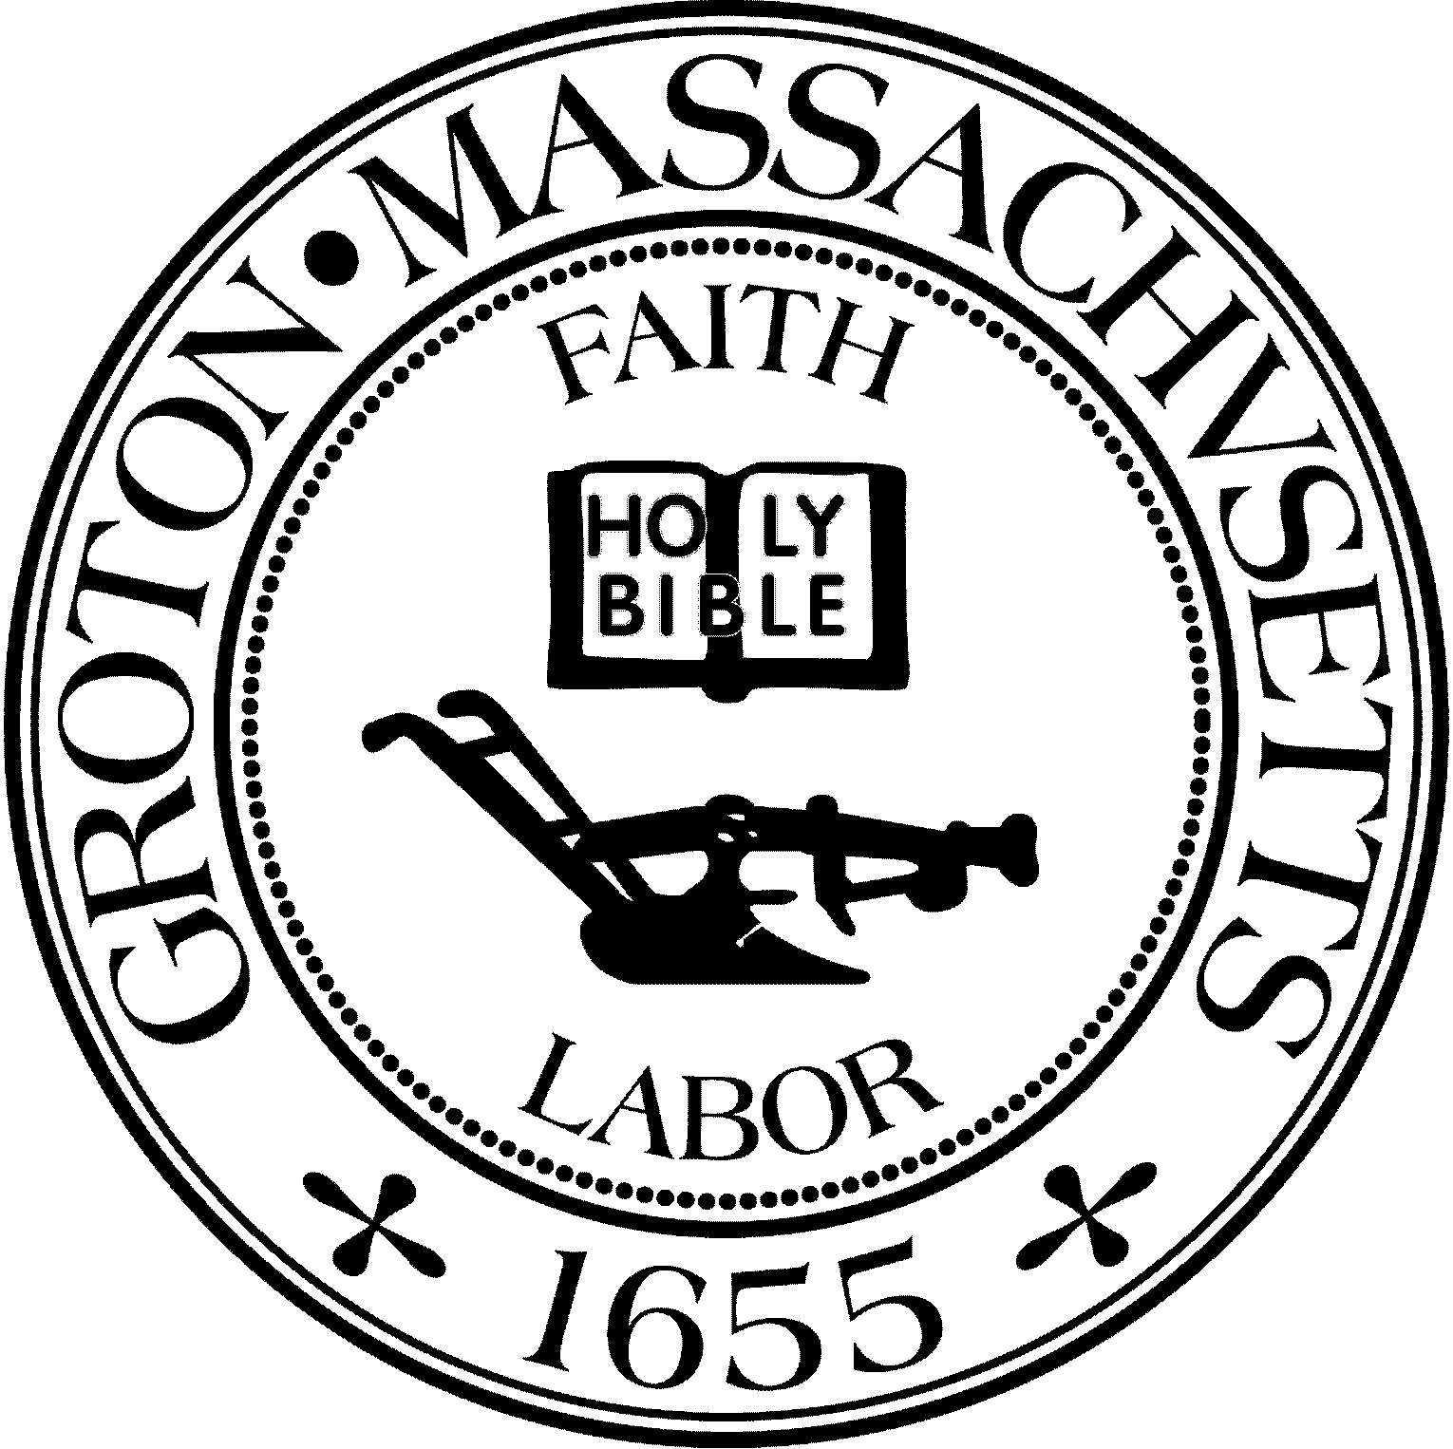
Town Manager
Mark W. Haddad

TOWN OF GROTON
173 Main Street
Groton, Massachusetts 01450-1237
Tel: (978) 448-1111
Fax: (978) 448-1115

Destination Groton Committee
Greg Sheldon, Chair
Jeff Gordon, Vice Chair
Mairi Elliot, Clerk
Julie Platt, Member
Joni Parker Roach, Member

Destination Groton Committee
Thursday July 20, 2023
Town Hall 6:30 pm - 8:00 pm
Minutes:
Present: Greg Sheldon, Jeff Gordon, Joni-Parker Roach, Julie Platt, Guests: Judy Anderson, Margot McWilliams, John Sopka, Phil Francisco Karen Chapman
1. Review and Approve Minutes:
A) June 22, 2023: Motioned by GSheldon, Seconded. By JGordon. Approved unanimously B) July 7, 2023: Motioned by Sheldon, Seconded by JGordon. Approved unanimously
2. Updates:
A. Regional Tourism Conference, November 1, 2023:
• GSheldon had a Zoom call with Rep. Margaret Scarsdale and Kate Fox, MOTT (Massachusetts
Office of Travel and Tourism) Director on July 17. Purpose of meeting was to update Ms. Fox on Destination Groton and Groton Hill Music Center in preparation of her attendance at November 1 Regional Conference
- The Destination Groton Gift Fund will be created to accept a $1000.00 donation each from
both North Central Chamber of Commerce and the GBA. GSheldon will represent DGC at the 7/31/2023 Selectboard Meeting to verify the creation of the Gift Fund.
- Conference Invitation List: GSheldon, JGordon plan to meet with Roy Nascimento and Melissa Fetterhoff regarding the Invitation List for the Regional Conference on Nov. 1, 2023.
• Clarification requested from guest John Sopka. Committee members updated him on the plans for a Regional Conference to be held at the Groton Inn for stakeholders in the region.
• Conference will be limited to 80 people in attendance due to size of room at Groton Inn.
D. Summer Newsletter: JPlatt created and emailed the Summer Newsletter using MailChimp and we have 99 subscribers on the mailing list. Fall newsletter to be discussed in mid-August. JPlatt to reach out to Elliot and photographer to focus on upcoming photo needs.
E. Master Plan Zoom Sessions:
DGC Committee members will represent at each of the topics to update Master Plan.
F. Resident Survey:
As of 7/20/23 there are 253 responses on Survey Monkey. JGordon is monitoring responses and the current results mention the need for small retail in town and traffic mitigation. 88% of respondents would support a regional effort to help solve these issues over the next 10 years. JGordon will end the survey on 9/15/2023 in order to analyze and record all comments.
G. Grant Writing Working Group:
MMcWilliams summarized the potential for 3 Grants that will be worthy of investigation and applying to: 250th America Celebration, naming Groton as a Massachusetts Cultural District and a grant from Freedoms Way.
MSinger will also prioritize a list of potential grants.
No results yet on “Commonwealth Places” application
Work continues on a Grant “Playbook” - creating a library of helpful descriptions, letters of support and documentation.
Collaboration with Mark Haddad, Town Manager is on the TO DO list.
PFrancsico asked if MRPC grant writer is available to help all Town organizations.
Answer: Yes, MRPC grant writer is available to all

3) MRPC Data Analysis Presentation from Ryan Doherty and Karen Chapman - MRPC
Discussion regarding the “Groton Hill Music Center Impact Study”:
RDoherty presented numerous informational slides regarding the impact of the Groton Hill Music Center on the town of Groton. The information presented represented the years 2022- projected 2027. DGC asked if information can be gathered from 2018-2027.
Slides included, but were not limited to: Population growth, Labor force, Age Distribution, Tax Revenue, Average Household Income, Retail expenditures, Household budget and more.
The impact results will be shared in the Destination Groton Strategic Plan in Fall 2023.
Discussion: JGordon stated the original group report created in 2020-2021 was aware of the impact of Groton Hill Music Ctr and one of many of their stated goals was to retain the affordability and charm of Groton. The group realized one way to help was to add to revenue stream for the town of Groton. There are assets and challenges. Can MRPC create a projection for development in town and Station Avenue development impact and increase in revenue for Groton. KChapman said yes.
JSopka suggested that DGC is too concerned with monetizing Groton. DGC should remain focused on Why are people coming to Groton, What are people doing during their visits to Groton, and How can we insure that activity happens in low impact ways. JSopka continued that zoning and parking are huge issues in Groton. JSopka is concerned Groton is not optimizing the parking areas we currently have in town.
DGC Committee members assured JSopka that these concerns are being addressed via the “Town Hall” meetings that were run by DGC in 2022, listening to concerns of residents and also by the online survey available now in 2023. JSopka’s concerns are noted.
MMcWilliams directed a Question to the group: how do we convert the visits to Groton into dollars for the Town? What other opportunities are available that can capture the dollars? PFrancisco commented: If we attract more people to Groton, current businesses will also benefit from increased growth and visitors.
Current neighborhoods/ business districts: West Groton, Four Corners, Groton Center, Mill Run area / Groton Farms.
GSheldon referred to a letter regarding the potential for $21 million in economic impact to the region when Groton Hill Music Center is fully operational. Growth needs to be analyzed and planned in response to economic demand and different business areas in Groton. This is a 10 year vision plan. It is important to DGC to enhance Groton and its infrastructure yet respect existing community and business areas.
JSopka: Would like to stop or reverse creating parking lots. Wants Groton Hill Music Ctr to open up their parking lot for public use.
JGordon: Extra revenue will solve many issues in Groton however we need more to help pay for it. There is very limited commercial space remaining in town.
GSheldon: DGC is trying to think, plan and address challenges. Sen. Cronin has noticed our needs and is trying to help with focused state aid. We will know more when the Massachusetts State budget for FY2024 has passed in the legislature.
Wrap Up: RDoherty will send the report shared at meeting to GSheldon via email.
JParker-Roach discussed merchandise samples from J&S Designs. T-shirt material is fine. Groton logo needs to be enlarged. Baseball cap color is fine and so is style. Logo is discussed and needs another sample and future approval.
PFrancisco/GSheldon would like DGC to meet with Sustainability Committee possible date could be Tuesday, August 25 at the Groton Center in West Groton. Time to be confirmed and finalized.
Meeting adjourned: 8:50pm
Respectfully submitted,
Julie S Platt
Member, Destination Groton
Action Items:
*JParker-Roach will have postcards printed with AlphaGraphics. *JParker-Roach to contact Yankee Magazine.
*Create talking points for postcards
*All Committee members to share survey link to social media pages both personal and professional.

