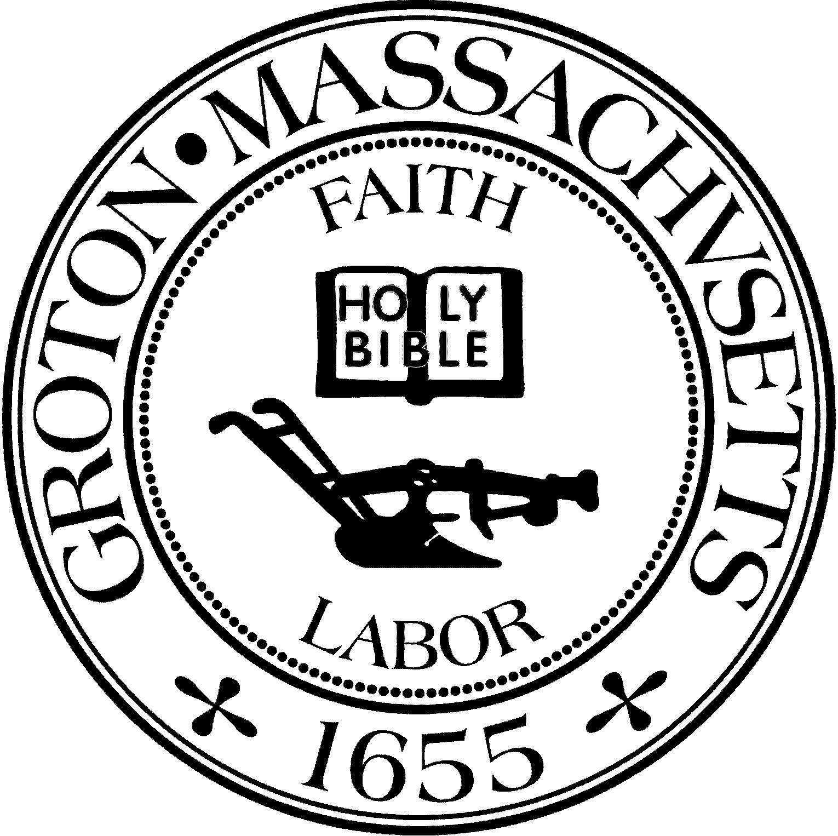
Town Manager
Mark W. Haddad

TOWN OF GROTON
173 Main Street
Groton, Massachusetts 01450-1237
Tel: (978) 448-1111
Fax: (978) 448-1115

Destination Groton Committee
Greg Sheldon, Chair
Jeff Gordon, Vice Chair
Mairi Elliot, Clerk
Julie Platt, Member
Joni Parker Roach, Member

Destination Groton Committee Meeting
Thursday July 6, 2023
Town Hall 6:30 pm - 8:00 pm
Minutes:
Present: Greg Sheldon, Mairi Elliot, Joni-Parker Roach, Julie Platt
Guests: Judy Anderson, Margo McWilliams

1. Review and Approve Minutes:
Clarifications/Questions from JPlatt:
A) Was video footage obtained from Riverfest?
• Yes: Video is ready. GSheldon would like to see narrative added to “set the scene”.
• An interview Marion Stoddart would be an important addition to our video archives.
B) Were the MRPC representatives present at the prior DGC meeting?
• No. Data analysis will be ready for 7/20/23 meeting.
C) Destination Groton meetings are now bi-weekly on Thursday, 6:30pm, Town Hall. Approval of 6/27/2023 minutes postponed until 7/20/23.

2. Updates:
A) Regional Tourism Conference, November 1, 2023:
- Rep. Margaret Scarsdale has secured Kate Fox, new MOTT (Massachusetts Office of Travel
and Tourism) Director to attend and speak.
- Roy Nascimento from North Central Chamber of Commerce would like an Invoice from the Town of. Groton for sponsorship of the conference.
- Groton Business Association is another sponsor.
- Conference will be limited to 80 people in attendance.
- Roy Nascimento and Melissa Fetterhoff will have input on stakeholders and interest.
B) Summer newsletter:
• Topics: Riverfest, Marion Stoddart, Destination Groton news, Survey prompt, Open Doors, Makers on the Road, Library Concerts
• Next newsletter will be early Labor Day
C) Post Card/Poster design:
• 5x7 size with a blurb
• Contact infö for all DGC members
• Needs a small narrative to describe who we are and our purpose
• Take a look at first advertisement in Nashoba Valley Living for ideas?
• POSTERS: Will develop 6 re-usable posters or for conference (clarification needed)
D) Merchandising update:
• JParker-Roach will review hat and t-shirt quality. JPlatt will send the logos to t-shirt maker
E) Resident Survey Ad (6 weeks through. summer):
An advertisement has been placed in the Groton Herald to ask residents to take the online survey through Labor Day.
F) WEBSITE: Needs SEO input - MElliot will contact Deb Buckley
G) MRPC Data Analysis at 7/20 meeting- important meeting. GSheldon hopes all will be in
attendance.
3. Grant Writing Working Group- Report from Margo McWilliams
- Met at the end of June.
- Working with a short term plan.
- Formal grant writer Molly Singer is on leave for 6-8 weeks. MRPC has grant writer assigned to us until December 2023.
- Working on a “playbook” to easily apply for grants.
- Plan to sit with MHaddad to sync and collaborate town needs.
- JAnderson: Can post a meeting if need to invite more collaborators.
- Group thinks it would be worthwhile to meet or DGC to meet with Town Committees we have not yet had opportunity to meet: for example: Historic Districts, Historical Commission, CPC, Conservation Trust and more.
- JAnderson: Can the Town manager announce grant news?
- Group will present a strategic plan to DGC on August 2 meeting.
- There is a healthy list of grant opportunities. See attached sub-group minutes.
4. FY 23 FINAL Budget to Town expenses/turnback:

Total: $12,700
Expenses:
Nashoba Valley Living: $ 875
GELD insert: $ 481.48
Alpha Graphics $ 126
Grotonfest Table: $ 75
Photographer: $ 750
Lowell Tourism Conference: $ 150
Logo Merchandise: $1500
Website Maintenance: $1500
Groton Inn deposit: $ 225
Printing: $ 650
Survey Ad (Groton Herald): $ 364.80
Total: $6697.28

Turn Back to Town: $6072.72

Assignments for 7/20/2023 meeting:
- 1) All DGC members to be sworn in
- 2) MElliott to contact Deb Buckley, contact Shaw’s buyer
- 3) JPlatt to send logos to J&S Designs. Write and create DG Summer Newsletter
- 4) JParker-Roach to contact Yankee Magazine, J&S Designs
- 5) GSHeldon to contact Roy Nascimento and Melissa Fetterhoff
- 6) ALL: Consider hours spent and find an online tracker? “Track it Forward” Time spent working for committee can be considered as matching dollars.
5. Adjournment 8:15pm

Attachment: Grant Writing Working Group
The Working Group is comprised of Joni Parker-Roach,
Margo McWilliams, other members of the DGC as warranted,
Molly Singer (MRPC professional Grant Writer), and other Town Officials depending on the specific grant.

The Working Group is targeting a series of potential grant opportunities that can be used well into next year. The objective is to have a generic narrative on the goals of Destination Groton and the Town of Groton that can be adapted to meet the specific needs and requirements of individual grants (from Infrastructure, Historic Preservation, Arts and Culture, Economic and Community Development, etc.).
The Working Group will collaborate with Town Officials, Committees, Boards, and the MRPC to identify Town needs and opportunities to improve, enhance and celebrate the Town we love.
Potential Grant Opportunities:
1) Infrastructure
- Traffic volume, noise, congestion, speed, rotary
- Parking on street, Trail sites, structured garage
- Sidewalks Townwide, Town Center
- Signage directional, historic homes, sites
- Transportation shuttle to Ayer and Lowell train stations
- Powerlines bury Main St (Old Ayer Rd- ChampneySt
- Monuments Historic statutes, observation sites, trails
- Gathering Space Pavilion at Station Ave Rail Trail
- Restrooms Town Center, Rail Trails
- Rest Areas benches, tables, educational plaques

2) Commercial Growth
- Development Retail Stores and Arts and Culture
- Town Center Main Street and Station Avenue
- Four Corners existing and potential
- West Groton existing and potential

3) Conservation and Preservation
Open Space
Farming
Historic Preservation

4) Arts and Culture
Fine Arts
Performing Arts
Cultural growth

5) Town Events
Existing events inventory and promote
Identify potential new events celebrations, commemorations
Working Group Minutes June 28 meeting:
Name | Organization
Molly Singer | MRPC Grant Writer
Margo Tyler-McWilliams | Grant Writing Working Group  Co-chair
Joni Parker-Roach | Grant Writing Working Group  Co-chair
Greg Sheldon | Grant Writing Working Group  Member  Chair, Destination Groton Committee
Karen Chapman | MRPC

Meeting Date 28 June 2023
Meeting Start 1:00 pm
Agenda:
Safe Streets Grant update- Margo/Molly
Subcommittee oversight and communication expectations- Margo
MRPC Grant Writing resources- Molly
Priority and Timeline discussion- All
Grant Opportunity - Greg

Meeting Minutes:
Safe Streets Grant update
• 2023 "Safe Streets" planning grant will not be pursued through the Destination Groton Grant Writing Working group. Safe Street grant funds will be awarded through the MRPC regional efforts.
Action (All)- Team to share any Groton Safe Street priorities that would be included in planning needs and will communicate to the MRPC-Groton Safe Streets team

Subcommittee oversight and communication expectations:
The Destination Groton Grant Writing Working Group will report into the Destination Groton Committee. The Working group will prepare a list of potential grants to prepare, timelines and resource requests. This will be presented to the Destination Groton Committee for review and approval. Once committee approval is secured, grant writing efforts will be initiated.

MRPC Grant Writing Resources
• Molly will be available as an MRPC Grant writer through June 30th. An RFP is expected to open July 8th for upcoming grant writng services.
Action(Greg)- Destination Groton Chair to get more details around RFP/bid completion dates
New Grant Opportunities
• Greg prepared and team reviewed the compiled list of grants and areas of focus. New grant opportunities have been added for consideration.
Action (Molly)- Review new grants and prepare synopsis of grant criteria and timing.
Action (Margo)- Identify grant LOI dates and add to the inventory
Action (Greg)- Email Molly details for any other grants mentioned during the call (MA 250th Anniversary, Johnny Appleseed, Federal AARPA, Mass Office of Travel and Tourism, PPP Funding, etc.)
Priority and Timeline discussion
• The working group will prepare a one year plan of grant opportunities and will target August 2nd for presentation to the Destination Groton Committee.
Action (Greg)- the Destination Committee Chair will work with the Town Manager and other partners to identify ongoing or planned grant efforts in other groups. Once overlapping grant request efforts have been consolidated, the Working group will remove competing efforts from the final grant recommendations.
Meeting Close- 1:57 pm
Next Meeting: Series to be scheduled by Margo

Working Group: Groton Grant Opportunities

Summary

Funding Name |  | Notes | Amounts |  | Dates
Complete Streets |  | Partially approved. Could be used for enhancing streets, sidewalks, etc as a method to reduce cars and inc peds/bike | $363,365 |  | N/A
MA Works Infra |  | Infrastructure projects that are near shovel ready. Altho pre- development is possible. Requires specifics about project | $50-$500K |  | June 2
MA Downtown Init |  | Technical Assistance only | $25,000 |  | June 2
Commonwealth Places |  | For social, economic development, enhance public accessibility, loves partnership. Can be used for signage, seaSng, sidewalks, beauSficaSon | $2500-50K 1:1 match req’d |  | Submit June 2, 2023
Rural & Small Town Dvlpt |  | Project based on nexus of housing, transportation, infrastructure. Esp good for low income issues. Housing Choice Community are automatically eligible | $25-50K |  | June 2
Safe Streets |  | Public safety measures, reduce fatalities. Could be used for signage or the like. Planning and implementation grants | $100K-10  M  20% cost share |  | July 30
Battlefield  Restoration |  | Need partnership. Only for historic restoration, not interpretation, etc. | $30-500K 1:1 match req’d |  | July 6
Urban Agenda |  | Small business development, TA and  community leadership | $100L |  | June 2
MA Preservation Funds |  | Predevelopment and development funds for historic restoration | $7500-100  K  1:1 match req’d |  | Last cycled closed 3/23
NEA Our Town |  | Placemaking. Coordinated downtown  redevelopment that includes art/culture. | $25-150K 1:1 match req’d |  | N/A

June 29, 2023
Ofc of Eco Dev | Strengthen Commonwealth communiSes; includes One Stop This includes the two below.  - Local infrastructure  - Towns and cities to revitalize underutilized properties |  |  | $163.1M
 |  |  |  | $96 M $16.6

Scenic America | Federal: pursuing solutions to bury utility infrastructure underground. Public Law No: 117-58) establishes a new $5 billion program to enhance the resilience of the electric grid (which includes undergrounding of power lines  Public Law No: 117-58 makes the undergrounding of utility wires an eligible expense in the $31.6 billion per year National Highway Performance Program when carried out in conjunction with a project already underway. | $5B  $31.6B
Mass  Downtown Initative | Regional libraries, birth centers, walkable downtowns: promote compact, walkable downtowns that have a vibrant mix of commercial and residenSal uses, cultural and recreaSonal ameniSes and access to public transportaSon | $600K
U.S. Dept of Energy  N/A | $2.3 billion formula grant program (going to states)designed to strengthen and modernize America’s power grid against wildfires, extreme weather, and other natural disasters exacerbated by the climate crisis | $459 million annually to States

Other 6/29/23
Shared Streets and Spaces MA | A range of community development project | $100-  500K
DOT Freedom’s  Way Partnership Grant Program | investments in the natural, cultural, and historical resources that enhance the sense of place within the Freedom’s Way NaSonal Heritage Area | $50K total for all grants:  $1500-  $2500  Max

