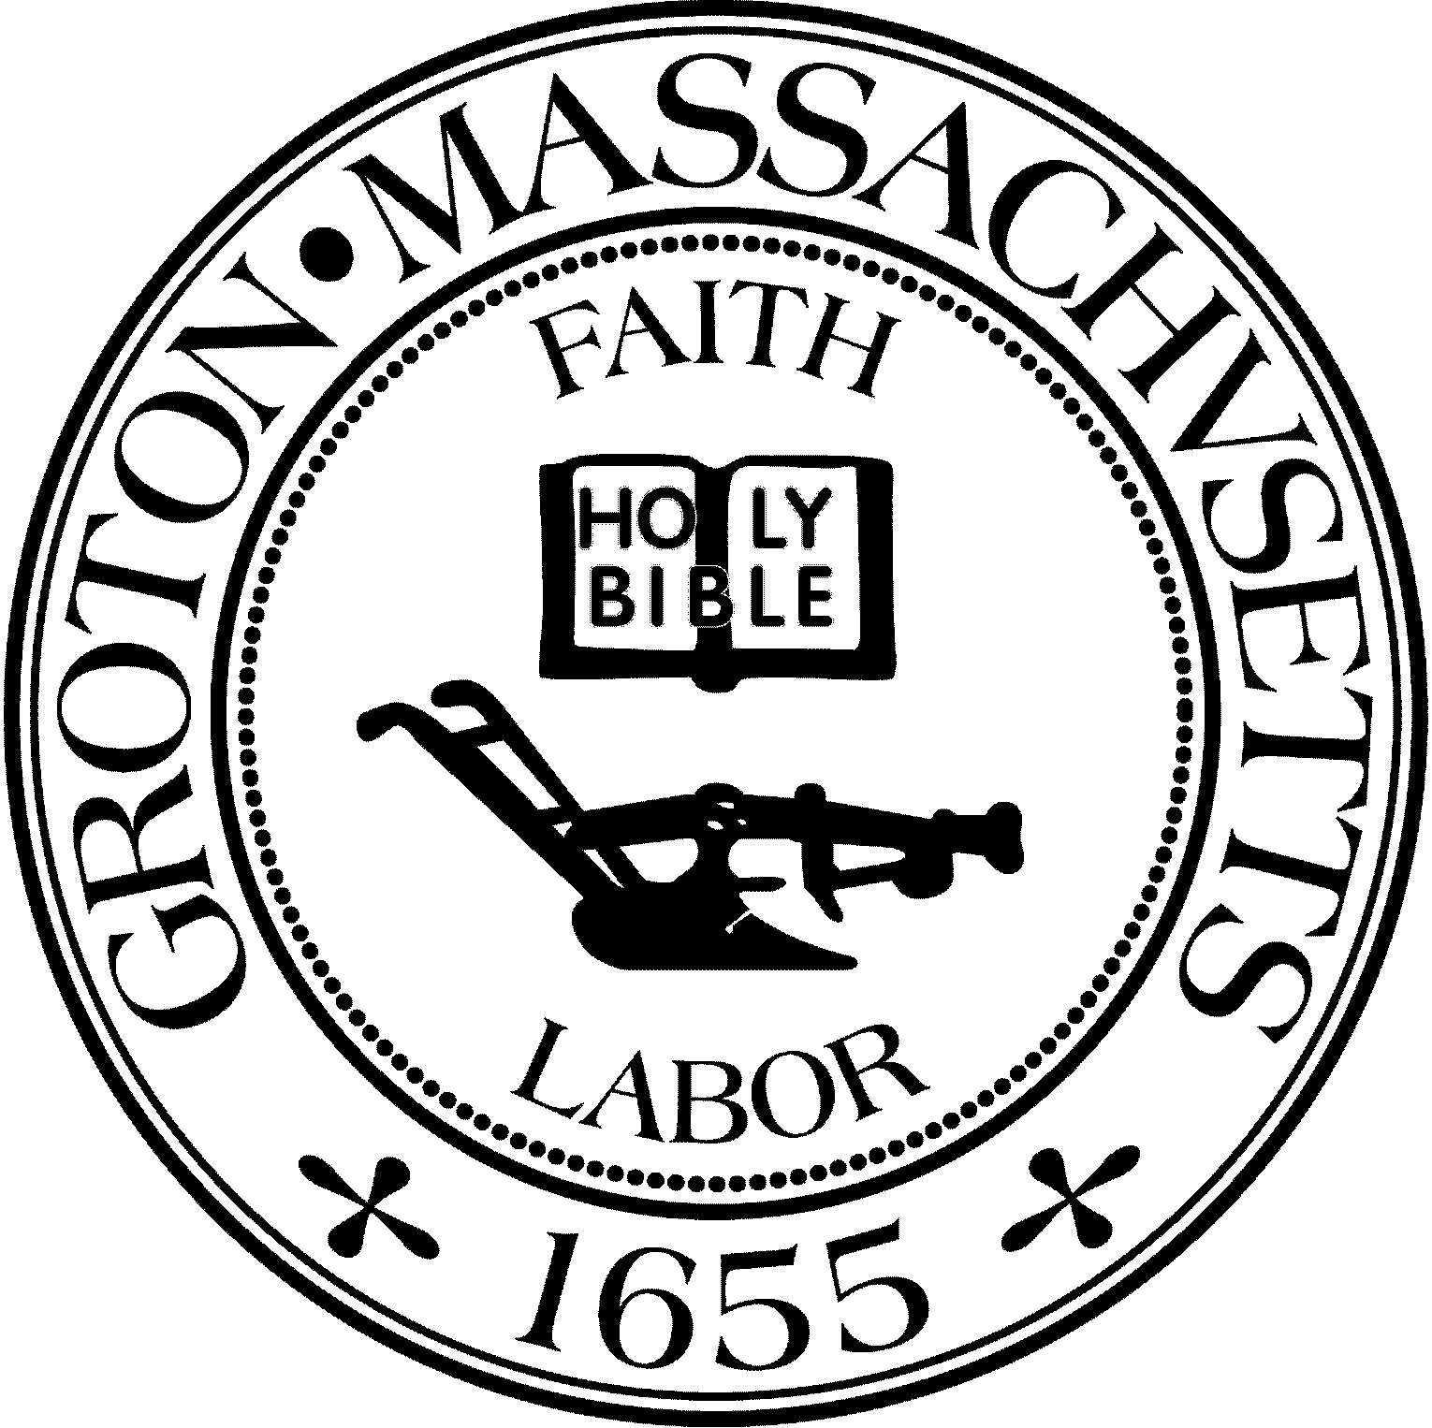
Town Manager
Mark W. Haddad

TOWN OF GROTON
173 Main Street
Groton, Massachusetts 01450-1237
Tel: (978) 448-1111
Fax: (978) 448-1115

Destination Groton Committee
Greg Sheldon, Chair
Jeff Gordon, Vice Chair
Mairi Elliot, Clerk
Julie Platt, Member
Joni Parker Roach, Member

Destination Groton Committee Meeting Minutes
Wednesday June 7, 2023
Town Hall, Lunchroom, First Floor 7-9 PM
Present: Greg Sheldon, Mairi Elliot, Jeff Gordon, Julie Platt
Guests: Phil Francisco, Margo McWilliams
1. Minutes from 4/27/23: Approved into the record: Motion by MElliot, 2nd by JGordon.
2. Commonwealth Places Grant submission: “Groton Gathering"
Discussion:
-This is a “One Stop” grant, DGC applied for $15,000.00 to engage in the planning process to create a Kiosk or Pavilion/Gathering spot/perhaps Public Restrooms at or near where the rail trail passes by the bottom of Station Ave. This will provide stimulus for Station Ave.
-The team of GSheldon, JParker-Roach, MMcWilliams and Molly Singer from MRPC wrote Ada submitted the grant in 1 week.
- JParker-Roach has contacted architect Tim Hess regarding his work on a previous plan for Station Ave in 2014. He is willing to revisit the 2014 Station Ave plan and help with a site plan./schematic plan for the “Groton Gathering” if the One Stop Grant is awarded DGC will most likely hear back later in August.
Next Steps:
-Discuss Grant research/submission plan and work group
-DGC objective with grants to revise the vision for grants to the potential vs “need”
-Review possible grants to see which might be a good fit for Groton
-MElliot suggests we collaborate with existing Town Committees i.e. “Complete Streets Committee” or “Sustainability Committee” to base applications on previous research or to insure there is no overlap
-Report from MRPC data will hopefully aide in targeting the potential needs in Groton
-GSheldon confirmed to JGordon that Mark Haddad also knows where the needs are in Groton
-PFrancisco questioned if grant funds can be re-purposed into investing in small business?
-Brainstorming on creating a draw to the area near the Rail Trail with an Ice Cream truck or Twisted Pickle food truck.
-Statistic of 3.995 bike riders over the 4 day 2019 Memorial Day weekend via rail trail through Groton.
-MMcWilliams stated that 5 letters of support are an excellent start. We need to keep building our “library of support”.
ACTION: Grant Task Force will be comprised of Molly Singer, MMcWilliams, JParker-Roach, GSheldon. Other DGC members will contribute on an as needed basis.
3. Regional Tourism conference update
-MHaddad is the contact and signator for the contract between The Groton Inn and DGC
-The Conference has 2 sponsors so far contributing $1000.00 each: Groton Business Association and North Central Massachusetts Chamber (led by Roy Nascimento).
-GSheldon has asked Representative Margaret Scarsdale to invite new Director of MOTT
-There will be a total of 80 seats available:
Current thought for invitees:
33 Towns with 2 town representatives each = 66 people Invited Dignitaries, Town of Groton staff = 14 people
-Have invites been sent to and confirmed from Reps Danillo Sena and Rep. Margaret Scarsdale?
-Senator John Cronin’s office needs an invite and confirmation from him
-Save the Date and Invite will come from Roy Nascimento and Melissa Fetterhoff -Checks will be payable to the Town of Groton
-Discussion: Registration logistics - can “EventBrite” be used for registration? Who needs to be invited? Town Planners? Economic Development Directors?
Do smaller towns need 2 representatives vs. larger towns and small cities?
-Idea to send the “CEO” of each of the 33 towns to invite 2 representatives from their town who will be able to engage in the ideas of tourism/development for their town/region.
-MMcWilliams suggested we capture what the Town of Groton is underwriting: i.e a “percentage of the conference”
-Agreed that RNascimento and MFetterhoff can have a more informed conversation with us/each other regarding appropriate delegations or invitees from town to town.
4. Destination Groton Strategic Plan: will be written for OCTOBER Town Mtg Outline:
Executive Summary
(Roadmap for Groton and execution PLAN)
Discussion: DGC will move items on the plan forward. A good example may be “to work with he Sustainability Committee to create a Dark Skies initiative in Groton”. DGC will also write a formal letter to the Planning Board to express interest in the next Master Plan which gets underway this month.
Conclusion (to be written)
Chapter 1.
Chapter 2.
Chapter 3.
(These chapters will come from the original report)
Destination Groton: Vision, Goals, and Objective Community Engagement Groton
Challenges and Opportunities
Chapter 4. Enjoy the Experience
(Discusses the website and website development and newsletter)
Chapter 5. Forming Strategic Regional Partners Chapter 6. Economic and Community Data Analysis (This is where the data from the MRPC narrative will be shared)
Chapter 7. Ten Year Strategic Plan
5. Other Issues:
FY23 Budget: DGC has money available to spend and also return to the Town of Groton.
Return: $5000.00 due to obtaining a grant for a Grant Writer
Spend: JPlatt to look in to contracting landscape photographer (possible events too): Kirsta Davey
JPlatt & JParker-Roach to look into T-shirt vendors for Groton: Enjoy the Experience shirts, caps
MElliot to look into what needs to happen to trademark the new logo: legal and costs
$150.00 for 2 attendees (JPlatt, JParker-Roach) to Greater Merrimack Valley Conference
?? To research a Consultant for Cultural Grant writing
Events:
MElliot to attend Riverfest: 6/11 with AJ Peckonis for vide JPlatt and JParker-Roach to attend 6/13
Juneteenth: 6/18 GHMC (interview/video) Attendee?
6. Adjournment: 8:59pm: Motion JGordon, MElliot 2nd

