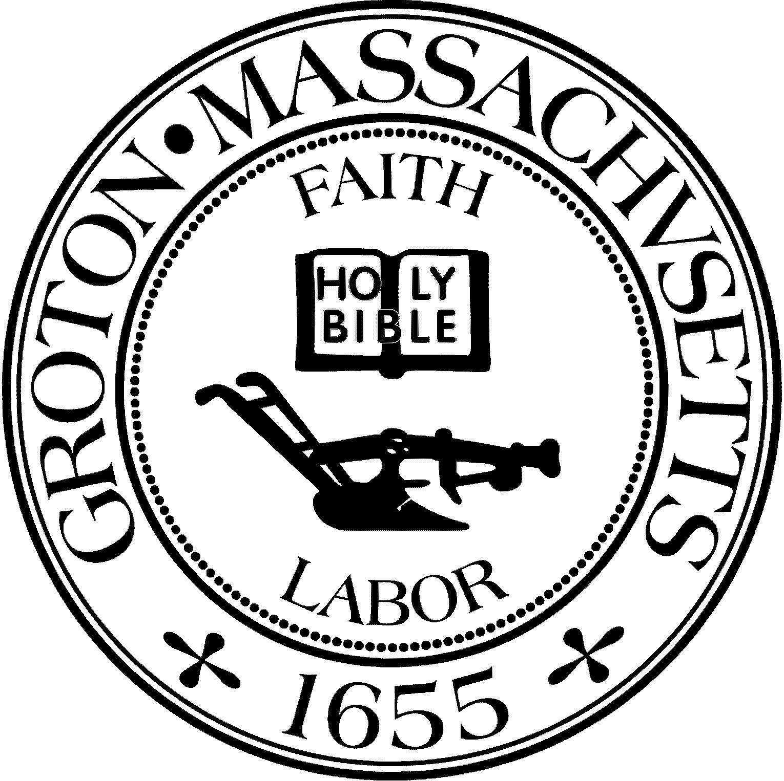
Town Manager
Mark W. Haddad

TOWN OF GROTON
173 Main Street
Groton, Massachusetts 01450-1237
Tel: (978) 448-1111
Fax: (978) 448-1115

Destination Groton Committee
Greg Sheldon, Chair
Jeff Gordon, Vice Chair
Mairi Elliot, Clerk
Julie Platt, Member
Joni Parker Roach, Member

Destination Groton Committee Meeting Thursday April 27, 2023
First Floor Meeting Room Groton Town Hall 2pm - 4 PM
Minutes
Present: Greg Sheldon, Jeff Gordon, Joni Parker-Roach, Julie Platt, Mairi Elliott,
Judy Anderson, Phil Francisco
Guests: Melissa Fetterhoff and Roy Nascimento
1. Review Town Meeting Article 8 Presentation
-Discussion regarding why should we ask for $15K
-Judy A suggests emphasis on benefits we are finding for the town i.e. improved infrastructure. -Joni PR suggests to mention how the money will be used and tied together with matching funds -All reiterate we are still just in the beginning phases.
-ACTION: All please review the power point Greg S will send around for Town Meeting and comment prior to meeting
2. Project Updates:
-Newsletter: Julie P sent the draft and all reviewed. Helpful tips to finish the newsletter include: Add a dividing line between each section. Tweak the graphics and wording. Add a section regarding the Groton Visitor Center and link to web address. Add a link to the DGC video that was created by Mairi E and AJ.
-State Cultural District Formation/Application: Joni PR would like to form a coalition of stakeholders to include Hanaku Brass (sp?) from the Mass Cultural Council. Local people in town have shown interest: Pat PR, Julie P, Local Cultural Council members.
Applications are being taken on an ongoing basis and earliest Groton could be reviewed is 2025. Idea is that the area to be designated as a Cultural District is from Groton School to Lawrence Academy and Main St. area. If/When we qualify we ill receive $15,0000/year for cultural events. -250th U.S. Anniversary 2025: Joni PR is filling out the application for Groton to be a key part of the celebrations. Applications to be filed through Sen. Kennedy in Lowell.
-Small Retail Initiative: Greg/Jeff are asking the questions what are we doing as a town to encourage small retail to find locations to begin/continue/expand their business here in town? Plan: Meet with Takaski Tada and Town Manager Mark Haddad about possible incentives. Phil F reminded us not to forget about all business areas of Groton: 4 Corners area and West Groton, Mill Run Plaza.
3. Regional Tourism Conference: Co-Chairs Melissa Fetterhoff and Roy Nascimento Organize Planning Committee
This conference will be focused on the region between Greater Fitchburg and Lowell, where Groton is located.
Discussion was focused around the time of day for the conference and how to best utilized the assets that Groton has such as the Groton Inn and Groton Hill Music Center.
Who is the audience? Stakeholders, venues, local business, regional state representation, possibility of Governor Maura Healey?
Work of conference: Network, Discussion attractions, branding, strategic partners, general tourism issues.
Keynote speaker: State Representative Lori Trahan (possible Gov. Healey?)
Roy N: Suggested tour of GHMC either first or last for audience to opt into tour.
Melissa F: If this occurs on a workday, business people will want to get to work- entire day may not be possible.
Roy N: Breakfast meeting with speakers.
Jeff G suggested we create an outline of the meeting to move forward.
Timing: 8am-11:00am, Date in November TBD
-Welcomes- Selectboard Chair, Town Manager Mark Haddad
-Speaker 1: Roy N,
-Speaker 2: Melissa F
-Speaker 3: Kieko Orall
-Speaker 4: Keynote Lori Trahan
Limit speakers to 15 minute presentation and short Question & Answer
-Speakers will point their presentations toward the topics we would like to be covered
-Judy A/Phil F suggested getting Lisa Fiorentino to have a 5-10 minute visual presentation re: Groton Hill Music and the outreach to the over 89 local communities which is also a large part of their organization beyond just the concert hall.
-TOUR of Groton Hill Music is optional - Participants will drive on own to venue- then depart or back to Groton Inn to join Networking session
Networking session (ongoing after conference)
Discussion regarding if day should/could be longer. Would like to see connections being made and opportunity to start dialogue with others. Will the conference be invite only? Registrations can be handled by the North Central Chamber or Nashoba Valley Chamber (or both?)
What are goals of conference for Destination Groton?
-We want this to be informational, perhaps create a Regional Advisory Group to have a Listening session. We want to create a survey asking what others may be looking for / need from regional and regional leadership. Looking for people to get more involved in the overall regional partnership idea.
Budget: Breakfast food number needs to be updated from the Groton Inn. Large Room Rental. Nametags, charts, handouts, signage? Will there be a charge for guests? Discussion regarding how much. Range of $25 - $40 discussed. Tour of Groton Hill MC will be free.
ACTION: Joni PR to speak with Groton Inn to ask about breakfast buffet costs.
Maximum attendance will be 70 as meeting room at Groton Inn capacity is 80.
Invite and insure there is room for State Reps/DGC members and organizers.
Conference to be targeted at local businesses, influencers, Chambers of Commerce, MRPC, Groton School, Lawrence Academy, Economic Development Directors, regional lodging, dining, attractions.
Melissa F: Suggests there is overlap between North Central and Nashoba Chambers of Commerce. Roy N has lots of great data and will speak / make presentation. Perhaps Melissa F can lead a thought or conversation starter workshop for 15 minutes. (Icebreaker? Brain break?)
Suggested dates: Wednesday November 1, Wednesday November 8, Tuesday November 14. All agreed that Wednesday, November 14 seemed like a good date after election season and the Veterans Day holiday week.
ACTION: Joni PR to check with the Groton Inn.
Meeting adjourned at 3:59pm.
Respectfully submitted, Julie S. Platt

