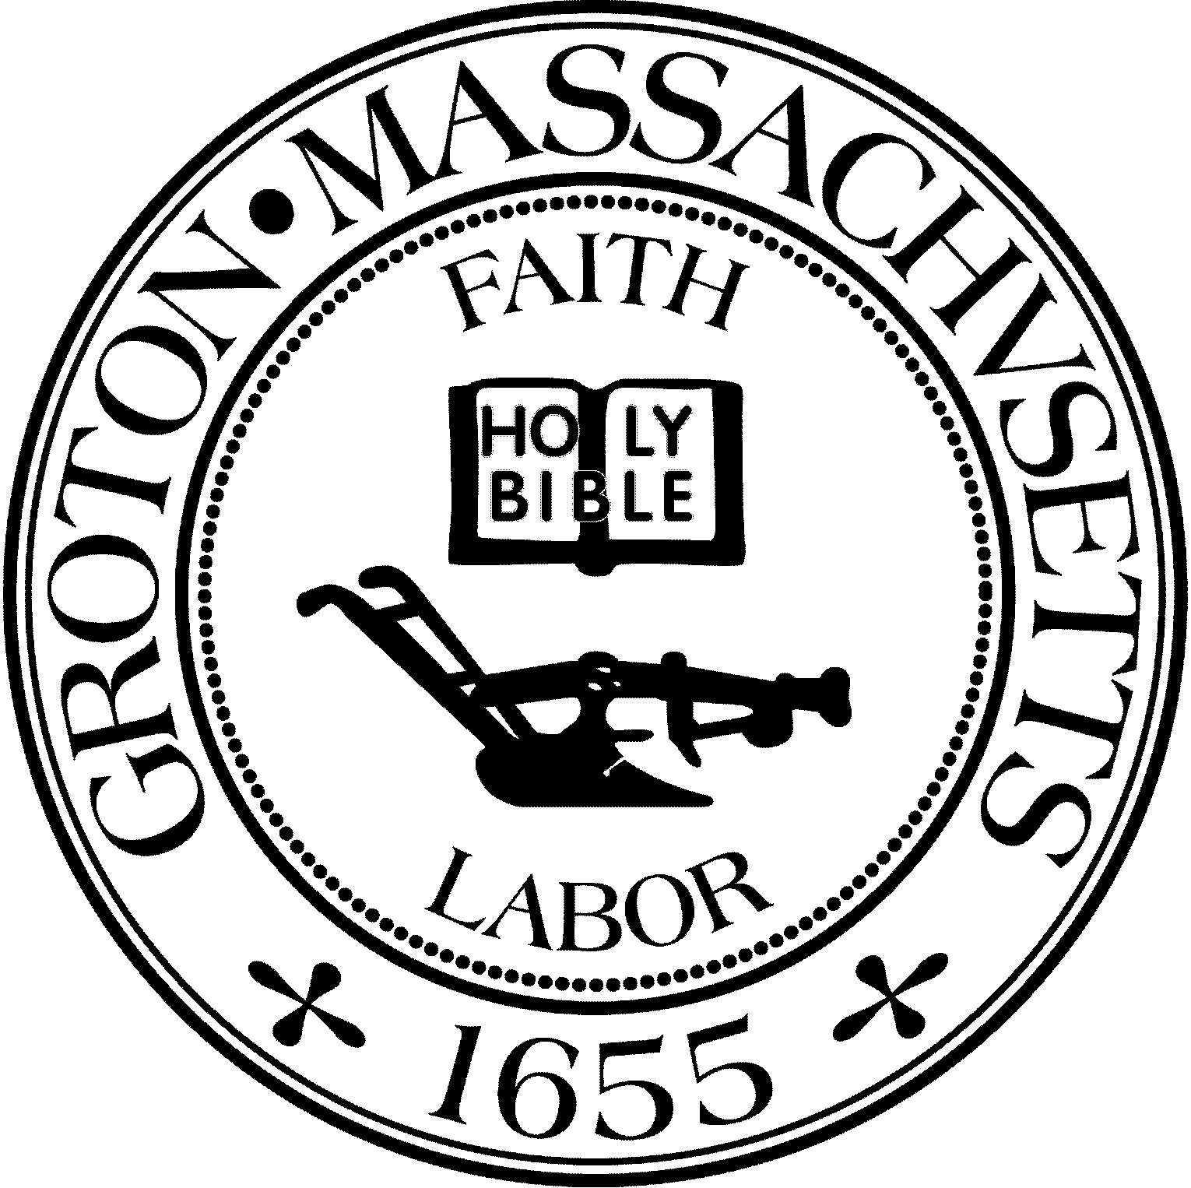
Town Manager
Mark W. Haddad

TOWN OF GROTON
173 Main Street
Groton, Massachusetts 01450-1237
Tel: (978) 448-1111
Fax: (978) 448-1115

Destination Groton Committee
Greg Sheldon, Chair
Jeff Gordon, Vice Chair
Mairi Elliot, Clerk
Julie Platt, Member
Joni Parker Roach, Member

Destination Groton Committee Meeting Minutes March 2, 2023
Present: Greg Sheldon, Joni Parker-Roach, Jeff Gordon, Julie S Platt Absent: Mairi Elliott
Guests: Judy Anderson, Phil Francisco
1. Review and approve minutes:
MElliott is absent, JPlatt will take notes for today’s meeting.
2. Discuss Grant Writer Scope of Work: advertise, interview
-GSheldon states we are sending out a request for hiring a grant writer through Mark Haddad, town manager. JPlatt will receive the resumes and report to Chair GSheldon and DG Committee. -Grant writer will identify and write grants for appropriate funding sources
-Discussion regarding original thought vs. Chat GPT
3. Discuss Website “Partnership” Plan
-Committee discussed what “partnership” means when people sign up on the website. What does partnership mean? Listing on the website free of charge? What can be monetized by Destination Groton? Is there overlap with Groton Business Association and Groton Visitor Center?
JGordon shared a list of possibilities for Partnerships with Destination Groton:
*Collaboration Partners*:
Local & Regional Chambers / Local & Regional Tourism Groups & Organizations / Local & Regional Groups: GBA Family of Grotonfest Events, Lowell Festivals, NOA, Groton Hill Music, Groton Visitor Center etc.
*Publication Partners*:
Nashoba Publication, Lowell Sun, Groton Herald etc
*Backlink Partners:* Everyone who chooses to partner with us
*Monetizing Partners*: Supporters
*Paid Service Partners*: Printed advertising or online paid advertising.
-GSheldon states “we are not in the monetizing business”. Maybe we will promote Destination Groton by selling hats/ t-shirts / other items at events however we are not aiming for profit all monies go back to the Town of Groton.
-PFrancisco suggests to allow cross-links, as it will benefit Destination Groton website, and wonders about DGC will handle partners from out of town?
-JPlatt wants to make sure the relationships between GBA, GVC and Destination Groton are clear.
-JGordon declares that Destination Groton should remain neutral / agnostic and that DG appeals to a higher level.
-JPlatt- Would like there to be a cross-marketing plan that supports efforts between GVC, DG and GBA activities and promotions.
-PFrancisco asks if Deb Buckley, DG web designer, is tracking where the inbound online traffic is coming from on the website - are people clicking onto DG website after visiting one of our partners?
-GSheldon made a Declaration: Any organization that a would like to be a Partner with Destination Groton must have a reciprocal link on their website Destination Groton homepage. -This can be as simple as a hotlink attached to the Destination Groton logo.
ACTION: JParker-Roach will call Nashoba Paddler. Other entities listed on the website need to be called: Groton Inn, Groton Hill Music, Galleries, Businesses etc.

4. Review NMCOG Tourism Working Group Zoom call from 2/27/23:
Some key take aways:
-Arrivalist is a tracker for visitors - could be helpful to Groton to track visitors to Groton Inn or Groton Hill Music. OR we could ask Groton Inn and Groton Hill Music if they track visitors by zip code.
-June 13 (Tuesday) there will be a tourism conference organized by the Greater Merrimack Valley Chamber of Commerce. One or more of DGC should plan to attend.
5. Discuss MRPC Scope of Services: tasks and deliverables:
ACTION: All REVIEW and ADD TO/SUBTRACT from this list of possible ways funding can be used for our purposes. Primarily information that may be HARD for us to obtain:
Tourism and Community Development
Traffic Survey- where? Rt. 40 or Hollis St. intersections Infrastructure needs
Historic Preservation
Potential Commercial Development- categorize
Town /Regional Demographics
Arrivalist data (Total Visitors to Groton/Region) Economic Profile (Meal tax/Room tax)
Groton Weddings/Diners/Arts/Culture/other?
Statewide Tourism Data
Others?
6. Article 8 Budget Request at Town Meeting: Current draft: (proposed changes in parentheses)
Article 8: Funding for Destination Groton Committee
To see if the Town will vote to raise and appropriate, transfer from available funds, and/ or borrow pursuant to any applicable statute, a sum or sums of money, to be expended by the Town Manager in Fiscal Year 2024 and thereafter, for the purpose of providing funding for the Destination Groton Committee to carry out the Charge of the Committee and all costs associated and related thereto, or to take any other action relative thereto.
Destination Groton Committee
Select Board: Finance Committee:
Summary: The purpose of this Article is to provide $30,000 in funding for the Destination Groton Committee to carry out its charge, which is to pursue a course of action intended to engage all Town stakeholders, including the business and non-profit communities, Town leaders, (Federal and State officials,) and Town residents in a series of public information forums, (economic research and data analysis) in order to prepare (a 10 year strategic plan) for an increase in visitors to town while at the same time work to preserve its rural small-town charm. A portion of this funding will be used to hire consultants to assist in procuring grant funding to create tourism programing, strategic marketing, infrastructure improvements and regional transportation mitigation.
The proposed breakdown of funds: -Grants 10K in grant writer -Marketing - what kinds?
-Conference - event space rental / expenses
JPlatt suggested since this is a long-term growth strategy maybe talk to the Chair of the Finance Committee?
7. Discuss future DGC projects:
Town Survey (rank responses/percentage of support):
-JPlatt noted the survey is posted on Groton Facebook page. JGordon has the response data on Survey Monkey so far. 76 responses in one week. JGordon will share results so far with GSHeldon. JPlatt said the survey needs to be promoted more than once if we desire a larger base of respondents.
ACTION: JGordon to get in touch with MElliott to promote survey online.
-Strategic Plan (tie into MRPC data)
GSheldon has an outline for the DGC Strategic Plan report and most is straightforward.
Areas we will need to obtain more information:
Economic and Community Development Data Analysis- understand our market and projected market. With a working group we will need to create a 10 year strategic blueprint for Groton. Side discussion RE: Cultivating a walkable downtown by creating incentives for businesses to open in Groton. JGordon believes we need “buy in” from town and residents on a vision for a business district, specifically Station Avenue.
TO DO: Establish a Working Group.
-Newsletter (Quarterly):
GSheldon asks who is interested in working on Quarterly newsletter?
JPlatt says YES, JGordon states NO.
JPlatt would like to research different online delivery programs: Constant Contact, Mail Chimp - all will probably charge a rate for the service.
Topics could include- Overview of DGC / website unveiling /In the News / Upcoming Events
-Annual Regional Tourism Conference (NMCoG 6/13/23)
Discuss hosting a conference that showcases Groton Hill and Groton as Destination. GSheldon presented a possible outline:
Date:
Location:
Agenda:
Keynote speaker (s): Tour of Groton: Evening event:
Discussion: Rep. Lori Trahan
representation, including Gov. Healy and Lt. Gov Driscoll. Breakout sessions - who? Should we hire an Event Planner? Ideas for dates include a weekday in October - perhaps a Thursday.
ACTION: GSheldon and JGordon to invite Melissa Fetterolf /Nashoba Valley Chamber of Commerce and Roy Nascimento/ North Central Chamber of Commerce to co-chair the Conference. JParker-Roach to contact Groton Inn to ask about capacity for a conference and breakout rooms and dates.
Mid October 2023
Groton Inn
Breakout Sessions (TBD)
Governor Healy, Congresswoman Trahan, Lisa Fiorentino, others? Historic Sites and Arts & Culture -
Groton Hill Music Center: Vista Philharmonic Orchestra agreed to be a speaker. DGC to invite all of the State 250th Lexington/Concord/Groton (2025)
From State Rep. Margaret Scarsdale’s newsletter:
Plans are already underway for the celebration of this 250th anniversary of the American Revolution with events taking place in Massachusetts in 2025 and 2026. Senator Ed Kennedy is co-chair of the Special Commission on 250th Anniversary Celebration of the American Revolution. Are you or your local organization interested in being part of the festivities? If so, we invite you to make your interest known to the Commission
-All agree that Groton should participate in these festivities.
ACTION: Need to follow up by showing interest. JParker Roach will inquire with a Concord contact.
8. Set weekly date/time for DGC meetings: Thursdays 2-4pm
-Questions regarding meetings
JAnderson: Should size of DGC increase as committee does more so that work can be spread out? Is DGC meeting too frequently so that things cannot get done in between meetings? PFrancisco: Is there any thought about the sustainability of DGC so that burn out doesn’t happen? Any thoughts about inviting others to the committee?
9. Adjournment 4:25pm

