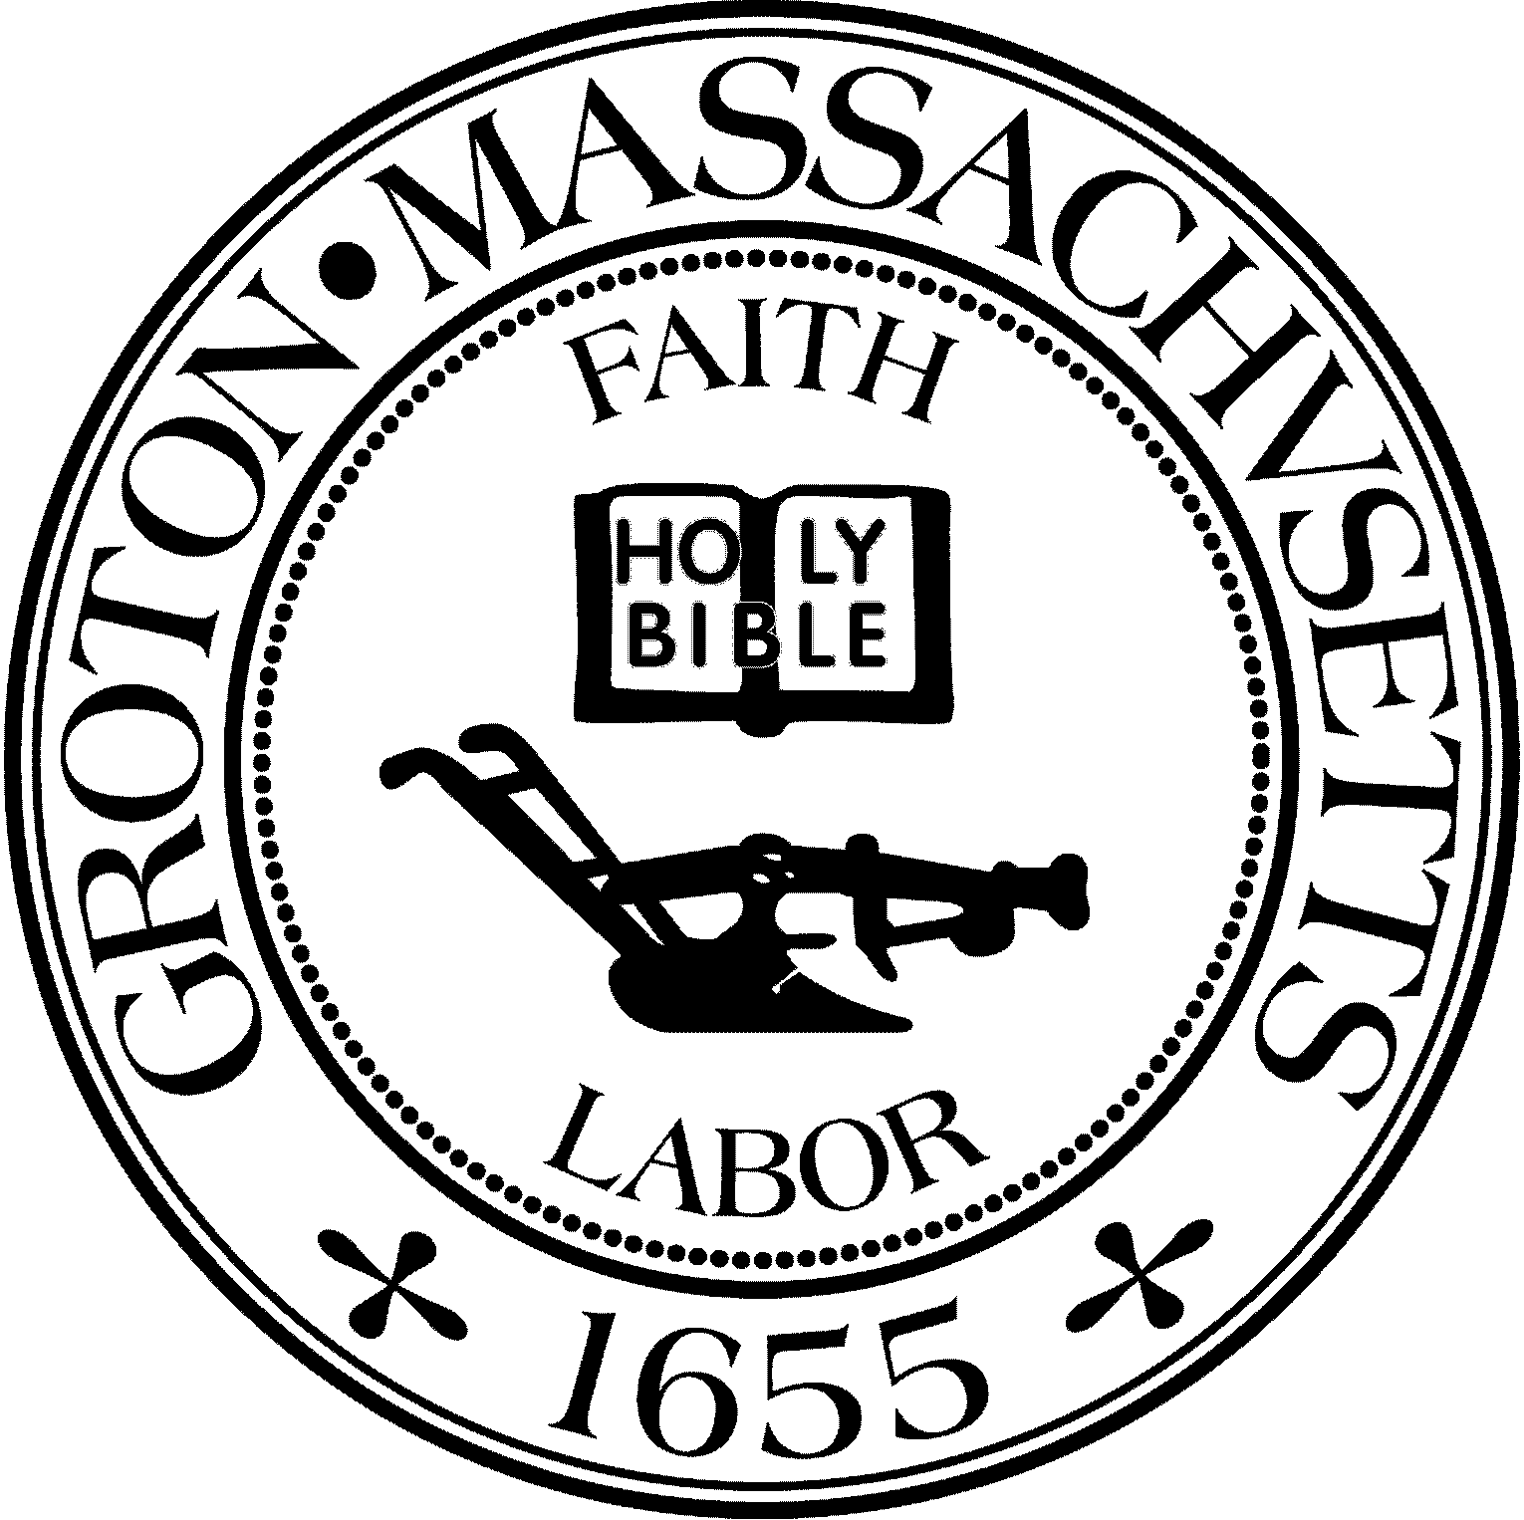
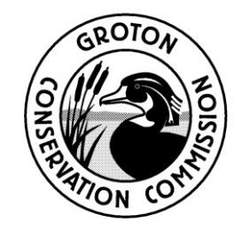
TOWN OF GROTON
Conservation Commission
173 Main St
Groton, MA 01450
(978)448-1106
Fax: 978-448-1113
conservation@grotonma.gov

Conservation Commission Meeting Minutes
Tuesday, May 15, 2023 at 6:30 PM

Held virtually on Zoom

Present: Eileen McHugh, Chair; Larry Hurley, Vice Chair, Bruce Easom, Clerk; Olin Lathrop; John Smigelski
Absent: Peter Morrison; Alison Hamilton
Others Present: Nikolis Gualco, Conservation Administrator

E. McHugh called the meeting to order at 6:30PM

Topic: Consider accepting a deed to the Casella Property, located off of Nashua Road (Parcel 227-117)

Upon a motion by O. Lathrop, seconded by B. Easom, it was:
VOTED to accept a deed to the Casella Property, as presented, and authorize the Chair to execute a certificate of approval for this vote.
The motion carried by a roll call vote: (YES – LH, BE, JS, OL, EM)

Adjournment (6:32 PM)

Upon a motion by O. Lathrop, seconded by L. Hurley, it was:
VOTED to adjourn the public meeting.
The motion carried by a roll call vote: (YES – LH, BE, JS, OL, EM)

Minutes Approved: May 23, 2023

