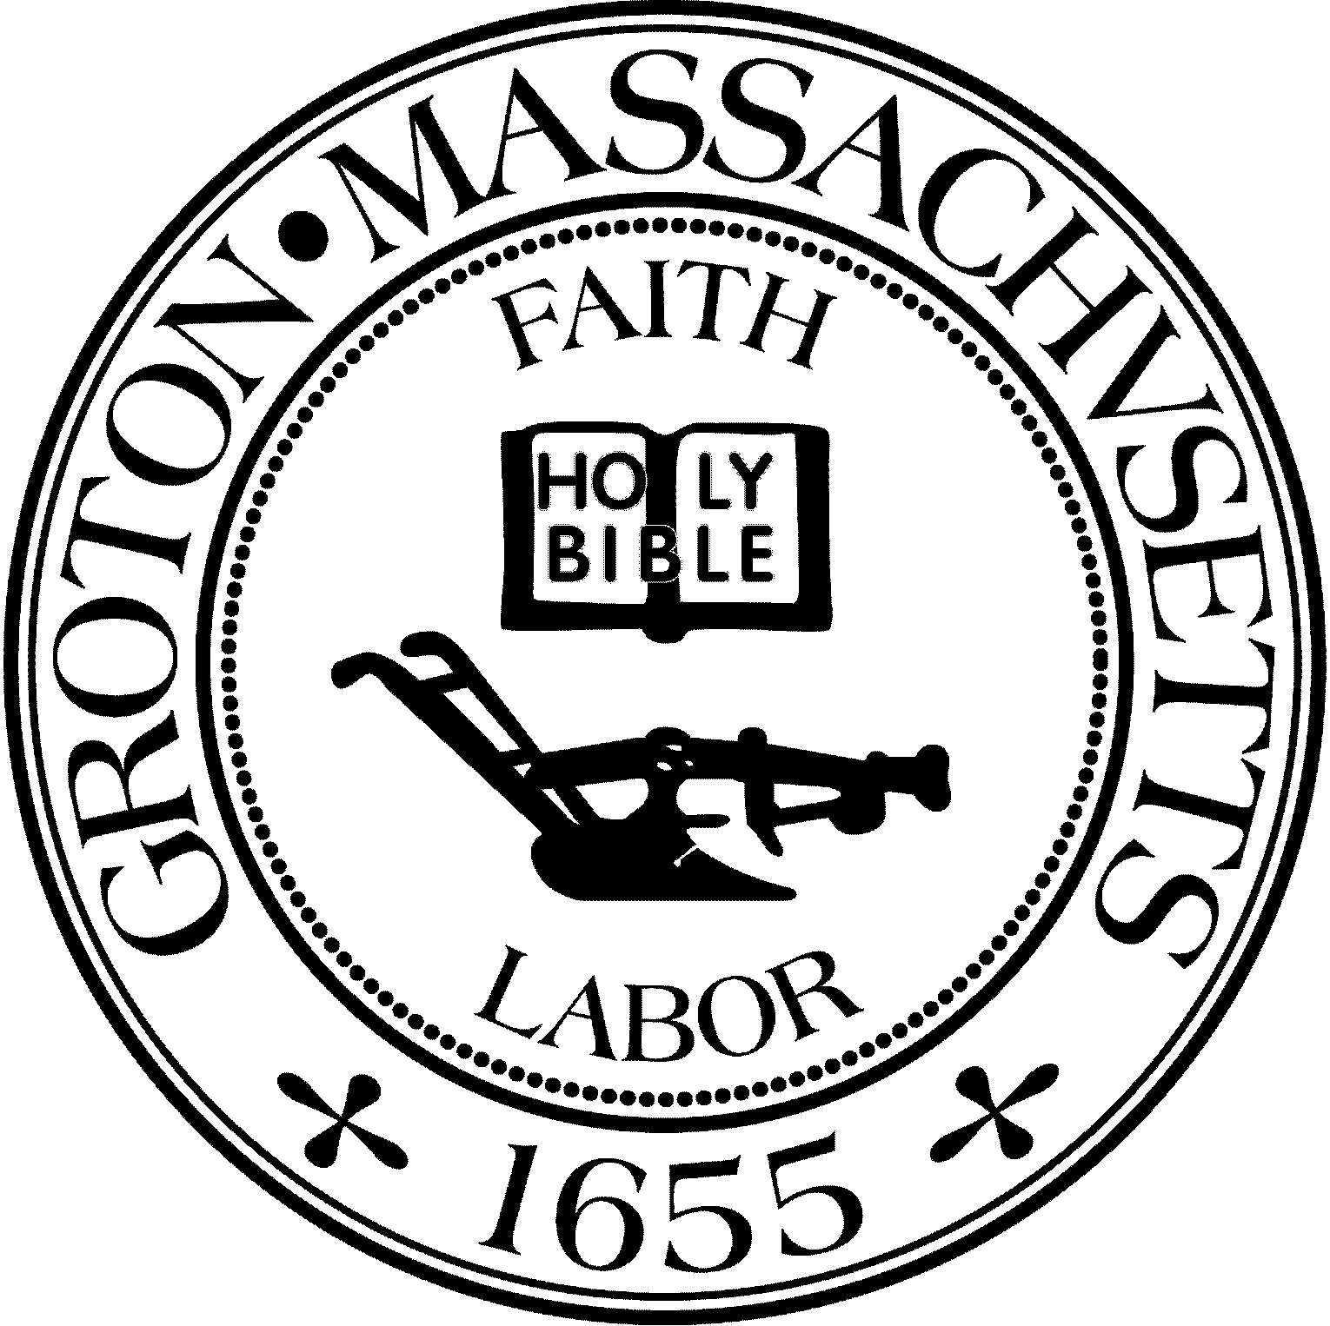
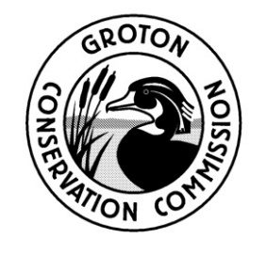
TOWN OF GROTON
Conservation Commission
173 Main St
Groton, MA 01450
(978)448-1106
Fax: 978-448-1113
conservation@grotonma.gov

Groton Conservation Commission
Wednesday, January 11, 2023 at 7:00 PM
Groton Senior Center
163 West Main Street, Groton, MA

Agenda

1. Attend the Public Hearing on Broadmeadow Road improvements.

Note: A quorum of the Conservation Commission was not reached

