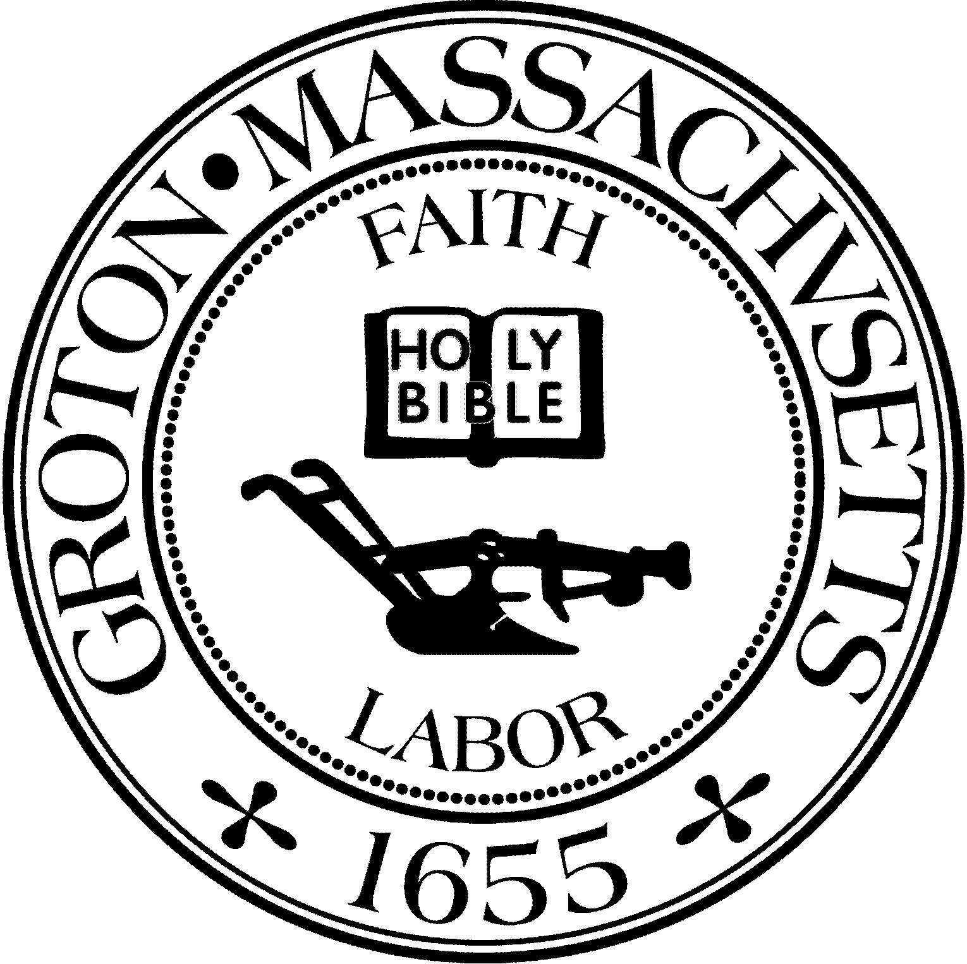
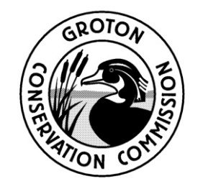
TOWN OF GROTON
Conservation Commission
173 Main St
Groton, MA 01450
(978)448-1106
Fax: 978-448-1113
conservation@grotonma.gov

Conservation Commission Meeting

Tuesday, February 17, 2022 at 7:00 PM
Victual Meeting – Zoom

Present: Larry Hurley, Chairmen; Alison Hamilton, Clerk Olin Lathrop, John Smigelski, Peter Morrison, Eileen McHugh, Bruce Easom,

Absent:
Others Present: Nikolis Gualco, Conservation Administrator, Mark Haddad, Town Manager\

7:00 PM L. Hurley called the meeting to order.
Members of the Groton Conservation Commission participated in the annual Groton Conservation Forum and discussed conservation issues and priorities across the Town.

The meeting adjourned at the conclusion of the Forum at 9:12 p.m.

Minutes Approved: March 8, 2022

