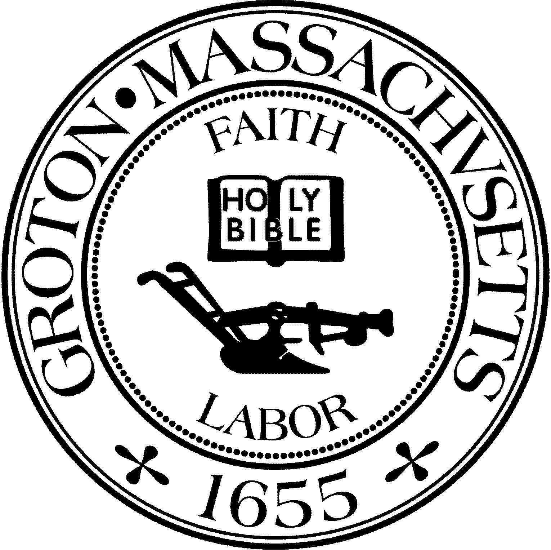
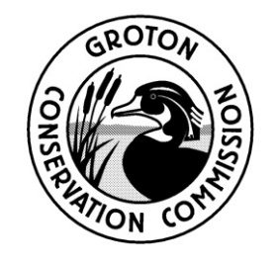
TOWN OF GROTON
Conservation Commission
173 Main St
Groton, MA 01450
(978)448-1106
Fax: 978-448-1113
conservation@grotonma.gov

Conservation Commission Meeting
Sunday, May 2 2021 at 12:00 PM
Location: Priest Family Conservation Area

Agenda

Work Day at the Priest Family Conservation Area

The Groton Stewardship Committee, a sub-committee of the Conservation Commission, gathered and conducted land management activities (mowing, clearing overgrown vegetation, etc.) on the open field hilltop.

