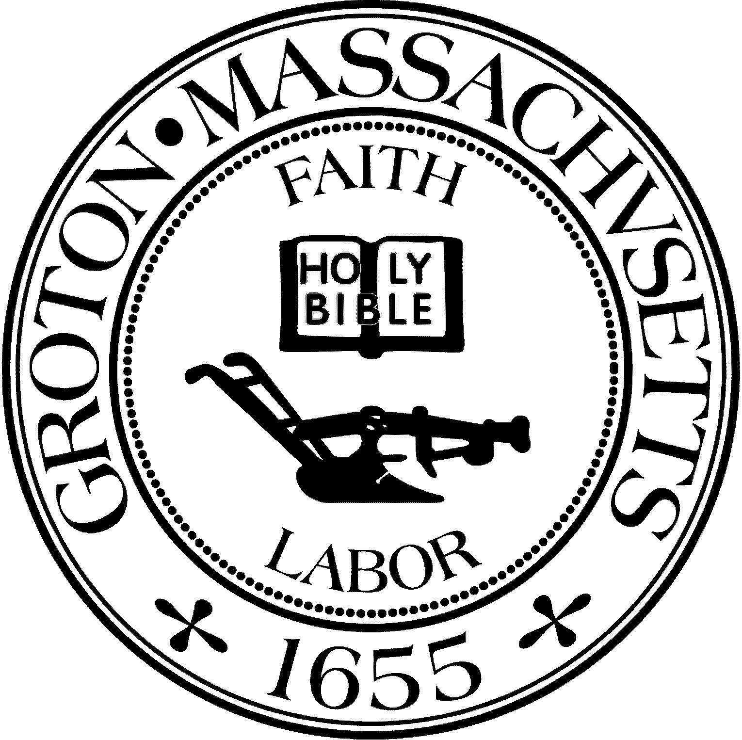
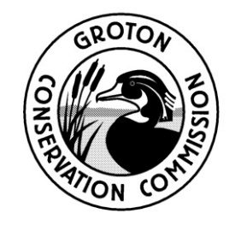
TOWN OF GROTON
Conservation Commission
173 Main St
Groton, MA 01450
(978)448-1106
Fax: 978-448-1113
conservation@grotonma.gov

Groton Conservation Commission
Thursday, February 27, 2020 at 6:30 PM
Groton Senior Center, 163 West Main Street, Groton, MA

Conservation Commission: John Smigelski, Chairman; Laurence J. Hurley, Vice Chair; Eileen McHugh, Clerk; Peter Morrison; Bruce Easom; Marshall Giguere; Olin Lathrop. Nikolis Gualco, Conservation Administrator.

Agenda

6:30 PM – 6th Annual Groton Conservation Forum

Members of the Groton Conservation Commission attended the annual Conservation Forum and reported on land conservation efforts taken during the past year.

