TOWN OF GROTON
173 Main Street
Groton, MA 01450

Community Preservation Committee
Bruce Easom, Chair – Conservation Comm.
Carolyn Perkins – at large
Russell Burke – Planning Board
Robert DeGroot – Historical Comm.
Daniel Emerson – Housing Auth.
Anna Eliot – Parks Comm.
Richard Hewitt – at large
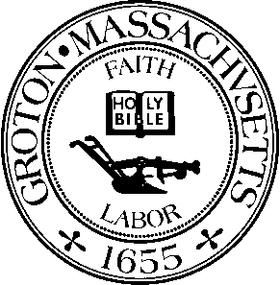

MEETING MINUTES

Date: Thursday, August 25th, 2022
Time: 5:30 PM
Location: Virtual Meeting via Zoom
Members Present: Bruce H. Easom, Carolyn Perkins, Russell Burke, Robert DeGroot, Daniel Emerson, Anna Eliot and Richard Hewitt
Others Present: Mark Haddad, Donald Black

The meeting was called to order by Chairperson Bruce Easom at 5:30 PM.

MEET WITH PROCUREMENT OFFICER TO DISCUSS HANDLING SITUATIONS WHERE CPA PROJECT MANAGERS HAVE PAID VENDORS AND THEN SUBMIT INVOICES TO GET REIMBURSED

The Town Procurement Officer / Town Manager Mark Haddad was present. The Project Manager for CPA Project # 2022-01 Maintenance Shed Restoration Donald Black was also present.

The CPC members asked that any requests for invoice payment reimbursements to the Town be pre-approved by the Town Manager prior to it being presented to the CPC for review.

There is no obligation for the CPA to pay for any project work completed if the proper CPA protocols for invoices submitted are not followed.

Mr. Haddad will adhere to the regular procedure for the processing of CPC invoices and ensure that all CPA protocols are followed.

CPC members encouraged Mr. Black to contact the appropriate CPC liaison for any CPA project in instances where an invoice requires immediate attention and they will assist with getting it through the proper channels for processing.

Anna Eliot moved to adjourn the meeting at 5:51 PM. Daniel Emerson seconded and the motion carried by unanimous vote.

Respectfully submitted by Sammie Kul, Inter-Departmental Assistant

APPROVED: SEPTEMBER 26, 2022

