TOWN OF GROTON
Office of the Commissioners of Trust Funds
173 Main Street, Groton, Massachusetts 01450
Karen F. Tuomi, Executive Director
trustfunds@grotonma.gov
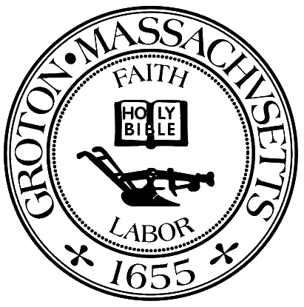

Commissioners of Trust Funds Meeting Minutes
January 9, 2024 11am
Town Hall 1st Floor Meeting Room
Attendees: Martha McLure, Rachael Bielecki, Joe Twomey
Guests: Hannah Moller, Mike Hartnett, Jason O’Connell, Caroline Randall, Brian Jamrosa, Kathleen Glowcki,Vanessa Abraham, David Zeiler
Review bills for approval and signatures
Meet with Boston Trust financial Advisors – Jason O’Connell and Caroline Randall
With the anticipation of interest rates falling should changes be made to our benchmarks 85/15. Jason feels that the need is not imminent but should be kept an eye on. The range should remain at 75-85% - 25-15%. Joe made a motion to change the range 65-85% - 35- 15%. Rachael seconded and voted unanimously.
Jason feels that the change to prudent investor was a positive for our funds (5% growth to 15%)
Meet with Barthlomew Financial Advisors – Brian Jamrosa, Kathleen Glowacki
Bartholomew range is 30-70 (equity/bonds) Brian said it was a good move to go away from the Legal List. Do they recommend a range for more flexibility? Range already exists of 20-40/80-60. They are looking for an increase of the target of 30%, however, they are also comfortable with this target. They would like to do some research and come back with some recommendations in February.
Lecture Fund Request from GDRHS- State Career Development Conference – Rosenfeld – registration fee
In Control Driving Program – McManus - approved
Lecture Fund Request from GDRMS – Pineapple Project Request not received
Lecture Fund Request from the Invasive Species Committee - approved
Director’s Report:
Social Media Update – Social Media posts have been very positively received. They were a huge help during the holidays spreading the word and look forward to seeing the impact it has on Lecture Fund applications and scholarship interest.
December holidays update – very successful holiday season thanks in large part to our social media presence. Twenty one families helped and toys were disbursed to over 100 children in the community

Open session for topics not anticipated 48 hours prior to the meeting -
Lecture Fund Request from Groton Business Association – Grotonfest – Spring 2024 $2500
A vote to enter into Executive Session was not taken.

